TAMU NSF GK-12 HOME

Forces Acting on an Airplane
Lesson Summary:
This activity will show and describe the main forces that are acting on an airplane while it is in flight, and would be a great beginning or end to a Force & Motion chapter. First, the forces will be described, and then the kids will get to build a paper airplane and determine which designs allow for further flight.
Subject:
- Math: Measurement, Reasoning and Proof
- Science: Unifying Concepts and Processes, Earth and Space Science, Science as Inquiry, Science and Technology
Grade Level:
- Target Grades: 6-8
- Upper Bound: 8
- Lower Bound: 6
Time Required: 40 to 50 minutes
Reusable Activity Cost Per Group [in dollars]: Approximately $10.00 per class (scissors, tape, paper clips, etc.)
Expendable Activity Cost Per Group [in dollars]: Approximately $6.00 per class (construction paper, computer paper, notebook paper, tracing paper, etc.)
Authors:
Undergraduate Fellow: Ross Shockley
Graduate Fellow: Erin Anitsakis
Teacher Mentor: Pamela Donald
Date Submitted: 10/12/05
Date Last Edited: 10/12/05
Lesson Introduction / Motivation:
You can begin the lesson by asking them if they know how airplanes work. Drop a pencil and ask them why it falls to the ground, while an airplane is able to remain in flight. Use this to lead into the discussion of the main forces acting on an airplane.
Lesson Plan:
Show or draw them a picture of an airplane, and the four main forces acting upon it (thrust, weight, lift, and drag). This is a free-body force diagram. Now provide a simple explanation of each force acting on the plane:

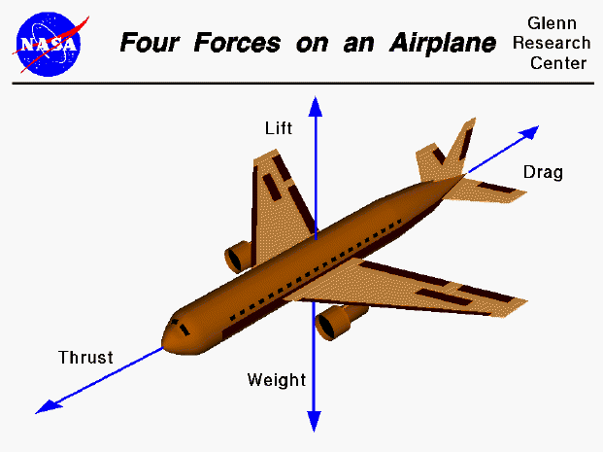

Weight - Weight is a force that is always directed toward the center of the earth. The magnitude of the weight depends on the mass of all the airplane parts, fuel, and any payload on board (people, baggage, freight, etc.).

Flying encompasses two major problems; overcoming the weight of an object by some opposing force, and controlling the object in flight. Both of these problems are related to the object's weight and the location of the center of gravity. During a flight, an airplane's weight constantly changes as the aircraft consumes fuel. The distribution of the weight and the center of gravity also changes. So the pilot must constantly adjust the controls to keep the airplane balanced.

Lift – Lift overcomes the downward force caused by weight and gravity. Lift is generated through the motion of the airplane through the air. Most lift takes place because of the wings

Drag – As the plane is traveling, air resists the motion of the aircraft and the resistance force is called drag. Drag is directed along and opposed to the flight direction. Like lift, there are many factors that affect the magnitude of the drag force including the shape and velocity of the aircraft.

Tell the kids to wave their hand through the air with their palm facing the direction of motion. Now get them to slice their hands through the air, with their palm facing the ground. Obviously, the second method has much less air resistance, making it easier to move your hand. This is a basic concept of aerodynamics.

Thrust – Airplanes generate thrust with the use of engines. The goal of thrust is to overcome the force of drag.

Important: While explaining these four forces, make sure the kids know that forces acting in the same or opposite directions have an affect on one another. In this case, thrust is used to overcome drag, while lift overcomes the weight of the aircraft.

Activity Plan:
Creating an aerodynamic paper airplane:
- After explaining the forces above, get the kids to create a paper airplane that they think would be aerodynamic. Have a few already made, some of which are very good, and some that are odd-shaped (boxes, etc.).
- Go outside with the airplanes, and see which designs fly the furthest. You may want to give the student with the best airplane an award for creating the plane with the smallest amount of drag and an ideal amount of weight.
- Ask them why their plane doesn’t fly forever. Which of the four forces is missing on their paper airplanes? The answer is thrust. Obviously, there are no engines attached to the wings or front of the paper airplanes.
Assessment:
- If the students can adequately describe how basic forces work on an airplane using the four forces described above, then the activity is most definitely a success!

Vocabulary / Definitions:
- Thrust - The forward-directed force developed in a jet or rocket engine as a reaction to the high-velocity rearward ejection of exhaust gases.
- Weight - The force with which a body is attracted to Earth or another celestial body, equal to the product of the object's mass and the acceleration of gravity.
- Lift - The component of the total aerodynamic force acting on an airfoil or on an entire aircraft or winged missile perpendicular to the relative wind and normally exerted in an upward direction, opposing the pull of gravity.
- Drag - The retarding force exerted on a moving body by a fluid medium such as air or water.
Lesson Scaling:
- For greater grade levels or more advanced students, the distance traveled by the airplanes can be measured. Graphs and other data output can then be prepared.

Please email us your comments on this lesson:
E-mail to ljohnson@cvm.tamu.edu
Please include the title of the lesson, whether you are a teacher, resident scientist or college faculty and what grade you used it for.

Teacher's Comments:

