Garden Chemistry — Soil Science

Download all Associated Files for this lesson from our Website

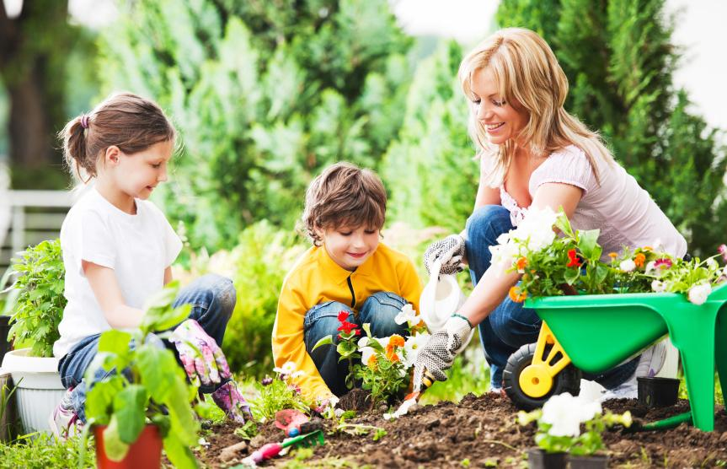
Summary: Students will learn about the dynamic relationship between plants and the soil in which they grow. They will identify the organisms that call soil home and describe the beneficial and detrimental effects they have on the plants with which they live. The PowerPoint presentation walks students through the variety of life found in a garden, including both plants and soil organisms. Students will identify essential nutrients of plants and define pH and describe its effect on plant life. The presentation also introduces for discussion how humans can interact to change a garden system.
Keywords: consumer, decomposer, gardening, host, microbes, mutualism, pH, parasite, parasitism, plants, predator, prey, producer, soil science, symbiosis

Subject:
- Science:
7(13) Organisms and Environments. The student knows that a living organism must be able to maintain balance in stable internal conditions in response to external and internal stimuli. The student is expected to:
(A) investigate how organisms respond to external stimuli found in the environment such as phototropism and fight or flight; and
(B) describe and relate responses in organisms that may result from internal stimuli such as wilting in plants and fever or vomiting in animals that allow them to maintain balance.
8 (11) Organisms and environments. The student knows that interdependence occurs among living systems and the environment and that human activities can affect these systems. The student is expected to:
(A) describe producer/consumer, predator/prey, and parasite/host relationships as they occur in food webs within marine, freshwater, and terrestrial ecosystems;
(B) investigate how organisms and populations in an ecosystem depend on and may compete for biotic and abiotic factors such as quantity of light, water, range of temperatures, or soil composition;
(C) explore how short- and long-term environmental changes affect organisms and traits in subsequent populations; and
(D) recognize human dependence on ocean systems and explain how human activities such as runoff, artificial reefs, or use of resources have modified these systems.

Grade Level:
- Target Grades: 7, 8
- Upper Bound: 9
- Lower Bound: 6
Learning Objectives:
- List different organisms found in soil
- Describe the role of organisms in garden systems
- Describe the interdependence between organisms in a system and the impact humans can have, both good and bad
- Calculate hydrogen concentration and learn how it affects plants and soil organisms

Time Required: 2 class periods
- One for PowerPoint presentation
- One for activities and videos
Materials:
- Soil sampler or spade
- Plastic bags
- Hand lens
- Microscope
- PowerPoint: Garden Chemistry

Video: The Science of Soil Health: Changing the Way We Think About Soil Microbes
Approximately 3 minutes
USDA Natural Resources Conservation Service
Dr. Kristine Nichols
https://www.youtube.com/watch?v=EyKfpOso8q8&list=PLa2RANW4lNUMHUJDK6x4gXu8yGJQ2KB0L&index=6
- Video: Why Soil is Important to Everyday Life
Approximately 2 minutes
British Society of Soil Science
Professor Phil Haygarth
https://www.youtube.com/watch?v=e3Tqbji30UM&index=7&list=PLa2RANW4lNUMHUJDK6x4gXu8yGJQ2KB0L
- Video: So You Want to be a Soil Scientist
Approximately 2 minutes
Adventures in Education
https://www.youtube.com/watch?v=5071UDkGpf0&list=PLa2RANW4lNUMHUJDK6x4gXu8yGJQ2KB0L&index=30
- Activity: Soil Scientist (adapted from Soil Sammy)
Soil Scientist Worksheet found on the PEER website
- http://seedsurvivor.com/documents/SeedSurvivor_SammySoil.pdf
- 1 plant per team, in addition to a “control” plant
- Products such as coffee grounds, cream of tartar, soda, apple juice, etc (see the full list below)
- Graphing paper, or something to graph the data on
- Activity: Soil is a Filter
http://www.doctordirt.org/teachingresources/soilfilter

Background Information:
The garden is a microcosmic environment providing an excellent example of the interdependence of organisms. Micro-organisms such as bacteria, fungi, and protozoa have complex symbiotic relationships necessary for survival. These relationships include:
- Mutualism - a relationship in which each individual benefits from the activity of the other.
- Parasitism - relationships between species, where one species, the parasite, benefits at the expense of the other, the host
- Commensalism - relationships between two organisms where one organism benefits from the other without affecting it
The garden microorganisms and the environment in which they exist also provide insight into the components of a food chain. Each element of this microhabitat plays a role as:
- Producer - an organism which creates its own food/energy
- Consumer – utilizes (feeds) on other organisms to obtain energy
- Decomposer – breaks down dead or decaying matter
In addition to the biotic factors of the garden biome, many abiotic factors including soil pH and nutrients interact and impact its overall health.

Lesson Introduction/Motiviation:
Begin by asking students what they know about soil. Is it made of living (biotic) or non-living (abiotic) matter? Is it the same everywhere? Does it change? Does it affect plant growth? Next, take students outdoors to collect cross sections of soil from various locations by using a soil sampler or digging down about a foot. Place each sample in a plastic bag and label with date and location. Finally, have students use hand lenses and/or microscopes to observe soil; record observations in journals or data tables. Revisit your initial questions to determine the accuracy of student knowledge.

Lesson:
- PowerPoint Presentation: Garden Chemistry- review the presentation ahead of time to make notes of discussion points. Allow ample time for students to take notes and ask questions.
- Video: The Science of Soil Health: Changing the Way We Think About Soil Microbes- a short video by a microbiologist discussing how important soil microbes are to plant life, accompanied by pictures and video clips of actual microscopic organisms.
- Activity: Students can become soil scientists and learn how dirt actually makes our water cleaner.

Activity/Application:
- Soil Scientist (adapted from Soil Sammy) http://seedsurvivor.com/documents/SeedSurvivor_SammySoil.pdf
Have students split into teams and come up with different substances that have the nutrients plants need, then add those to the plants and see what group grows the best plant! Students will be able to see firsthand a) that we can manipulate the environment and b) how manipulating the environment affects the organisms within it. This is also a great activity for developing scientific inquiry skills! Have students develop questions, hypotheses, experiment design, data tables, and graphs.
- Soil is a Filter
http://www.doctordirt.org/teachingresources/soilfilter

Lesson Closure:
- Review with students what the essential plant nutrients are and what soil organisms are imperative for life and why.
- Discuss with your class why pH is important to soil. Have the students research different plants and what pH they thrive in.
- Ask students to explore what different nutrients you can add to the soil and how.

Additional Resources and References:
- The PEER website, http://peer.tamu.edu/DLC/NSF_Resources.asp?type=search&num=5&terms=compost&content=allcontent&subject=allsubjects&grade=allgrades&query=query&hl=no&view=no , has many additional lessons on composting and soil. Search for “compost” in the search dialogue box.
- Activity: Collect Soil Bugs
http://www.blm.gov/nstc/soil/Kids/collect.html
- Using Soil to Solve Crimes
http://www.csiro.au/Outcomes/Environment/Australian-Landscapes/soil-evidence-murder-case.aspx
- University of Oxford Podcasts
Botanic Garden Audio Trail
http://www.podcasts.ox.ac.uk/series/botanic-garden-audio-trail
Authors:
Veterinary fellow name: Nikki Lejeune
Torri Whitaker Science Content Specialist
Please email us your comments on this lesson:
E-mail to ljohnson@cvm.tamu.edu
Please include the title of the lesson, whether you are a teacher, resident scientist or college faculty and what grade you used it for.

