http://images.google.com/imgres?imgurl=http://www.mhhe.com/earthsci/geology/mcconnell/images/anim_permeability.gif&imgrefurl=http://www.mhhe.com/earthsci/geology/mcconnell/demo/animations.mhtml&h=153&w=142&sz=132&tbnid=ILA0Ktlzf5kJ:&tbnh=91&tbnw=84&hl=en&start=16&prev=/images%3Fq%3Dpore%2Bspaces%26svnum%3D10%26hl%3Den%26lr%3D

Groundwater & Wetlands
 | Rock Properties  - The distribution of groundwater is controlled by the porosity and permeability of rocks  - Porosity is the capacity of rock or sediment to store water  - Permeability is the capacity of water to flow through rock or sediment  - Loose sand has a porosity of 30-40%  here is approximately 40 times more water below ground than in lakes and streams on the earth's surface. Cave systems represent the most dramatic landforms generated by groundwater. Although caves can be formed by other geologic processes, the dissolution of limestone (see Weathering) rocks by groundwater is the most common method of cave formation. The world's largest cave, Mammoth Cave, Kentucky, is also one of the prime attractions of the U.S. National Park system.  The flow of water through caves also generates one of the most commonly held misconceptions about groundwater. Groundwater is not made up of an network of underground rivers and lakes. Rather, most groundwater is present in billions of tiny spaces between mineral grains or in narrow fractures in bedrock. It helps to keep in mind that caves are relatively rare but groundwater resources are present nearly everywhere across the U.S. Groundwater distribution depends on the porosity and permeability of rocks or sediment.  Porosity  Porosity is the capacity of rock or sediment to store water. Porosity may be over 50% of rock/sediment volume. Rock and sediment contain spaces between grains (pore spaces), in fractures, or in dissolved cavities (limestone), that may become filled with water.  The proportion of the rock made up of pore spaces is dependent upon the size and packing (arrangement) of the constituent grains. Porosity is typically higher in unconsolidated sediments (sand, gravel) than in the equivalent rocks (sandstone, conglomerate) which have undergone lithification. The conversion of sediment to sedimentary rock results in the loss of porosity as a result of compaction (spaces destroyed as grains are squeezed closer together) and cementation (spaces filled with cementing agent holding grains together). Porosity may later be enhanced by dissolution in limestones (rock is dissolved by weakly acidic groundwater) or fracturing of all rock types during tectonic events.  Some groundwater is held as a film on the surfaces of grains by surface tension. This water will not flow through the rock and is termed the specific retention (S_{r}) of the material. The volume of groundwater that can drain from rock or sediment is known as the specific yield (S_{y}). The specific yield of  coarse-grained rocks is little different from porosity as the surface film is a small proportion of the pore space. In contrast, surface films represent most of the water in the small pores between clay and silt particles in fine-grained rocks. Consequently, the specific yield of these materials is low even though porosity is high (~50%) in clay-rich sediments and rocks.  Igneous and metamorphic rocks typically have low porosity and permeability as their grains grow together during rock formation. However, the presence of fractures in some rocks produces properties suitable for the storage and flow of groundwater. Thousands of meters of ancient lava flows are preserved as the Columbia Plateau basalts in the northwestern U.S. The tops of the lava flows were heavily fractured during formation and the bases of the adjacent flows often contain abundant vesicles (gas bubbles). Wells penetrating these zones of high porosity and permeability can yield as much as 450 liters (117 gallons) of water per second.  Porosity Demonstration  A 1000 ml beaker was filled with sand and 500 ml of water was added to a second beaker (below). Water was slowly poured into the sand-filled beaker. The water moved down through the sand (permeability), darkening the grains. We continued to pour the water until all the sand was completely saturated and water rose to the surface of the sand.  The water level in the second beaker had declined from 500 ml to 150 ml. The difference was in the sand-filled beaker. The 350 ml of water filled the pore spaces between sand grains. Therefore, 350 ml of the original 1000 ml sand volume was made up of air-filled pore spaces (porosity = 35%).  Permeability  Permeability is the capacity of water to flow through rock or sediment. Water can flow readily through rocks with high permeability values.  High permeability often goes hand-in-hand with high porosity and large grain size. Connections between pore spaces are wider in coarse-grained sediment (sand, gravel) and rock (sandstone, conglomerate) and are narrower in fine-grained materials (silt, clay, shale, mudstone). However, not all pore spaces may be connected while others may contain clay minerals that can expand in the presence of water to block passageways and reduce permeability. Surface water films in fine-grained materials may fill the narrow connections between pore spaces blocking the passage of groundwater.  Numerous measurements of natural groundwater systems have revealed that groundwater flows much more slowly than water in streams due to the effect of friction from the surrounding grains. Rapid groundwater flow is measured meters per year. In contrast, streams typically travel a meter in a few seconds. One benefit of the excruciatingly slow movement of groundwater is that pollution may be anticipated and mitigated before it contaminates underground water supplies. The net direction of groundwater flow is downward under the influence of gravity. (For more on on factors influencing the rate of flow of groundwater, see Darcy's Law).
   | Go to  the  Web:
  Environment Canada’s tutorial, Groundwater
  - Nature's Hidden Treasure, presents a comprehensive discussion of groundwater and includes an illustration of three types of porosity
  USGS Groundwater Information - includes links to the Ground Water Atlas of the U.S. and a recent report to Congress on U.S. ground water resources
  Porosity of some common sediments and rocks
  Soil: 55%
  Gravel & sand: 20-50%
  Clay:
  50-70%
  Sandstone: 5-30%
  Limestone: 10-30%
  Fractured igneous rocks: 10-40%
  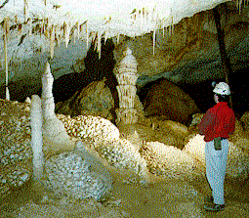 | Geologist views rock formations formed in a limestone cave formed by groundwater dissolving the rock. Image courtesy of Dr. Ira Sasowsky, University of Akron
  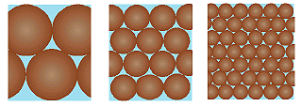
  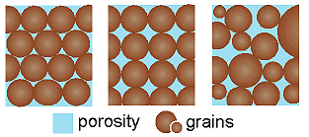
  Different grain sizes and packing arrangements result in different porosity values. Top: individual pore spaces decrease in size with decreasing grain size. Bottom: porosity varies with packing (arrangement) of grains.
  S_{y} = Porosity - S_{r}
  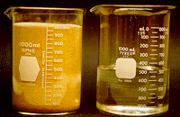 |  | 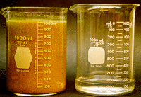
  Before: Beakers filled with 1000 ml of sand (left) and 500 ml of water (right). The water is poured into the sand. |  | After: Sand-filled beaker now contains an additional 350 ml of water. The water filled original pore spaces.
  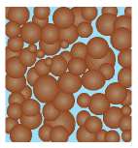 | Simple animation of flow of groundwater between connected pore spaces. Permeability is greater (flow is faster) through the wider passage on the right. Note that not all pore spaces are interconnected.
  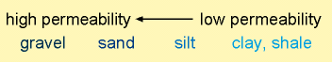
 | Chapter index | go to top of document

