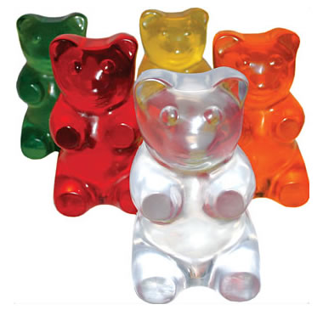
Gummy Bear Analysis
Now, let’s think about our hypotheses, analyze our data, and draw some conclusions: Compare your data to a group next to you that had a bear in a different temperature water.
- Did a bear in cold water or a bear in RT water have more mass today? _________________
- Did a bear in cold water or a bear in RT water have more volume today? ________________

- Did the temperature of the water you kept your gummy bears in overnight have an effect on them today? (If yes, why do you think that it made a difference? If no, why do you think it didn’t make a difference?) __________________________________________________________________________________________________________________________________________________________________

