Halloween Science “Magic” Show
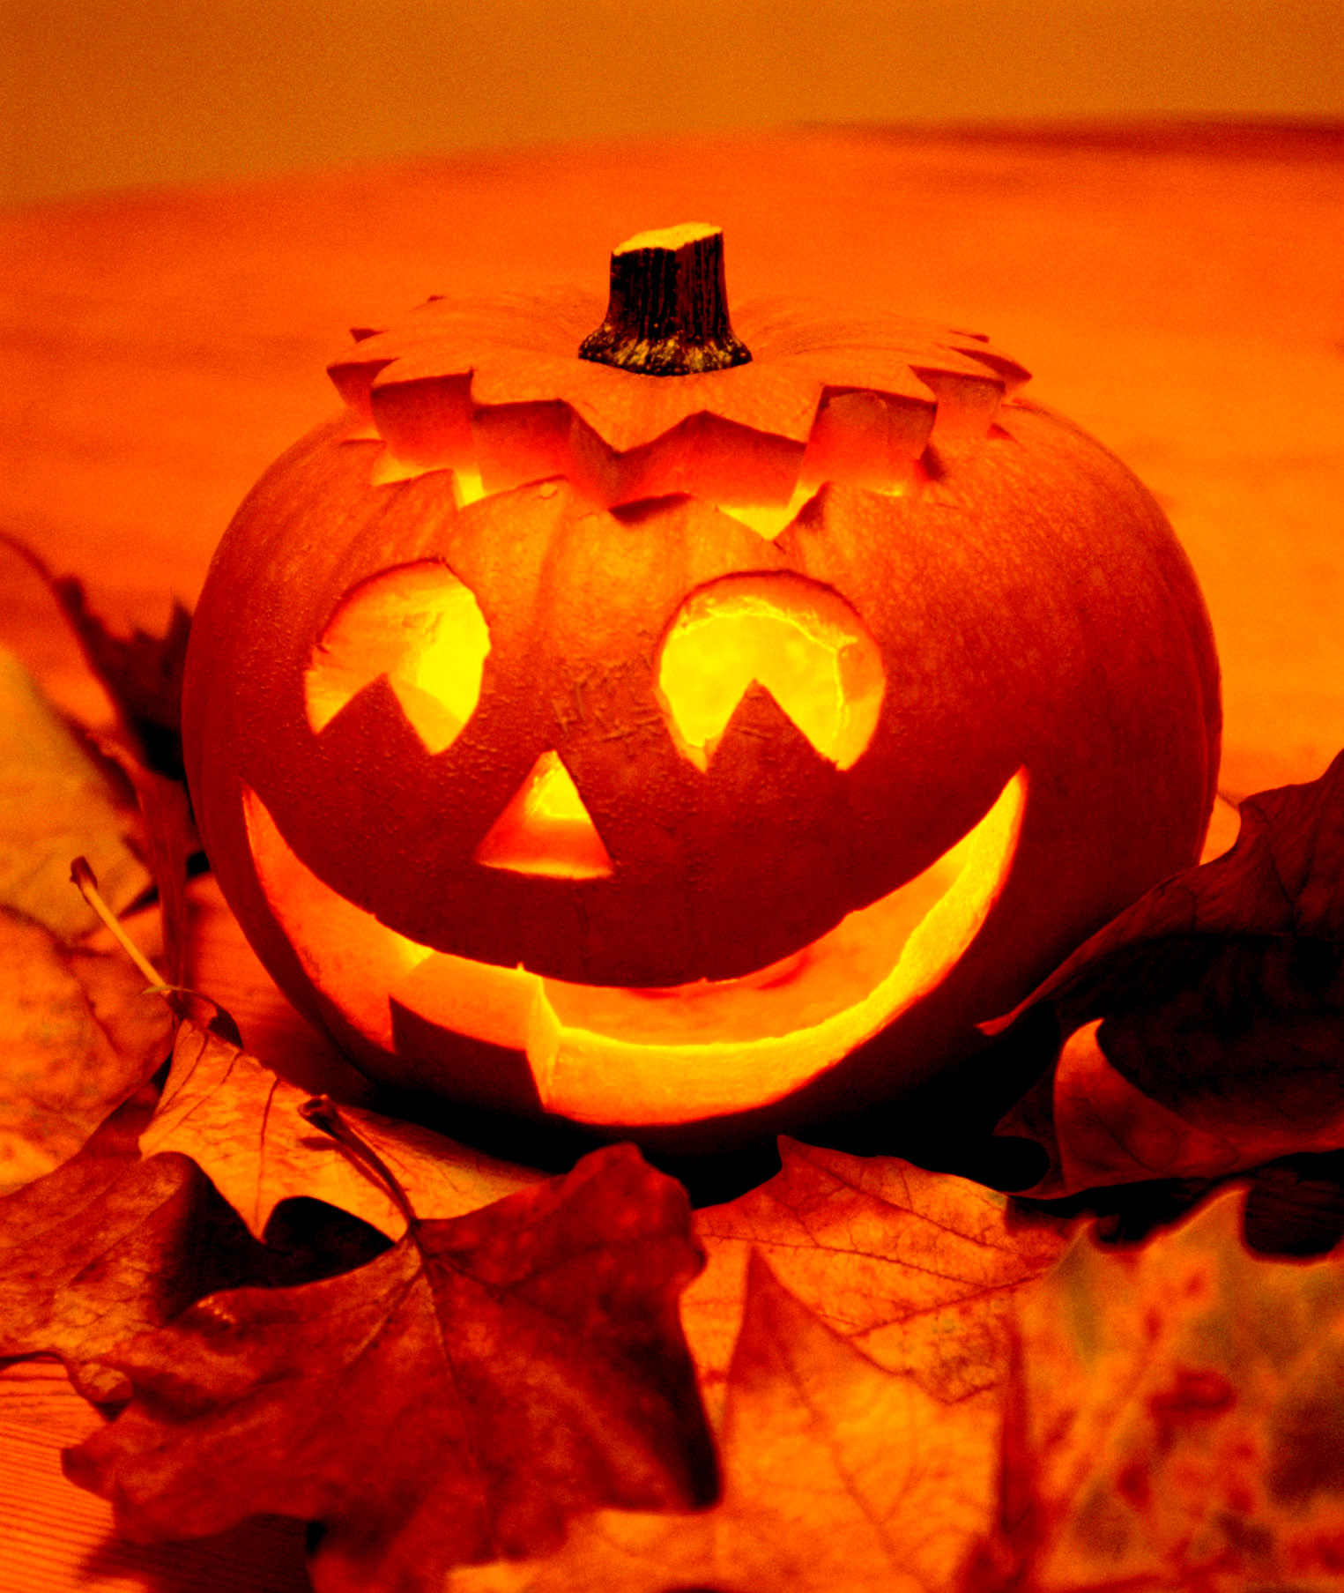
Summary:
Halloween has the reputation for magic and tricks. This activity is designed to show students that a lot of things that are seemingly caused by “magic” can actually be easily explained by science. Flinn Scientific is a company that specializes in providing school teachers with kits, equipment, and other supplies to enhance scientific learning—this lesson uses many of the kits available from their company.
Subject:
- Science: 6
6.a.1 and 6.b.3.A
Grade Level:
- Target Grade: 6
- Upper Bound: high school
- Lower Bound: 6
Time Required: One class period for the demonstrations and one class period for explanations.
Activity Team/Group Size: This is an entire class period’s worth of demonstrations—it can be done on as small a scale as a single class, or on as large a scale as all science classes (depending on size of room available).

Materials (all of the following are materials required IN ADDITION to the kits available from Flinn. Additional materials (besides the ones mentioned here may be required)):
- Green Fire Pumpkin
  - Roach killer (containing boric acid)
  - HEET Gas Line Antifreeze and Water Remover
  - A pumpkin (with a face carved into it and all insides removed). (http://chemistry.about.com/od/funfireprojects/a/greenfire.htm)
- The Yellow and Blue Switcheroo
  - 50mL graduated cylinders (3)
  - 250mL beaker (1)
- Amorphous Monster
  - Large latex glove (for each demonstration)
  - Food coloring
  - Dixie cups
  - Wooden stirring stick
- Energetic Light
  - 250mL beaker (2)
  - Stirring rod
  - Glow sticks
- Fluorescent Slime Monster
  - Plastic cup (sterile urine collection cups work really well)
  - Graduated cylinder (1)
  - Wooden stir stick
- Slime
  - 50/50 mixture Elmer’s glue and water
  - Saturated Borax solution
- Ghosts and Goblins
  - Tissue paper
  - Thread
  - 1-L soft drink bottles (cheap off-brand Ginger Ale bottles work the best)
  - 1-hole stopper
- The Reappearing Pumpkin
  - 250 mL flask with a pumpkin face drawn on (1)
  - Rubber stopper
- Dry Ice Show
  - Distilled water (very important! Colors don’t work very well if the water you use has any pH)
  - 1 L beakers (5)
  - Dry ice
- Crystal Ball
  - Dry ice
  - Sudsy, soapy solution (made from dishwashing detergent and water)
  - Soft cloth soaked in soapy solution
  - Vase with wide, smooth lip
  - http://www.stevespanglerscience.com/experiment/00000079
- Bubble blower
  - 2 L flask (1)
  - Rubber tubing attached to a funnel
  - Dishwashing detergent and water solution in a large petri dish
  - Dry ice
- Pumpkin Head
  - Plastic pumpkin trick or treating bucket with holes cut out in the eyes and nose
  - A large plastic tray
  - A large plastic tablecloth to protect the table and/or carpet
  - Dishwashing detergent
  - Food coloring
  - Styrofoam plate
  - 250 mL beaker
  - 10mL graduated cylinders (2)
Reusable Activity Cost Per Group [in dollars]:
Many of the materials outlined above are re-usable. This cost depends on what you already have available.
Expendable Activity Cost Per Group [in dollars]: ~ $230
The kits available from Flinn Scientific:
- The Yellow and Blue Switcheroo—$23.95
- Energetic Light—$20.80
- The Reappearing Pumpkin—$21.50
- Chemistry of Halloween Chemical Demonstration Set—$104.81
  - Includes:
    - Ghosts and Goblins
    - Amorphous Monster
    - Pumpkin Head (“Evil Spirits”)
    - Fluorescent Slime Monster
Additional expendable purchases:
- Dry Ice
- Glow sticks
- Off brand Ginger Ale bottles

Learning Objectives:
- The purpose of this activity/demonstration is to show students the chemistry behind “magic”. By explaining each demonstration after performing it the students have the chance to be intrigued (possibly astounded!) and then learn HOW it worked and why. It’s a great Halloween activity and a good way to introduce different states of matter (you work with dry ice so they can see solid→gas (sublimation) and the slime you have spread out that they will have a chance to touch/play with is an example of a non-newtonian fluid.
Lesson Introduction / Motivation:
The quickest way to grab the students’ attention is to turn the lights out and light the green fire in the pumpkin. Every student will be on the edge of their seat and ready to see more!
Lesson Plan:
Before the demonstrations start on Day 1, the handout “Halloween Science Magic Show” should be passed out to each student. This will be used to assess how well students understood the demonstrations on Day 2.
Listed below is the order we performed our “magic” tricks. All of the Flinn kits come with a detailed procedure written out; included with each demonstration are some helpful notes. The demonstrations can be done on Day 1, the students can think about the tricks over night, and then on Day 2, students can discuss how they think the chemical reactions occurred and the teacher can direct the discussion and then explain how each demonstration worked :
- Green Fire Pumpkin
  - The bottom of the carved pumpkin required for this demonstration should be lined with aluminum foil (to prevent being burned through by the end of the day).
  - After all of the students have been seated, turn off the lights, pour a little of the roach powder into the bottom of the pumpkin, add just a little amount of the HEET, then use a long candle lighter to light the mixture on fire.
  - Green flames will immediately light up through the cut-outs of the pumpkin.
- The Yellow and Blue Switcheroo (we re-named “Rotating Lights”)
  - To prep for this demonstration pour the required amount of each of the solutions into three 50mL beakers prior to the demonstration.
  - Hold up one beaker, show the students that it is clear and pour it into a 250mL beaker. Do this for the two other beakers.
  - Hold the 250mL beaker up for everyone to see—the color change is immediate and really cool.
- Amorphous Monster
  - Use a Dixie cup to combine the liquids and food coloring, and stir with the wooden stick.
  - Immediately pour this mixture into the large latex glove and make sure to spread it out equally between all of the fingers.
  - This is not an immediate reaction—we pretended to be disappointed and just moved on to the next demonstration and waited for students in the front to notice how much the glove ultimately grows.
- Energetic Lights (we re-named “Eerie Lights”)
  - It is very important to stir as you add the energetic light solution.
  - Additionally, after making this you can talk about the science behind glow sticks (and break open a glow stick to show that chemical reaction).
- Fluorescent Slime Monster
  - This is a really cool demonstration. . .when it works. For us it worked one time, and that was it. Unfortunately, we’re not sure how to troubleshoot this demo. Perhaps Flinn has good technical support.
- Ghosts and Goblins
  - We determined that cheap plastic works better for this works better than nicer plastic.
  - These can be easily set-up beforehand.
- Reappearing Pumpkin (we re-named “Disappearing Pumpkin”)
  - We set these up beforehand, then shook them, and the students saw the pumpkin disappear. Later on they would see the pumpkin reappear.
- Dry Ice Show
  - The beakers of water can already be set-up before the show. They form a pretty rainbow and once the dry ice is added the colors change.
  - USE DISTILLED WATER!!
- Crystal Ball
  - Fill the vase with water. Drop a chunk of dry ice into it, and then use the cloth to put a layer of soap film over the mouth of the face. The CO2 released will cause the soap to puff up into a giant dome.
- Bubble blower
  - To assemble the apparatus, put the small end of the funnel into the rubber tubing.
  - Fill a 2L beaker with about 500mL of water. Drop a hunk of dry ice into it, then cover the mouth of the flask with a balloon to make a seal. Cut a small hole in the balloon and put the tubing down into the flask. Prepare a large petri dish bottom with a soap and water solution. Dip the large end of the funnel into the soap/water solution. The CO2 gas will flow up the rubber tubing and come out through the funnel into the soap. Huge bubbles filled with CO2 gas will form. Because CO2 is heavier than air the bubbles will fall to the ground.
- Pumpkin Head
  - This is EXTREMELY messy and kind of corrosive!!! Make sure the plastic pumpkin is on a plastic tray and that the table or surface it is located on is covered by a plastic table cloth and that there is something protecting the floor underneath.
  - Also, it’s a great way to end the show because it is so messy and awesome. It ends the show on a high note.
Some additional notes: This show really works best with 3-4 people working the different demonstrations. Some of the demonstrations require extensive clean-up which is difficult to do by yourself in between classes. However, if this is only for one show, then one person could easily do it.
Lesson Closure:
After all of the demonstrations are over on Day 1, students are told to think about how they think the chemical reactions worked. After the explanations on Day 2, the teacher can review some of the major chemical reactions that were done.
Assessment:
Collecting the handouts “Halloween Science Magic Show” from the students after Day 2 will show how well students observed the demonstrations on Day 1 and how well they understood the reactions after Day 2.

Vocabulary / Definitions:
- Depending on which demonstrations you actually perform there will be different vocabulary and definitions. All of the Flinn kits come with explanations and vocabulary you would find helpful for the explanations.
Background and Concepts for Teachers:
- All background/concepts is explained in the procedures for each demonstration.
Lesson Scaling:

To scale this lesson down—the demonstrations can be explained very briefly as they are done and the students won’t have to determine how they think they occurred.

To scale this lesson up—students could be assigned homework for them to write down how they think each demonstration was done for a grade—this would most likely require them to do some background research.

Safety Issues:

There are MANY safety concerns for these demonstrations. Read and follow all precautions in the Flinn procedures to the best of your ability.

References:
- http://www.stevespanglerscience.com/experiment/00000079
- http://chemistry.about.com/od/funfireprojects/a/greenfire.htm
- http://www.flinnsci.com/
  - Catalog numbers:
    - The Yellow and Blue Switcheroo
      - AP8660
    - Energetic Light
      - AP8978
    - The Reappearing Pumpkin
      - AP6384
    - Chemistry of Halloween Chemical Demonstration Set
      - AP2102
Keywords:
- Halloween
- Chemistry
- Science show
- Chemistry demonstrations
Authors:
Graduate Fellow Name: Lauren Schilling
Teacher Mentor Name: ___
Undergraduate Fellow Name: ___
Date Submitted: ___
Date Last Edited: ___
Please email us your comments on this lesson:
E-mail to ljohnson@cvm.tamu.edu
Please include the title of the lesson, whether you are a teacher, resident scientist or college faculty and what grade you used it for.

Teacher’s Comments:

