Introduction:
The flow of blood is vital in how the heart functions, and this activity gives you the opportunity to master the pathway and structures of the heart through a hands-on, creative in-class project. In groups of 3 or 4, you will work together to create an illustration with labels of the heart.

Materials:
- White Butcher Paper (Cut to the size of upper body)
- Pencils, Markers, and Colored Pencils (especially blue, red, and black)

Instructions:
1. Start by tracing, in pencil, one person from the waist up on the piece of butcher paper. You can use the image on the next page as an example when drawing.
2. Make sure to draw the following structures.
-Superior and inferior vena cava
-Right atrium
-Tricuspid valve
-Right ventricle
-Pulmonary semilunar valve
-Right and left pulmonary arteries
-Lungs
-Right and left pulmonary veins
-Left atrium
-Mitral valve
-Left ventricle
-Aortic semilunar valve
-Aorta
-Sinoatrial node
-Atrioventricular node
-Bundle of His
-Purkinje Fibers
3. In black, label each of the structures listed above.
4. In blue (for deoxygenated blood) and red (for oxygenated blood), trace the flow of blood through the heart from the vena cava to the aorta.
5. If time remains, be creative and give your person hair and a face.

KEY
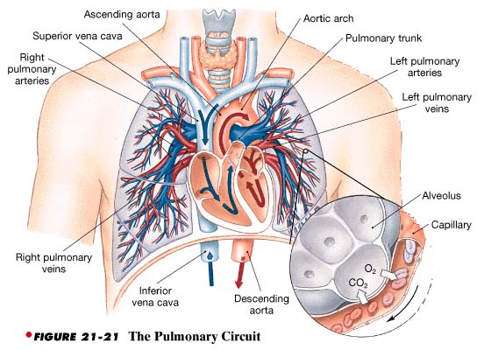
Lesson adapted from http://intranet.tdmu.edu.ua/data/kafedra/internal/anatomy/classes_stud/en/nurse/1/bsn/ptn/1/17.%20ARTERIAL%20SYSTEM%20SYSTEMIC%20AND%20PULMONARY%20ARTERIES.htm

