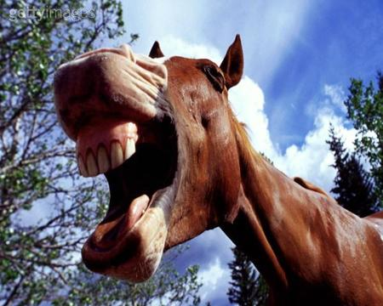
All About Horse Teeth

Summary:

Students will participate in an interactive PowerPoint, covering background information about horse teeth care and floating.
Subject:
- Agriculture:
  - TEKS: 119.66-Equine Science- 3A- The student knows the nutritional requirements of horses and the students are expected to determine nutritional requirements of horses.
  - TEKS: 119.66 Equine Science- 3B- Describe the anatomy and physiology of horses.
  - TEKS: 119.66 Equine Science -3C- Explain the methods of maintaining horse health and soundness.
Time Required: One class period of about 60 minutes.
Activity Team/Group Size:
- The whole class should participate in the PowerPoint. Following along with the PowerPoint students should be filling out their student worksheet. Then arrange students into groups of 2-3 and complete the equine dental sugar cube activity.

Materials:
- Pencil/Pen
- “All About Horse Teeth” student worksheet
- 10 sugar cubes per group
- Super glue
- Nail file, 1 per group
Activity Cost Per Group [in dollars]: All materials about $5 per student for sugar cubes and nail file.
Learning Objectives:
- To teach students about equine dentistry. Specifically to influence student understanding of the importance of equine dentistry.
Lesson Introduction / Motivation:
- Introduce the lesson with the “All about Horse Teeth” PowerPoint. Ask students if they know what the equine dentistry is. Let students share their knowledge, and use student responses as a guide to gauge how well students have absorbed the lesson during the closing activity.
Lesson Plan:
- After introducing the lesson as stated above begin the “All about Horse Teeth” PowerPoint presentation. Keep students attention throughout the presentation by clicking through slides and pausing between the appearance of the title on the slide and its explanation text. Take time to ask the students what they know about the title on the slide, can they teach you anything? Be sure that there is class participation during the presentation.
- During the presentation the students will complete the “All about Horse Teeth” student worksheet. Have students fill it out individually.
- After students have completed the worksheet, collect the worksheet, and break them into groups of 2-3 and have them complete the sugar cube activity.
  - Sugar Cube Activity:
    - Before the class the instructor should glue 10 sugar cubes together with the super glue, and allow time to dry before the activity. Each group should have one of the 10 sugar cube glued stick and a nail file.
    - The instructor should unevenly file the corners of the cube down the long side of the stick. So there are “Sharp Points” on the “Teeth” for students to correct.
      - Explain that the sugar cubes are representing horses’ teeth.
      - Have the students turn the cubes diagonally and file the “Sharp Points” to simulate floating horses’ teeth.
- After all groups are finished collect the cubes and nail files, and begin the exit activity (This is found in the Day1 lesson closure section below).
Lesson Closure:
- For students to leave class at the end of the period there will be a 3-2-1 activity. Ask each student to use a sheet of notebook or scratch paper and pen or pencil. Write down 3 things they learned, 2 things they have a question about, and 1 thing they want the (you) the instructor to know. Collect these as students leave class, and before the next day’s class period begins address the most frequently asked questions from this activity with the class.

Assessment:
- Grade all student worksheets for accuracy, and assess the students’ ability to grasp the information based on number of correct answers. Give bonus points for student participation during the PowerPoint presentation and sugar cube activity. Poster grading should be a participation grade.

Vocabulary / Definitions:
- Float – Means to level or equalize.
- Equine – Horse

Background and Concepts for Teachers:
- Read over the definitions above, and click through the PowerPoint presentation alone before presenting it in class. Be sure to have a grasp of each concept to be able to field student questions if needed.
Lesson Scaling:
- To modify the lesson if time or supplies are running short, the sugar cube activity can be eliminated.

Multimedia Support and Attachments:
- There is a PowerPoint attached for the lesson presentation.
References:
- http://tamunews.tamu.edu/2010/05/27/horse-cribbing-and-dentistry/
- http://tamunews.tamu.edu/2011/02/18/horse-dental-care/

Keywords:
- Horse
- Equine
- Dentistry
- Agriculture
Authors:
Undergraduate Fellow Name: Beverly Crocker
Date Submitted: 8/16/11
Please email us your comments on this lesson:
E-mail to ljohnson@cvm.tamu.edu
Please include the title of the lesson, whether you are a teacher, resident scientist or college faculty and what grade you used it for.
Teacher’s Comments:

