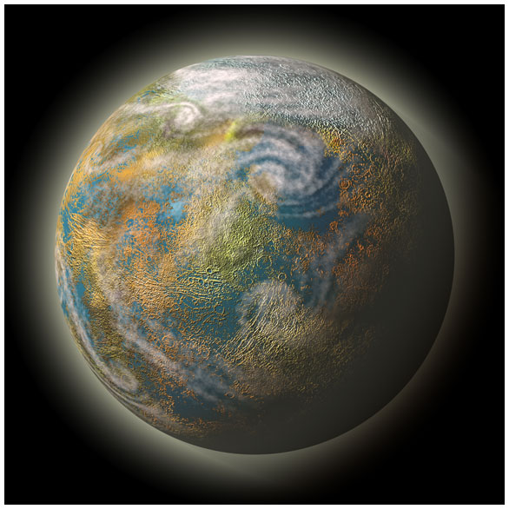
How Does Life on Earth Exist?
Summary:
After viewing a PowerPoint and taking notes about the things that allow life to exist on Earth, students will complete an activity that allows them to create their own planet and list how life survives there.
Subject:
- Science: 7.9 Earth and Space
Grade Level:
- Target Grade: 7
- Upper Bound: 8
- Lower Bound: 5
Time Required: 50 minutes approx.
Activity Team/Group Size: 3-4 and individual

Materials:
- There is Life on Other Planets Activity
- How Does Life Exist on Earth? PowerPoint
Learning Objectives:
- Students will be able to recognize and understand the intertwining factors that enable life to exist on Earth.
Lesson Introduction / Motivation:
Explain to the students that the Earth is very unique. If even one thing was different, we might not even exist!
Lesson Plan:
Present the PowerPoint to the students. Make sure they take notes. Afterwards, pass out the Activity sheet and put the students into groups of 3 to 4. Explain the directions then let students work on their drawing and papers.
Assessment:
Grade students’ on whether or not they followed instructions, not if their planets’ requirements for life make sense or if they are possible. You could give bonus points if you feel like a group was especially creative.

Vocabulary / Definitions:
- Homeostasis - an internal steady state
Lesson Scaling:

For a longer class, allow groups to present their drawings to the rest of the class, and then work on their individual papers. For a shorter class, or if the students seem to be running out of time, allow students to work on their individual papers at home.

Multimedia Support and Attachments:
- See link for the accompanying PowerPoint

Authors:
Graduate Fellow Name: Daniel Meysing
Teacher Mentor Name: ___
Undergraduate Fellow Name: Jillian Van Zandt
Date Submitted: ___
Date Last Edited: ___
Please email us your comments on this lesson:
E-mail to ljohnson@cvm.tamu.edu
Please include the title of the lesson, whether you are a teacher, resident scientist or college faculty and what grade you used it for.

Teacher’s Comments:

