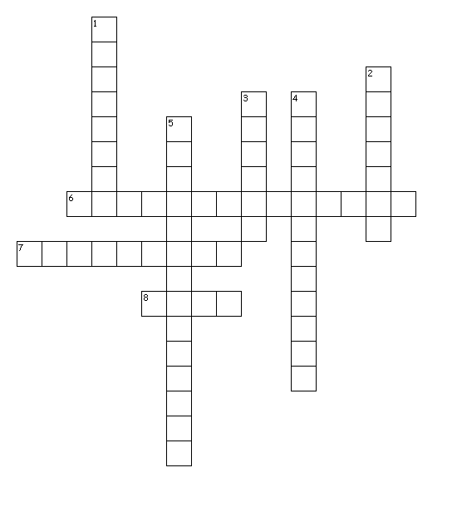
Protecting the Human-Animal Bond

Across
6. Veterinarians who focus on the human-animal bond understand the ___ they have to the
family unit.
7. Because of the possibility of legally increasing the value of a person's pet, a client may be able
to sue for what kind of distress?
8. As a pet's value, to an owner, increases, the level of _____, by a veterinarian, also increases.
Down
1. To maximize the human-animal bond, veterinarians must ___ for an animal.
2. What percentage of pet owners consider their pets to be children?
3. Now that animals share the family environment, veterinarians should be more aware of ___ health.
4. These are the most effective tools to prevent diseases in humans and animals.
5. The increase of pet value also demands increase in _____ from a veterinarian practitioner.

