Please identify and mark in the spaces provided the name of the different parts labeled by numbers 1-6. Work Bank provided:
Bone marrow Cancellous bone Compact bone Diaphysis Epiphysis Medullary Cavity
2
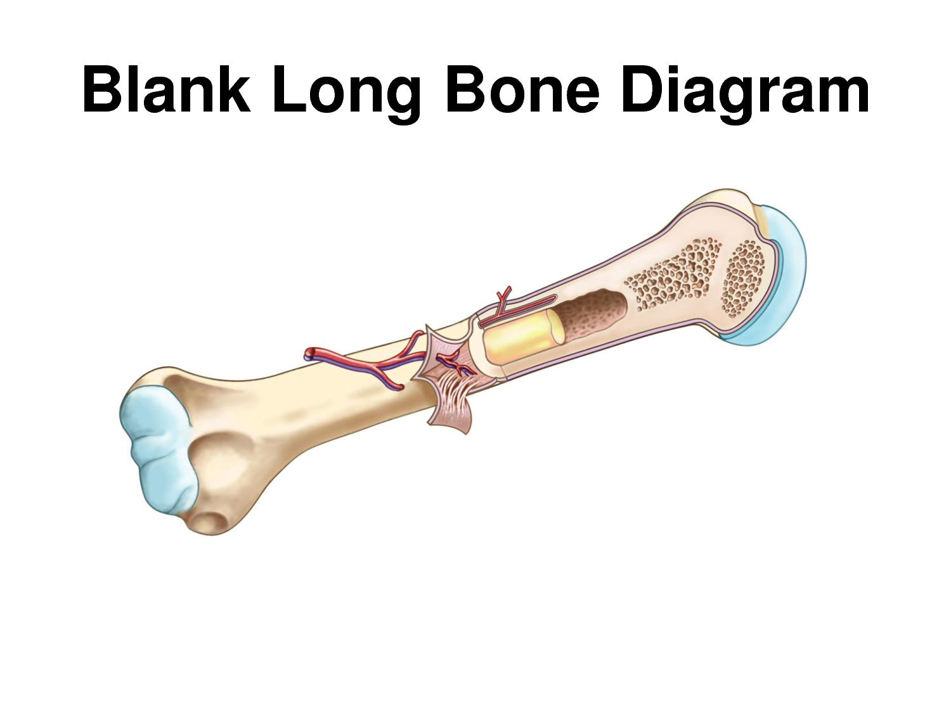
1
3
3
4
6

5

1_______________________________ 4_______________________________
2_______________________________ 5_______________________________
3_______________________________ 6_______________________________
------------------------------------------------------------------------------------------------------------
Name the different SHAPES of bones:
1_______________________________ 2_______________________________
3_______________________________ 4_______________________________
5_______________________________
List 2 of the 4 functions of the skeletal system:
1. 2.

