Please identify and mark in the spaces provided the name of the different parts labeled by numbers 1-6. Work Bank provided:
Bone marrow Cancellous bone Compact bone Diaphysis Epiphysis Medullary Cavity
2
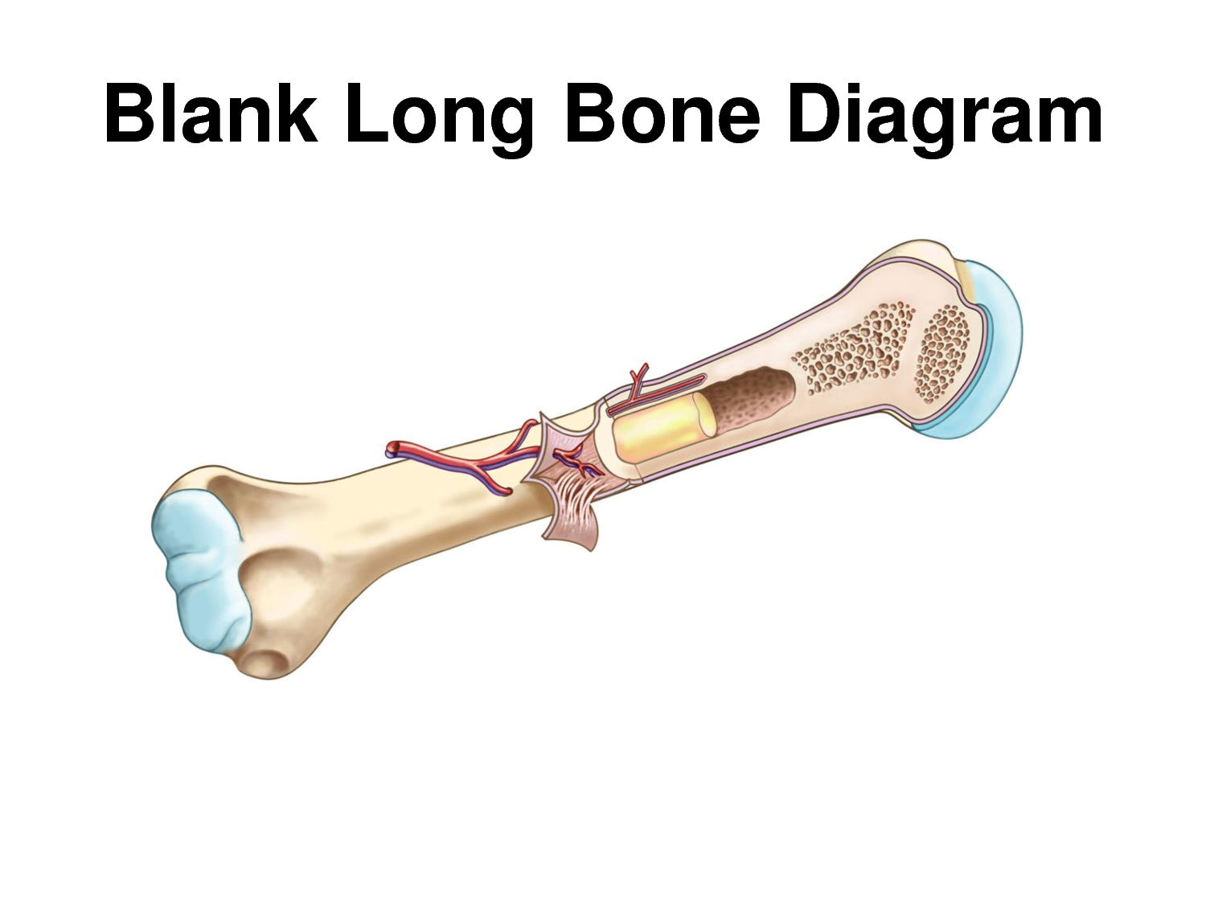
1
3
3
4
6

5

1 Medullary cavity________________ 4 Bone marrow______________
2 Compact bone_________________ 5 Spongy bone_______________
3 Epiphysis_____________________ 6 Diaphysis_________________
------------------------------------------------------------------------------------------------------------
Name the different SHAPES of bones:
1 Long _________________________ 2 Short__________________________
3 Flat___________________________ 4 Irregular_______________________
5 Sesamoid_______________________
List 2 of the 4 functions of the skeletal system:
1. Protects our organs.
2. Stores minerals.
3. Provides a framework for body movement.
4. Produces blood cells.

