Immu–Knowledge–y
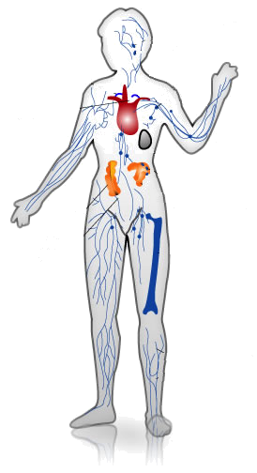

There are three folders containing three separate activities in them all involving the immune system. Below are summaries of these activities for your convenience as all three activities are different in composition and teaching technique.

Immune System Activity:
This folder contains an Activity Plan, and a Handout. The students will act out an immune response to either the exposure to a bacteria or a virus for a more than hands-on learning experience of the immune system. Pattern cut-outs are provided for each different component of the immune system to designate roles and an example script is also included with the lesson. Exactly how the response takes place is to your discretion but, however it is done, the students will be able to learn from their own actions and visualize what happens in their body.

Infected! Activity:
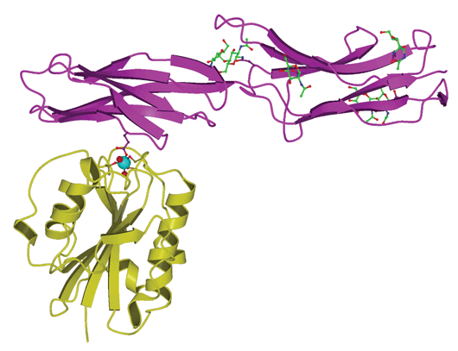
This folder contains an Activity Plan, a Worksheet, and an Answer Key. As another interactive activity, the students will be able to have fun while understanding how the immune system works. Students will play a game where one student is the virus and the rest are cells waiting to be attacked. The students will draw their roles from a container filled with slips of paper. The student virus will wink at other students to infect them right out of the game. The trick is for the other students to find out who the viral student is and send them out of the body to end the game. An extension of the same game teaches students about vaccination and how it can prevent viral infection. A worksheet is provided for assessment.

Immunology Documents:

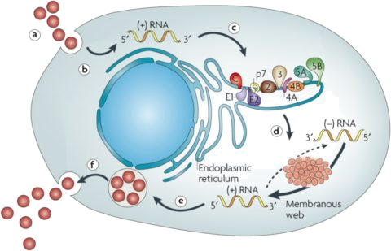
This internet module from a site called Sepa has many different parts which include hands-on, computer-based, and gaming activities all towards teaching about the immune system. Included in the folder are an Activities Summary pdf document and a Teacher Module that explains everything from the teacher’s point of view. Clicking on the link in the upper right hand corner of the Activities Summary document takes you to the main site where the Immunology Module can be chosen and all of the necessary downloadables accessed. There are two hands-on labs, an internet webquest activity, and a board game that can be downloaded for immune system fun. A lesson in and of itself, this module has all of the materials necessary for teaching the immune system to middle school students.

