Investigating Pulleys

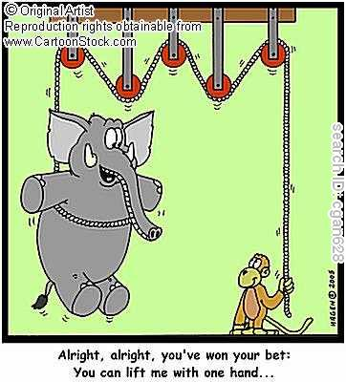
Summary:
This is a fun, interesting activity to help students understand force and motion. Students will use a series of small pulleys to help illustrate these concepts. The activity includes a worksheet to fill out, a series of real life examples, and several follow-up questions to help reinforce the lesson.
Subject: .
- Science: 6th B: 8E Investigate how inclined plans and pulleys can be used to change the amount of force required to move an object.
Grade Level:
- Target Grade: 6
- Upper Bound: 7
- Lower Bound: 5
Time Required: One class period.
Activity Team/Group Size: This activity is most easily completed in small groups.

Materials:

- Pulleys (we’ve used ones from Nasco)
- String
- Weights
- Meter Sticks
- Stacks of Textbooks (to weigh down the meter stick)
- Spring Scale

Reusable Activities: All materials are reusable.
Expendable Activity Materials: Possibly string or rope. You will also have to print new worksheets each time.

Learning Objectives:

- Become familiar with the ways pulleys are able to create easier ways for us to move objects.
- Use the concepts of force and motion in a real world application.

Lesson Introduction / Motivation: A good suggestion for getting the students interested may be a short clip from the internet, an example that you may have seen, or asking the students to relate times when they had to move something heavy, and explaining how much easier it would have been if they had some ‘help.’ If you were to take a clip off of the Internet, there are several humorous ones; for example, a piano-moving company using pulleys to get the massive instrument onto the fourth floor of an apartment building.
Lesson Plan: Students will construct a pulley that hangs over their desk, using the simple materials listed above. With a spring scale attached at the end of the string, students will lift objects or weights several different times and see how the spring scale is affected. The information is recorded and students observations are discussed. During the second part of the activity, students combine a fixed and moveable pulley to create a new outcome on the force of the experiment. Students will be able to make inferences about how pulleys make our lives easier, and develop the skills to determine why pulleys have a mechanical advantage and how they are used in complex and applicable real world examples.
Pulley Worksheet Packet
Pulley Powerpoint

Lesson Closure: There are several real world examples and questions that provide closure for the activity listed at the end of the Pulley Worksheet Packet. These questions are excellent to discuss verbally with students, as well as having them record their own thoughts in the spaces provided on the worksheet.
Assessment: To assess this activity, I would keep a close eye when students begin filling out the worksheet. You may decide to have them fill it out on their own, or ask them to answer the questions at the end individually. If your students seem to be moving rather quickly, it may be a good idea to have them work the questions individually, or ask them to provide more data on the worksheets. If your students are struggling during the activity, you may need to provide an “example pulley” at the front of the classroom, or give more background material on the experiment before beginning.

Vocabulary / Definitions:
- Pulley - A mechanism of composed of a wheel and axle, or shaft, that may have a groove between two of its flanges for rope or string.
- Force - is used to describe an influence which causes a free massive body to undergo an acceleration.
- Motion
- Spring Scale

Prerequisites for this Lesson:
- Must have an understanding of force and how pulleys relate to it.
- Must be able to adequately explain the relationship force has on daily life.

Authors:
Graduate Fellow Name: Lauren Schilling
Teacher Mentor Name:
Undergraduate Fellow Name:
Date Submitted:
Date Last Edited: 1/29/10
Please email us your comments on this lesson:
E-mail to ljohnson@cvm.tamu.edu
Please include the title of the lesson, whether you are a teacher, resident scientist or college faculty and what grade you used it for.

Teacher’s Comments:

