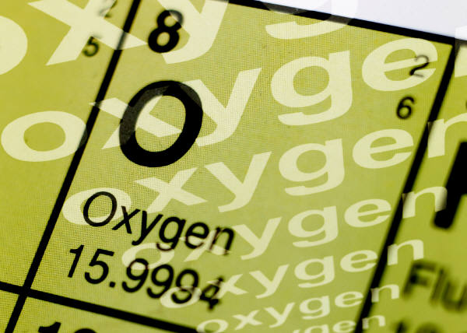
It’s Elemental, My Dear Oxygen

Summary:
The goal of this lesson is the teach students about the properties of elements and how they affect where an element is located on the periodic table. It will start with a lecture by the teacher on the components of the periodic table. Once the lecture is completed and the students seem to have an understanding of the topic, an activity will reinforce learning. The teacher will hand out the first set of matching cards and have students match the name of the element with the symbol. Once that task has been completed, the students will have to match elements with their properties according to a periodic table they are also given.
Subject:
- Science:
8.9 (B) Show an element’s properties affect its position on the Periodic Table
Materials:
- Periodic table
- Set of name and symbol cards
- Set of name and property cards
Grade Level:
- Target Grade: 8
- Upper Bound: 8
- Lower Bound: 7
Learning Objectives:
- Learn about the chemical names and symbols of the elements.
- Learn how the chemical and physical properties of elements can be used to identify them.
Time Required: 1 class period
Activity Team/Group Size: 4 members to a team (adjustable)
Reusable Activity Cost Per Group [in dollars]: $5.00
Cards and periodic tables can be re-used indefinitely if they are laminated.
Expendable Activity Cost Per Group [in dollars]: $0.00

Lesson Introduction / Motivation:
Have the students count off to make groups of four (The group size can vary depending upon how many students are present. Try to keep the groups small enough that each student will have a chance to match up at least a few cards.). Once in the groups, hand out a stack of the name/ symbol cards and a periodic table to each group. Time each group of students to see how quickly they can match everything up. This is also a way of seeing how much initial knowledge they have on the topic. Once they have completed the task, ask the students what they think these cards symbolize and what might be today’s lesson. After they give you their thoughts, tell them what you are going to be studying.
Lesson Plan:
Lecture on the PowerPoint and the basic topics. Once the students seem to have a grasp, have them get back into the groups they were in at the beginning of the period and have them do the same activity and time them again. Ask if they improved. Was it because of a better knowledge of the periodic table or because they have already done it once? Do they think they could do more difficult identification? Give them the second set of cards with the properties instead of names. Time them again (time is less important now, because you aren’t going to time them again, but it does motivate with some competition).
Lesson Closure:
Ask the students what they learned today. Remind them of the objective and ask if they feel they achieved it. If not, of what are they still unsure? What can be better improved for the next time?
Assessment:
For the next class period or as part of a comprehensive exam, give the students just the periodic table and ask them several questions about identifying an element (i.e. give them the name and ask the symbol, or vice versa or ask for an example of a liquid, gas, etc…). Have them write their answers down on a whiteboard, piece of paper, or notebook and keep track of how well they do.

Vocabulary / Definitions:
- Atomic Mass (Weight)- The average mass of an atom of an element, usually expressed in atomic mass units. The terms mass and weight are used interchangeably in this case. The atomic weight given on the periodic table is a weighted average of isotopic masses found in a typical terrestrial sample of the element.
- Chemical Property- Measurement of a chemical property involves a chemical change. For example, determining the flammability of gasoline involves burning it, producing carbon dioxide and water.
- Electron- A fundamental constituent of matter, having a negative charge of 1.602 176 462 × 10⁻¹⁹ coulombs ± 0.000 000 063 × 10⁻¹⁹ coulombs and a mass of 9.109 381 88 × 10⁻³¹ kg ± 0.000 000 72 × 10⁻³¹ kg.
- Neutron- An elementary particle found the atomic nucleus of all stable atoms except the hydrogen-1 atom. Neutrons have no charge and have a mass of 1.008665 daltons.
- Physical Property- Measurement of a physical property may change the arrangement but not the structure of the molecules of a material. Examples of physical properties are density, color, boiling point, volume, temperature, and mass.
- Proton- An elementary particle found the atomic nucleus with a positive charge equal and opposite that of the electron. Protons have a mass of 1.007276 daltons.
- Elements- substances that cannot be broken down any further by chemical means.
- The Periodic Table- the arrangement of elements by increasing atomic number and similar properties.
Keywords:
- Periodic Table
- Physical Properties
- Chemical Properties
- Chemistry
- Science
- Elements
Lesson Scaling:

This lesson could be scaled for lower grade levels by using only the element/ symbol cards or dealing with one aspect at a time (i.e. just atomic mass or just states of matter).

Multimedia Support and Attachments:
- It’s Elemental! PowerPoint
- It’s Elemental! Periodic Table
- Elements and Symbols Matching Cards
- Elements and Properties Matching Cards
Safety Issues:
Things can get exciting with trying to match the cards. Students should not be running around the room.

References:
- http://www.sciencegeek.net/tables/EniGcolor.pdf
- http://antoine.frostburg.edu/chem/senese/101/atoms/glossary.shtml
- http://chemistry.about.com/library/blperiodictable.htm
Authors:
Undergraduate Fellow Name: Megan Stussi
Teacher Mentor Name: ___
Date Submitted: ___
Date Last Edited: ___
Please email us your comments on this lesson:
E-mail to ljohnson@cvm.tamu.edu
Please include the title of the lesson, whether you are a teacher, resident scientist or college faculty and what grade you used it for.

Teacher's Comments:

