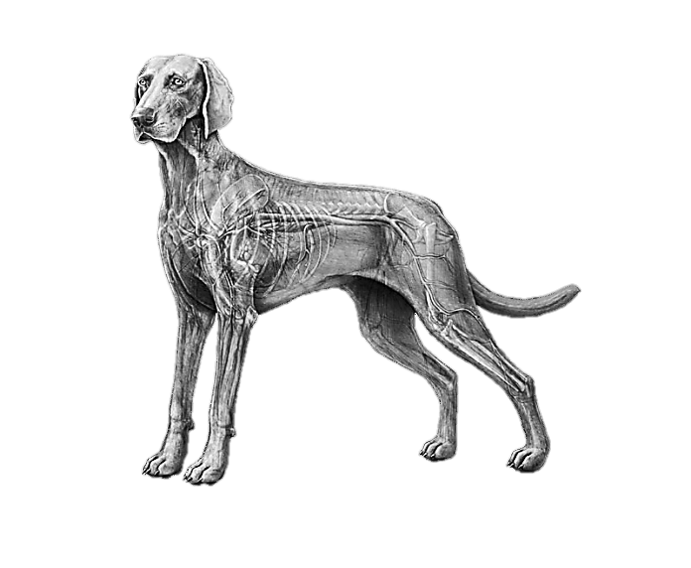
Name: ___________________________________ Date: ________________ Period: _________________

The Circulatory Systems of Animals

TEKS: 130.3 Livestock Production 4A, 130.6 Veterinary Medical, Applications 6A-B
What is the Circulatory System?
An animal’s body system concerned with the transport of blood through the heart,
blood vessels and lungs; helps move nutrients, oxygen, waste, etc. around the body.
Three Primary Types of Circulatory Systems:
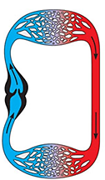 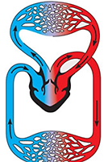 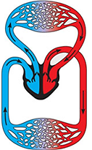
What animals have these types of circulatory systems?
Double Loop
4 Chamber Heart
Double Loop
3 Chamber Heart
Single Loop
2 Chamber Heart

Fish

Amphibians

Birds, Mammals
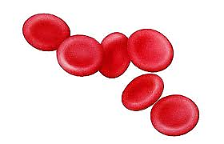
The Parts of the Circulatory System- Blood
- The liquid that _circulates ____ in the blood vessels,
_transporting _____ oxygen, carbon dioxide, waste, etc. around the body.
- What is blood made of?
Red Blood Cells (erythrocytes)- transport oxygen
White Blood Cells (leukocytes)- defense against infections
Platelets (thrombocytes)- assist with blood clotting
Plasma- liquid that suspends proteins and solid components of blood
The Parts of the Circulatory System- Blood Vessels:
Veins Arteries Capillaries
The pathway of oxygenated blood from the heart to the body. Oxygen is transferred to the tissues; Waste from the tissue cells is then transferred into the blood

The pathway of oxygenated blood from the heart to the body
The pathway of oxygenated blood to the heart

The Parts of the Circulatory System- The Heart:
- This is the muscle that is involved in pumping the blood throughout the body.
- What are the parts of the heart?
VENTRICLE CHAMBER(s): ATRIUM CHAMBER(s): VALVES:
The chamber(s) that pump the blood into the ventricle chamber(s)
The chamber(s) that pump the blood out of the heart,
to the lungs or body
Moving flaps between each chamber that keep the blood flowing in one direction; prevents backwards flow

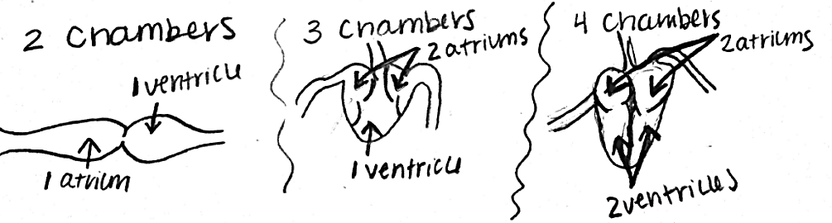
- Draw and describe the differences in the parts of 2, 3 and 4 chamber hearts.

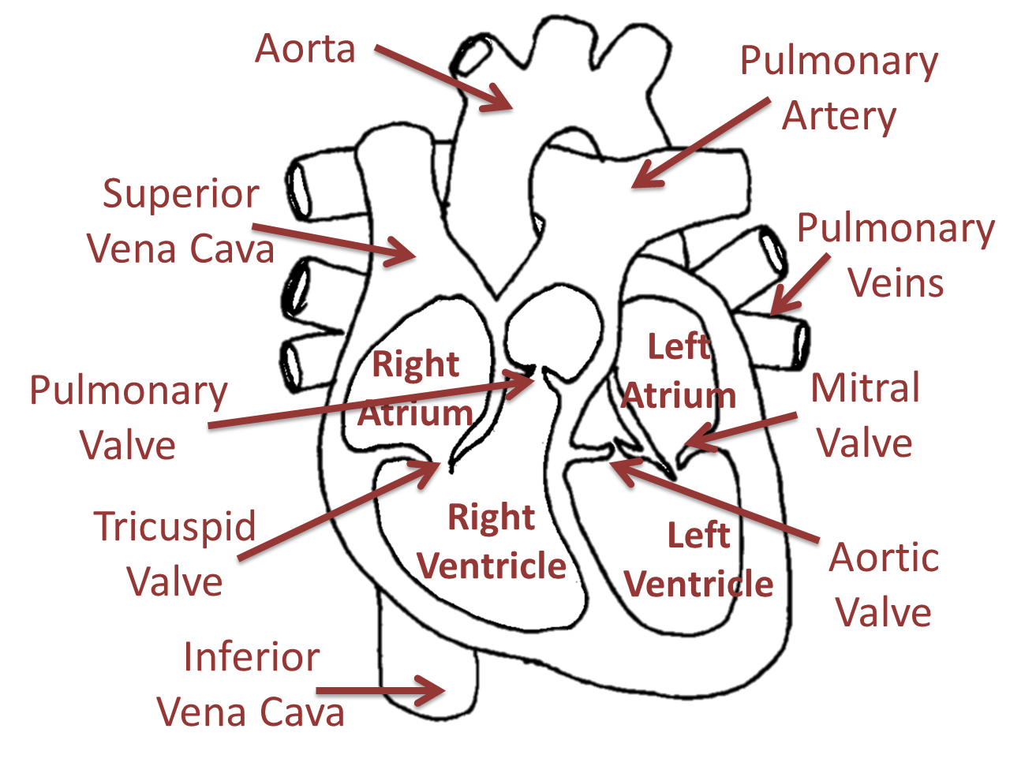
-Label each part of the 4 chamber heart.
Determine how many chambers each of the following animals’ hearts have:
Horse: 4
Catfish: 2
Turkey: 4
Pig: 4
Trout: 2
Bull: 4

