Desert Pocket Mouse: A Tiny Soldier
Activity Worksheet: Of Mice and All Other Organisms

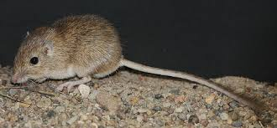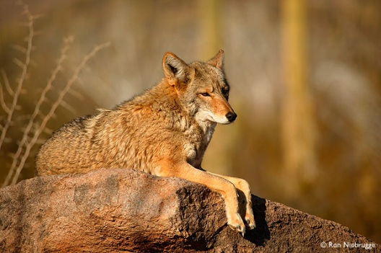

The Rock Pocket Mouse lives in a desert ecosystem: The Valley of Fire in New Mexico, United States. The mouse’s main predators are Owls, Hawks, Snakes, Coyotes, and Foxes.

1. The mouse relies on camouflage to hide and escape from predators.
a. If the mouse’s fur is typically light brown, what does that mean about the color of the desert terrain? How does this help the mouse to survive?
The desert terrain must then be also light brown. This helps the pocket mouse to go undetected by its predators, especially the flying ones such as hawks and owls.
b. What other traits could also help the Rock Pocket Mouse survive?
Student can include traits that help the mouse escape/fight predation, increase mating, and increase ability to find food and shelter. E.g. larger ears, faster legs, sharper teeth, etc.
c. How are these traits (fur color and other traits you came up with) adaptations?
An adaption is the inherited adjustment or change in behavior, physiology, and structure of an organism to become more suited to an environment. The mouse’s fur color helps it escape predators and thus fits the definition.
2. Most of the Rock Pocket Mouse population is light brown, yet there are a few mice that are black. The population distribution looks like this:

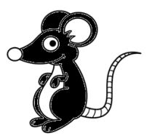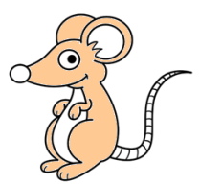

a. Why are some of the mice black? Where did they come from? (hint: your answer should include the words mutation and/or variation)
Black fur and brown fur are two variations of fur color for mice, meaning two different versions of the same trait. In this case, the black fur variation was caused by a mutation, which is a random process that changes DNA to form new alleles, and, thus, new variations.
b. Would black mice survive better or worse than brown mice? Why?
Black mice would have lower survival chance than brown mice because they are more easily detected against the brown terrain and killed by predators.
c. Compare the fitness of the brown mice to the black mice.
Fitness is the ability of an organism to survive long enough to re-produce and to reproduce well. Since black mice have a lower chance of survival than the brown mice, they have a lower chance of reproducing viable offspring. As a result, black mice would have a lower fitness level.
3. Now, suppose there was a volcanic eruption that left a significant portion of the terrain black instead of brown.
a. This means for predators it is now harder/easier to spot black mice and harder/easier to spot brown mice. (Circle correct answer for each)

b. Explain how the fitness of the brown and black mice would change:
Black Mouse –
The fitness of the black mouse would increase.
Brown Mouse –
The fitness of the brown mouse would decrease.
c. Compared to the mouse population before the eruption, the next generation of Rock Pocket Mice will have more/less brown mice and more/less black mice after the eruption. (circle correct answer for each) Why?
There will be more black mice and less brown mice than before in the Rock Pocket Mouse population. After the volcanic eruption because the black mice will have significantly better survival rates because they will escape predation better and produce more viable offspring.
d. Indicate (using colors or labels) what the Rock Pocket Mouse population would look like in terms of fur color in 1000 years, assuming the terrain remains black:

Conclusion Questions:

4. Do the mice have a color preference for their fur? Why does their fur color matter?
The mice have no preference for their own fur color. Here students should display an understanding that nature does the selecting. I.e. the mice’s fur color doesn’t affect them except in the capacity that it does make a difference in their predators’ ability to see them.

5. Is natural selection a random process? Why or why not?
Natural selection is not a random process; the only random component of the process is mutation. Natural selection sorts out the “winners and losers” within a population based and which variations and mutations are favored by a particular environment and environmental change.\. For this reason, evolutionary change can and does repeat itself and always continues to happen.

