*Answer the following questions using your knowledge of veterinary sutures.*

**Sutures in Veterinary Medicine**

1. Explain what a suture is and why it is important in veterinary medicine.

A stitch or row of stiches holding together the edges of a wound or surgical incision. This allows a patient to heal and prevent infection from entering the body.

1. Define the following types of sutures and explain why you might use each one.  
   1. Continuous Suture: A continuous suture made from an uninterrupted series of stitches. On a wound that needs to be sutured quickly, in a place on the body with less chance of the suture breaking…
   2. Interrupted Suture: An interrupted or non-continuous suture made where each stitch is tied separately. On a wound that is small or in a place on the body that is likely to pop a suture…
   3. Purse String Suture: A continuous stitch that closes the edges of a circular wound.

*Compare and contrast the different types of sutures and suture materials using the charts below*:

3.

|  |  |  |  |
| --- | --- | --- | --- |
| **Continuous** | | **Interrupted** | |
| *Pros* | *Faster, less expensive, less foreign material* | *Pros* | More tension control, if knot failure- not so bad |
| *Cons* | *Less tension control, knot failure is bad* | *Cons* | Slower, more expensive, more foreign material |

4. Absorbable All Suture Materials Non-Absorbable

Made of materials that can   
be broken downbody.   
Less of a likelihood of an immune reaction.   
Made of intestines.

Made of materials that are not broken down by the   
body.  
 can be removed or left in place permanently

Material used to close a wound and hold body tissues together

1. Describe the proper procedures for removing an animal’s sutures.  
   Cleanse the skin around the suture, gently elevate the suture and snip the suture with scissors, Remove the suture by *gently* pulling with the forceps.

**Practicing Sutures Activity**

Name: __________________ Date: ____________ Class: _________

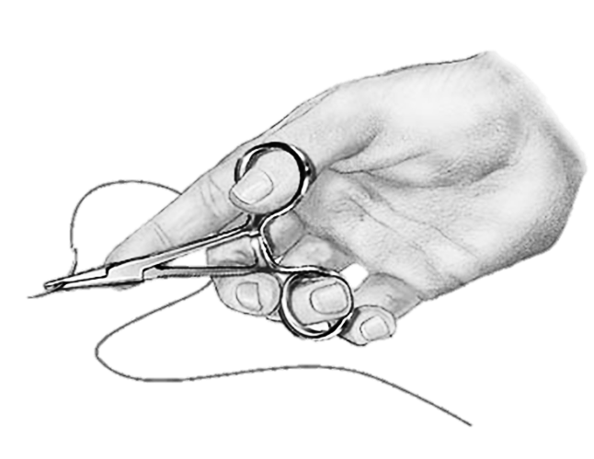*Follow the below steps to complete a suture on your model incision site.*

* **Collect the needed materials:**
  + 1 half banana with 2 incision sites, Needle, Needle Holders,   
    Suture Material, Surgical Scissors, and Forceps
* **Prepare your suture needle**
  1. Thread your needle with suture material.
  2. Tie a square knot, as shown by your teacher.
* **Practice Interrupted Sutures**
  1. Begin by threading the suture material onto the needle. Tie securely with a square knot.
  2. Next, use your forceps to lift the skin the banana enough to begin your suture.
  3. Beginning from the outside of the banana on one side of the incision site,   
     insert the needle through the skin but not into the below tissues.
  4. Pull the needle out from under the skin through the incision site.
  5. Next insert the needle through the skin on the other side of the incision site.   
     (Insert the needle from the bottom of the skin coming out the top).
  6. Pull the needle up and out, gently closing the incision.
  7. Tie a square knot and trim the suture material ends.
  8. Repeat Steps 1-5 along the incision site until the incision is completely closed.
* **Practice Continuous Sutures**

1. Begin this suture practice just as steps 1-6 are described for interrupted sutures.
2. Tie a square knot and DO NOT trim the suture material ends YET.
3. Repeat steps 2-6 as described for interrupted until the entire incision site is closed.
4. Tie end off with a square knot and trim suture material.

*Answer the following questions based on your experience practicing sutures.*

* What tasks did you find **easy** in this activity? Explain why.
* What tasks did you find **challenging** in this activity? Explain why.

**Teacher Tips for Practicing Sutures**

**Preparing the bananas for this activity**

* Each student will need ½ bananas.
  + (For every 2 students you will need to purchase 1 banana). The greener the better. Green bananas are more durable and the sutures are less likely to pull out.
  + Do not cut the bananas until just before the activity; cutting them too early increases ripeness and causes the bananas to become brown, soft and less durable.
* Using the knife, cut each banana in half, cross cutting the banana short ways.



* Using the knife, slice the peel of the banana long ways on two sides.
  + Do not cut into the meat below the peel; only cut the peel.

**Materials needed- What can be substituted?**

The following list tells what tools are needed to complete this activity and in parenthesis are suggestions to other tools or equipment that can be substituted if needed.

* + **Knife**- for teacher use only
  + (1 per student) half banana with 2 incision sites
  + **Curved Suture Needle** (sewing needle will work as well but shouldn’t be used in real life suturing situations; only for practice purposes)
  + **Needle Holders** (needle nose pliers will work as well but also shouldn’t be used during real sutures)
  + **Suture Material** (dental floss or sewing thread may also be used for this activity)
  + **Surgical Scissors** (normal classroom scissors will work)
  + **Forceps** (tweezers or other grocery store type forceps can be used during this activity)

**Safety Tips**

* Knife should be limited to teacher use only to prevent injury.
* Before handing out needles, be sure to count how many are given out and remember to recount them after the activity is completed and cleaned up..
* Be aware of any food allergies related to bananas or materials in dental floss (if used).

**Teacher tips for suturing demo**

Before demonstrating this skill for your class, be sure to practice on your own to get the hang of things. This will teach you what is challenging and help you better explain to your students a few key tricks for this skill. A few tips to get you started:

* It can sometimes be helpful to have someone hold the banana in place and keep it from rolling when suturing.
* Try to not pull the suture material too hard because this may cause it to pull through the skin and/or thread break.
* Even if you choose to not show the videos provided on the powerpoint to your class, these are very helpful for you to watch to get a better understanding of how to suture. The videos are examples using bananas as well and should give you an idea of how yours should look.
* Tying knots can be tricky check out this resource (Figures 177-179) by McGraw Hill:  
  <http://flylib.com/books/en/2.569.1.25/1/>

**Remember!**

* Do not turn or rotate your banana when practicing the suture, if this were a patient you would not be able to move him/her around either. It takes skill to suture in different positions and is why practice is necessary.
* Being gentle on the banana to prevent bruising is just the same as on an animal; too much trauma to the tissues such as rough handling or redoing sutures causes bruising on the animal as well.
* Little to no use of direct touch on the needle is optimal. You should use the needle holder and forceps to handle the needle during this process as much as possible.