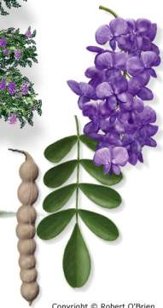
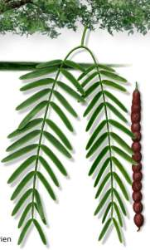
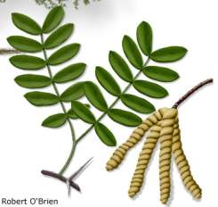
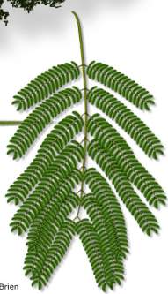
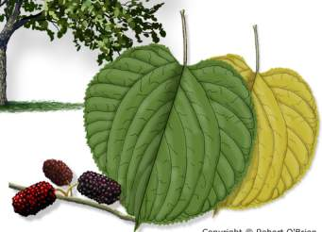
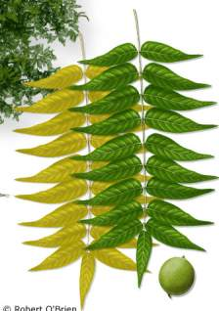
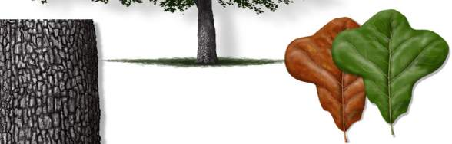
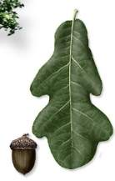
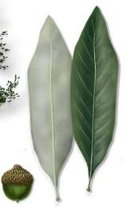
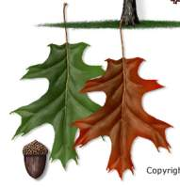
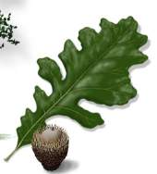
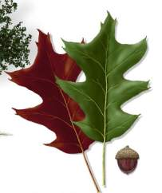
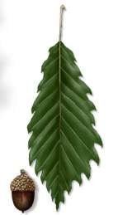
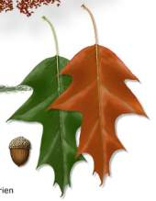
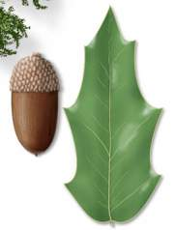
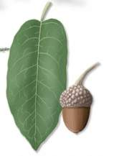
Honey Mesquite

Prosopis glandulosa var. glandulosa

Mesquite
Mescalbean

Sophora secundiflora

Texas Mountain-Laurel
Gray Oak

Quercus grisea
Red Mulberry

Morus rubra

Moral
Mimosa

Albizia julibrissin

Silktree
Screwbean Mesquite

Prosopis pubescens

Screwbean/ Tornillo
Lacey Oak

Quercus laceyi

Blue Oak/Canyon Oak
Texas Oak

Quercus buckleyi

Buckley Oak/Texas Red Oak/Spanish Oak
Bluejack Oak

Quercus incana

Sandjack Oak
Blackjack Oak

Quercus marilandica

Little Walnut

Juglans microcarpa

Texas Walnut/Nogalito
Cherrybark Oak

Quercus pagoda

Swamp Red Oak
Bur Oak

Quercus

Texas Mountain-Laurel
Emory Oak

Quercus emoryi

Chisos Red Oak

Quercus gravesii

Graves Oak
Chinkapin Oak

Quercus muehlenbergii

Chinquapin Oak

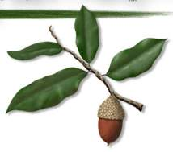
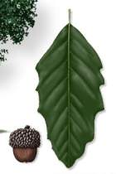
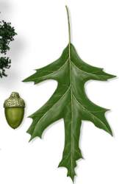
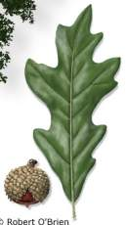
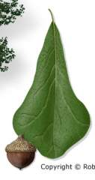
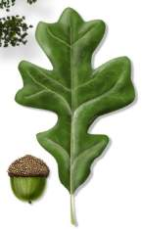
Mexican White Oak

Quercus polymorpha

Netleaf White Oak/Monterrey Oak
Nuttall Oak

Quercus texana

Live Oak

Quercus virginiana

Coast Live Oak

Post Oak

Quercus stellata

Water Oak

Quercus nigra

Pin Oak
Overcup Oak

Quercus lyrata

Swamp Post Oak

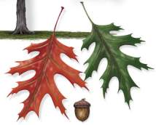

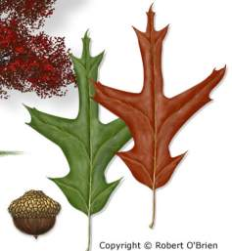
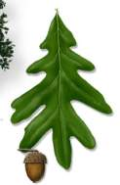
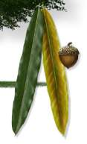
Shumard Oak

Quercus shumardii

Willow Oak

Quercus phellos

White Oak

Quercus alba
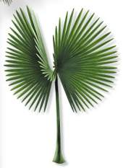

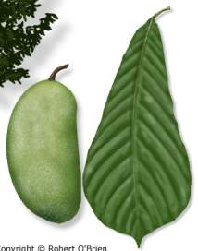
Pawpaw

Asimina triloba

Custard-Apple
Rio Grande Palmetto

Sabal mexicana

Texas Sabal Palm

Southern Red Oak

Quercus falcata

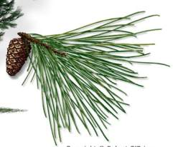
Afghan Pine

Pinus eldarica

Eldarica Pine/Mondel Pine
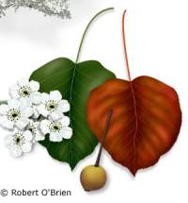
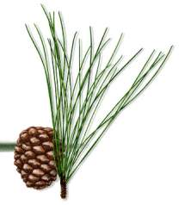

Callery Pear

Pyrus calleryana

Ornamental Pear
Italian Stone Pine

Pinus pinea

Umbrella Pine

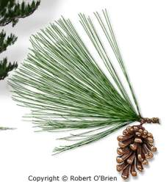
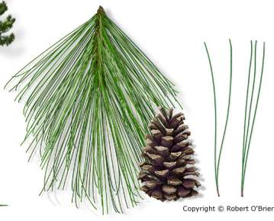
Longleaf Pine

Pinus palustris

Longstraw Pine
Japanese Black Pine

Pinus thunbergii

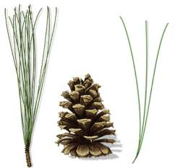

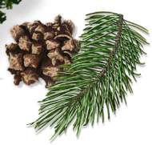

Loblolly Pine

Pinus taeda

Oldfield Pine
Mexican Pinyon Pine

Pinus cembroides

Mexican Pinyon

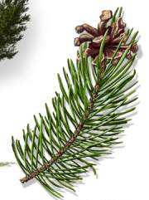
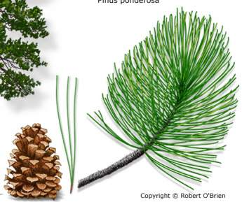
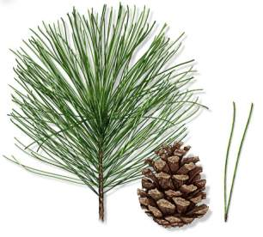
Shortleaf Pine

Pinus echinata

Shortleaf Yellow Pine
Rocky Mountain Ponderosa Pine

Pinus ponderosa var. scopulorum

Western Yellow Pine

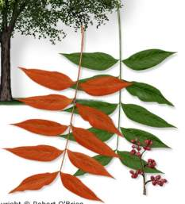
Pinyon Pine

Pinus edulis

Nut Pine/Two-Needle Pinyon

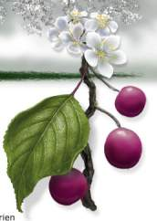
Chinese Pistache

Pistacia chinensis

Chinese Pistachio
Slash Pine

Pinus elliottii

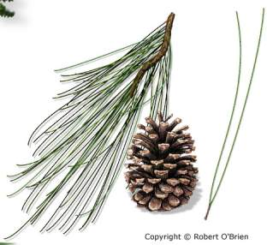

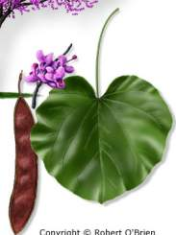
Mexican Plum

Prunus mexicana

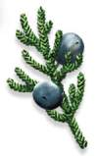
Mexican Redubud

Cercis Canadensis var. mexicana

Eastern Redcedar

Juniperus virginiana var. virginiana

Pencil Cedar

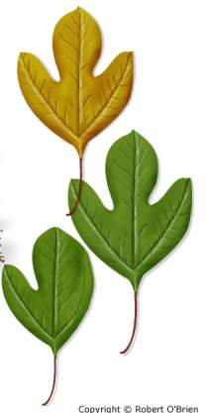
Sassafras

Sassafras albidum

Oldfield Pine
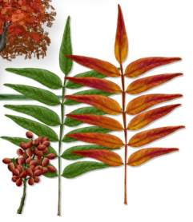
Prairie Sumac

Rhus lanceolata

Flameleaf Sumac/Prairie Flameleaf Sumac
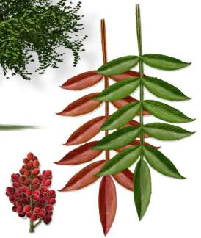

Winged Sumac

Rhus copallinum

Shining Sumac

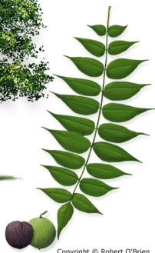

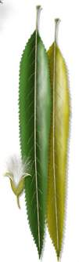
Black Willow

Salix nigra

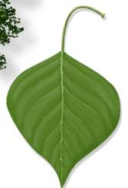

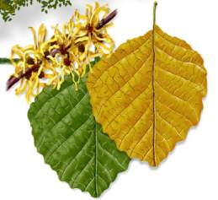

American Witchhazel

Hamamelis virginiana

Witch-Hazel

Black Walnut

Juglans nigra

Eastern Black Walnut

Tallowtree

Triadica sebifera

ChineseTallow

HOW TO ID

Identification Techniques:
- Tree Form
- Habitat
- Bark
- Leaves
- Leaf Arrangement
- Leaf Shape Descriptions
- Parts of a Leaf
- Twigs
- Buds
- Flowers
- Fruit
- Common Types of Fruits and Seeds
- Cones
- Wood

Leaf Arrangement

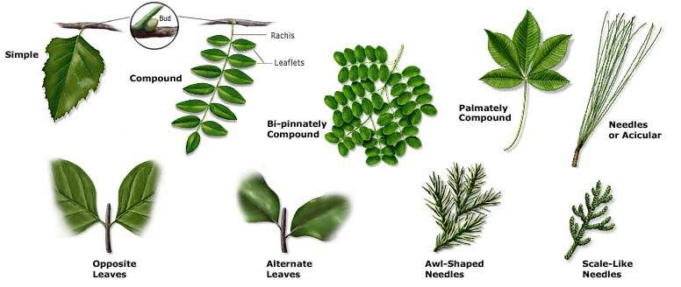

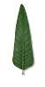
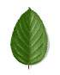
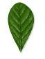
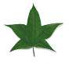
Leaf Shape Descriptions
Leaf Shapes

Lanceolate
Ovate
Obovate
Star-Shaped

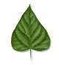
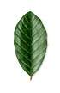
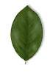
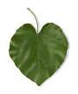
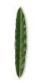
Leaf Apexes
Leaf Forms
Linear or Rectangular
Elliptical
Oval
Heart-shaped or Orbicular
Deltoid

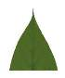
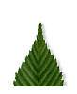
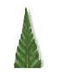
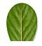
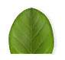
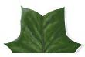

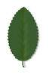
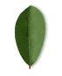
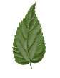
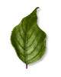
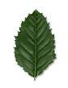
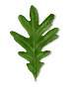
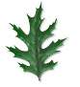
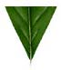
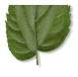
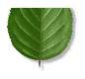
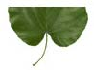
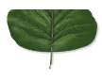
Leaf Bases
Leaf Margins
Acuminate
Acute
Obtuse
Bristle Pointed
Truncate
Rounded
Entire
Toothed or Serrate
Lobed
Dentate
Sinuate or Wavy
Doubly Serrate
Incised
Wedge-shaped or Cuneate
Inequilateral

Heart-shaped or Cordate
Rounded
Truncate

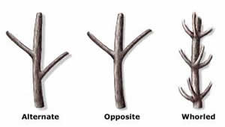
Twigs
Common Types of Fruits and Seeds

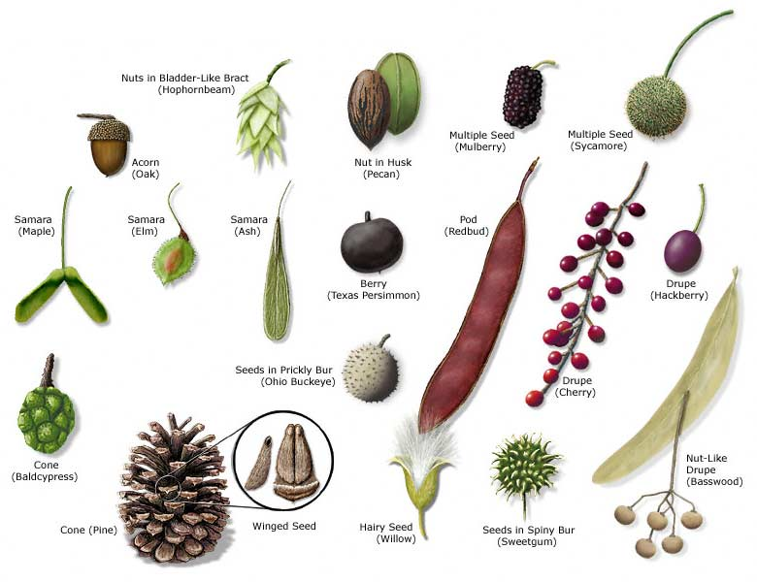

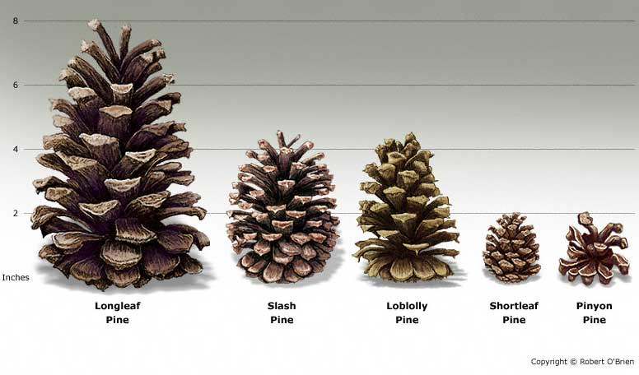
Cones

Tree Identification Key

Leaves are very large and fan-shaped………………………………………………………………………………….1
Leaves are feather-like…………………………………………………………………………………………………2
Leaves are needle-like………………………………………………………………………………………………….3
Leaves are scale-like or awl-like……………………………………………………………………………………….4
Leaves are compound, oppositely attached…………………………………………………………………………….5
Leaves are compound, alternately attached……………………………………………………………………………6
Leaves are simple, oppositely attached to twig………………………………………………………………………...7
Leaves are simple, alternately attached to twig………………………………………………………………………..8

1. Leaves are very large and fan-shaped……. ……………………………………………California Fanpalm
1. Leaf stalk has no thorns.............................................................................................................. Rio Grande Palmetto

2. Leaves deciduous; male flower clusters <6” long……………………………………………………… Baldcypress
2. Leaves evergreen; male flower clusters 6-12” long………………………………………. Montezuma Baldcypress

3. Needles attached singly………………………………………………………………. Rocky Mountain Douglas-fir
3. Needles in bundles of 2 (sometimes 3)……………………………………………………………………………...9
3. Needles in bundles of 3 (sometimes 2)…………………………………………………………………………….13

4. Foliage bluish-gray; fruit a woody cone…………………………………………………………....Arizona Cypress
4. Foliage green; fruit a berry-like cone………………………………………………………………………………15

5. Leaflets arranged palmately………………………………………………………………………………………..17
5. Leaflets arranged pinnately…………………………………………………………….…………………………..18

6. Leaves are one-compound………………………………………………………...……………………………….21
6. Leaves are bi-pinnate (just two sets of pinnae)… ……………………………………………………………...….26
6. Leaves are double-compound (four or more pinnae)… …………………………………………………………...27
7. Leaves are heart-shaped….………………………………………………………………………...Southern Catalpa
7. Leaves are lobed……………………………………………………………………………………………………33
7. Leaves are oval, round, or elliptical………………………………………………………………………………..36

8. Leaves are fan-shaped………………………………………………………………………………………...Ginkgo
8. Leaves are star-shaped………………………………………………………………………………….…Sweetgum
8. Leaves are triangular (deltoid)… ……………………………………………………………………………….…39
8. Leaves are heart-shaped (cordate)… ……………………………………………………………………..…….….40
8. Leaves palmately lobed………………………………………………………………………………………….…43
8. Leaves pinnately lobed…………………………………………………………………………………………..…44
8. Leaves ovate (wider at bottom than top)… ……………………………………………………………………..…51
8. Leaves obovate (widest towards top)… …………………………………………………………………………...54
8. Leaves linear or lanceolate…………………………………………………………………………………………58
8. Leaves oval, round, or elliptical……………………………………………………………………………………60

9. Needles 1-2” long……………………………………………………………………………………..…Pinyon Pine
9. Needles 3-5” long………………………………………………………………………………………………..…10
9. Needles 5” or longer……………………………………………………………………………………………….11

10. East Texas……………………………………………………………………………………………Shortleaf Pine
10. Central and West Texas……………………………………………………………………………..…Afghan Pine

11. Needles light green, dull…………………………………………………………………….........Italian Stone Pine
11. Needles dark green, glossy, stout………………………………………………………………………..………..12

12. Trees large, 30’ tall or more…………………………………………………………………………...…Slash Pine
12. Trees small, less than 30’ tall; crooked trunk……………………………………………….…Japanese Black Pine

13. Needles less than 5” long……………………………………………………..………………Mexican Pinyon Pine
13. Needles 5-10” long……………………………………………………………………………………………..…14
13. Needles 10-18” long……………………………………………………………...…………………..Longleaf Pine

14. East Texas…………………………………………………………………………………………….Loblolly Pine
14. West Texas…………………………………………………………………….…Rocky Mountain Ponderosa Pine

15. East Texas……………………………………………………………………………………...…Eastern Redcedar
15. Central Texas and Edwards Plateau…………………………………………………………………...Ashe Juniper
15. West Texas………………………………………………………………………………………………………..16

16. Bark forms rectangular blocks………………………………………………………….…………Alligator Juniper
16. Bark interwoven or shredding into linear strips………………………………………..…Rocky Mountain Juniper

17. Leaflets small, 1-3” long…………………………………………………………..…….…………Lilac Chastetree
17. Leaflets large, 3-6” long………………………………………………………………………………Red Buckeye

18. Leaflets 3 (sometimes 5), with coarse teeth……………………………………………………...………..Boxelder
18. Leaflets 5 (sometimes 7)… ………………………………………………………………………...…………….19
18. Leaflets 7-9….………………………………………………………………………………………………...….20

19. Leaflets oval or round, on stalks 0.25-1.5” long…………………………………………………………Texas Ash
19. Leaflets lanceolate, 3-4” long, short-stalked………………………………………………………….Mexican Ash

20. Bud sits in notch of leaf scar………………………………………………………………………….…White Ash
20. Bud sits on top of half-round leaf scar…………………………………………………………………..Green Ash

21. Leaves are an even number of leaflets…………………………………………….……………....Chinese Pistache
21. Leaflets alternate along leaf rachis…………………………………………………………...…Western Soapberry
21. Leaves with 3 leaflets only (DON’T TOUCH) …………………………………………………………Poison-ivy
21. Leaves with 5-9 leaflets………………………………………………………………………….……………….22
21. Leaves with 11 or more leaflets…………………………………………………………………..………………24

22. Leaflets toothed, all about the same size…………………………………………………………Mexican-buckeye
22. Bark has knobby “thorns”; small prickles on leaf…………………………………………………...Hercules’-club
22. Terminal leaflets larger than the others…………………………………………….………….………………….23
22. Leaflets entire, evergreen……………………………………………………………………………….Mescalbean

23. Leaves and twigs wooly (tomentose); nut husk thick……………………………………….…Mockernut Hickory
23. Leaves with red hairs underneath; nut husk thin…………………………………………………….Black Hickory
23. Leaflets narrow (1-2” wide); terminal bud yellow…………………………………………….…Bitternut Hickory
23. Bark peels into long strips; nut husk thick…………………………………………………….…Shagbark Hickory

24. Branches and twigs with long thorns………………………………………………………………..…Honeylocust
24. Twigs have a pair of short spines at leaf base…………………………………………………………Black Locust
24. Branches, twigs, and leaves w/o prickles or thorns………………………………………………………………25

25. Leaflet margins without teeth………………………………...……Winged Sumac, Prairie Sumac, Texas Sophora
25. Leaflet margins bluntly-toothed (crenate-serrate) …………………..………………………………Goldenraintree
25. Leaflets finely-toothed; largest ones at leaf end……………………..……………………….Water Hickory Pecan
25. Leaflets finely-toothed; largest ones in middle………………………….……………Little Walnut, Black Walnut

26. Leaves long, narrow, with many tiny leaflets……………………………………...………………Jerusalem-thorn
26. Leaflets 10-20, linear, up to 2” long by ¼” wide……………………………………….…………Honey Mesquite
26. Leaflets oval; fruit is a coiled pod…………………………………………………………….Screwbean Mesquite

27. Leaves have a terminal leaf/leaflet……………………………………………………………………………..…28
27. Leaves have no terminal leaf/leaflet…………………………………………...…………………………………30

28. Leaves, twigs, and stem with many sharp prickles……………………………..……………. Devil’s-walkingstick
28. Leaves and twigs without prickles or spines……………………………………...………………………………29

29. Leaflets with teeth or lobes….…………………….………………………………….…………………Chinaberry
29. Leaflets without teeth; flowers purple; South TX..……………………………………………………….Jacaranda

30. 2-4 pairs of pinnae; leaflets ¼” or larger……………………………………….…………………………………31
30. Leaflets very small, difficult to count…………………………………………….………………………………32

31. Twigs with recurved prickles (“catclaws”)… ……………………….………………………………Wright Acacia
31. Twigs thick, with pairs of short spines at nodes………………………………………………………Texas Ebony

32. Leaves 1-4” long, leaflets tiny; paired thorns…………………………………………………..…………Huisache
32. Leaves large, 10-15” long; not thorns………………………………………………………………………Mimosa

33. Leaf edge smooth……………...………………………………………………………………………………….34
33. Leaf edge with fine teeth….………………………………………………………………………………………35

34. East Texas……………………………………………………………………………………………Florida Maple
34. Central and West Texas…………………….………………………………………………………Bigtooth Maple

35. Sinuses between 3-5 lobes are shallow, angular……………...…………………………………………Red Maple
35. Sinuses between 3-5 lobes are deep, rounded…………………………………………………………Silver Maple
35. Sinuses between 5-7 lobes are deep, acute……………………………………………...………….Japanese Maple

36. Leaf edge finely-toothed…………………………………………………………………...………Rusty Blackhaw
36. Leaf edge without teeth……………………………………………………………………...……………………37
37. Leaves wavy-edged; veins parallel margin……………………………………………………Flowering Dogwood
37. Leaves velvety-pubescent; South Texas… …………………………………………………………..…Anacahuita
37. Leaves 3-8” long; not pubescent………………………………………………………………………….………38

38. Flowers and fruit are spherical clusters………………………………………………………Common Buttonbush
38. Flowers like white confetti; fruit a bluish drupe………………………………………………..…White Fringetree

39. Leaf edge coarsely-toothed (dentate)… ……………………………………………………....Eastern Cottonwood
39. Leaf edge smooth; leaf base wedge-shaped…………………………………..………………………….Tallowtree

40. Leaf edge smooth…………………………………………………………………………………………………41
40. Leaf edge toothed…………………………………………………………………………………………………42

41. Leaves dull, thin; East Texas…………………………………………….…………………………Eastern Redbud
41. Leaves small, wavy-edged; West Texas…………………………..………………………………Mexican Redbud
41. Leaves dull, thin; East Texas…………………………………………………………...……American Witchhazel
41. Leaves small, wavy-edged; West Texas………………………………….…………………….Carolina Basswood

42. Leaf edge sharp-toothed; some leaves lobed…………………………………………………………Red Mulberry

43. Leaves with just one or two lobes (mitten-shaped) ………………………………………….……………Sassafras
43. Leaves large; leaf edge with several large teeth………………………………….……………American Sycamore

44. Lobes bristle-tipped………………………………………………………………...…..…………………………45
44. Lobes without bristle-tips…………………………………………………………………………………………47
44. Lobes shallow, indistinct, or irregular……………………………………………………………………………50

45. East Texas…………………………………………………………...……………………………………………46
45. Central Texas ………………………………………….…………………………………………………Texas Oak
45. West Texas…………………………………………………………...…………………………….Chisos Red Oak

46. Leaves with 3-5 main lobes; underside hairy……………………………………………………Southern Red Oak
46. Leaves with 7-9 lobes that come to a single point………...……………………………………….Cherrybark Oak
46. Lobes near tip of leaf are widest ……………………………………..……………………………….Shumard Oak
46. Lobes narrow, sinuses often deep………………………………………...…………………………….Nuttall Oak

47. Leaves 6” long or more…………………………………………………………………………...………………48
47. Leaves less than 6” long…………………………………………………………………….……………………49

48. Top third of leaf roughly toothed; acorn large…………………………………….……………………….Bur Oak
48. Leaves with regular lobes, sinuses often deep………………………………………...…………………White Oak

49. Acorns enclosed by cup; East Texas bottomlands….…………………………...…………………….Overcup Oak
49. Leaf lobes often form a “cross” ……………………………………………...……………………………Post Oak

50. Leaves bluish-gray on top; Edwards Plateau…………………………………………….………………Lacey Oak
50. Leaves leathery, with prominent veins underneath……………………………………………Mexican White Oak

51. Leaf base lopsided………………………………………………………………...………………………………52
51. Leaf base even or balanced……………………………………………………………………………………….53

52. Leaf edge sharply-toothed……………………………………………………………..………Common Hackberry
52. Leaf edge smooth (sometimes a few small teeth)…. …………………………………………...………Sugarberry

53. Leaves and twigs with milky-white sap…………………………………………………………...….Osage-orange
53. Leaf edge faintly-toothed………………………………………………………………………………Callery Pear
53. Leaf edge double-toothed………………………………………………………………………….……River Birch

54. Leaves have blunt lobes with spines at tip……………………………………………………………….……….55
54. Leaf edge with a few teeth on upper half…………………………………………………………………………56
54. Leaf edge without teeth………………………………………………………………………………………...…57

55. Leaves 2-4” long (juvenile leaves highly variable)… ……………………………………………..……Water Oak
55. Leaves 4-10” long, 3-5” wide……………………………………………………………………..…Blackjack Oak

56. Teeth on leaf edge are sharp………………………………………………………………………..……Waxmyrtle
56. Teeth on leaf edge are dull, remote……………………………………………………………….…….Possumhaw

57. Leave <1” long, light green; tip often indented……………………………………………… Brazillian Bluewood
57. Leaves 1-2” long, leathery…………………………………………………………………….…Texas Persimmon
57. Leaves 2-4” long, undersides often hairy….…………………………………………………………….Gum Bully
57. Leaves 8-12” long, thin….…………………………………………………………………………………Pawpaw

58. Leaf edge finely-toothed………………………………………………………………………….…..Black Willow
58. Leaves <0.5” wide; leaf edge smooth……………………………………………………………..…Desert-willow
58. Leaves bristle-tipped………………………………………………………………………………..…………….59

59. Leaves <1” wide…………………………………………………………………………………….….Willow Oak
59. Leaves 1-1.5” wide, gray-hairy underneath…………………………………………………………..Bluejack Oak

60. Leaf edge spiny……………………………………………………………………………………..merican Holly
60. Leaf edge-bluntly—or remotely-toothed……………………………………………………………..…………..61
60. Leaf edge coarsely-toothed (dentate)… ………………………………………………………………...………..62
60. Leaf edge double-toothed………………………………………………………………………………...……….64
60. Leaf edge finely-toothed (serrate)… ……………………………………………………………………………..66
60. Leaf edge without teeth (entire)… ………………………………………………………………………...……..67

61. Leaves evergreen, 1-2” long….…………………………………………………………………………….Yaupon
61. Leaves evergreen, 2-4” long…………………………………………………………………Carolina Laurelcherry

62. Leaves glossy; leaf edge with a few pointed teeth……………………………………………….……..Emory Oak
62. Leaf edge with many pointed teeth…………………………………………….………………….American Beech
62. Leaf edge with teeth rounded at the tip…………………………………………….………………….………….63

63. Leaves 1-2” wide, teeth often recurved……………………………………………..………………Chinkapin Oak
63. Leaves 3-5” wide, teeth rounded or blunt……………………………………………………Swamp Chestnut Oak

64. Leaf base strongly lopsided……………………………………………………………….…………American Elm
64. Leaf base rounded or wedge-shaped……………………………………………………….……………………..65

65. Leaf Shapes variable; twigs often thorny……………………………………………………...………….Hawthorn
65. Leaves slightly hairy beneath; twigs “winged”… ……………………………………………...……..Winged Elm
65. Leaves smooth; bark blue-gray, “muscular” ………………………………………………....American Hornbeam
65. Leaves hairy above and below; bark “shaggy”……………………………………………...Eastern Hophornbeam

66. Leaf upper surface smooth, glossy………………………………………………………………...….Black Cherry
66. Leaf upper surface smooth, dull ……………………………………………………………………...Lacebark Elm
66. Leaf upper surface rough, like sandpaper ……………………………………………….………………Cedar Elm
66. Leaf upper surface textured; prominent vein below…………………………………………………Mexican Plum

67. Leaves 6-8” long, evergreen, leathery…………………………………………………….…….Southern Magnolia
67. Leaves <6” long…………………………………………………………………………………………………..68

68. Leaves semi-evergreen, top surface very rough………………………………………………………….....Anacua
68. Leaves evergreen, leathery………………..…………Texas Madrone, Sweetybay Magnolia, Gray Oak, Live Oak
68. Leaves deciduous, thin…………………………...………………….Carolina Buckthorn, Crapemyrtle, Blackgum For information and images http://texastreeid.tamu.edu/

