   
***Pharmacology for Veterinary Assistants***

What is **pharmacology**?   
The branch of veterinary medicine concerned with the   
  
___Uses__, ___Effects______ and __Administration___ of drugs; the study of *drugs*

1. What is a drug **classification**?

*Characterized by a drug’s ___*action(s)*___ in   
the body or on the target tissues.*  
*Emetics*- cause vomiting

Antiemetics- stop vomiting

Antidiarrheal agents- lessen diarrhea

Cathartics- increase bowels or loosen stools

Antacids- stop stomach acid

Diuretics- increase urine production

Antibiotics- kill/stop growth of bacteria

Anti-inflamatories- reduce inflammation/swelling

Analgesics- relieve pain; increase pain tolerance

Anesthetics- numbing drug

Anticonvulsants- stops seizures

Stimulants- excites activity of an organ

Tranquilizers- sedate, calm, quiet anxious patients

1. What is a drug **form**?

Characterized by a drug’s physical composition  
  
or _____state______ such as:  
*Solid tablet, syrup, lotion, ointment, extract, injectable, etc…*  
Solid- include tablets, gel capsules and coated tablets  
  
Solution- a drug that is dissolved in a liquid and will not settle if left sitting; syrups and elixirs

Suspension- a drug that is suspended but not dissolved in the liquid. The particles will settle and must be shaken before administered.  
  
Extract- agent composed of prepared plant/animal parts rather than manufactured cemicals

Topical- drugs that are liquid at room temperature and applied to the surface of the skin; include liniments and lotions   
  
Semisolid- drugs that are semisolid at room temperature and applied to the skin; include ointments and pastes.

Injectable- drugs that are administered via needle and syringe

1. What is a drug **route**?  
     
   *The drug’s ____*pathway*_____ of entering   
   the patient’s body.*

Intravenous (IV) – injected into the vein

Intramuscular (IM) – injected into the muscle

Intradermal- injected into the skin

Subcutaneous (Sub-Q, SQ, SC)- injected   
below the skin

Oral- given by mouth for digestive absorption

Inhalation-administration of aerosol, mist or gas for respiratory absorption

1. What are **methods** of administration?

*The ___*techniques*____ used to give the drug  
to the patient.*

*Injection*given by a shot

*Oral*given by mouth *Topical* applied to surface of skin  
 *Aerosol*mist or gas for respiratory tract

What are **controlled substances**?  
Substances that have the potential for   
  
_physical addiction_, _physiologic addiction_  
  
and/or ______abuse______.

Controlled Substances Act of 1970 states:

Doctors who have controlled substances__

stored in his/her office must keep them in a

securely locked, safe._________________

C-**I**—no med value; highest restrictions

C-**II**— highly addictive

C-**III**— some potential for abuse; less than CII

C-**IV**— low potential for abuse; dependence

C-**V**— subject to state/local reg; low abuse

Controlled substances should:

• Be kept in a locked, sturdy cabinet  
  
• Log must be kept of any controlled drug that  
 was used.

• Records must state: ___date___, _purpose_   
  
 and ___ amount ___ of each drug used.

• Records must include ___receipts___ of   
 purchase and sale of drugs.

• Log must be kept for at least __2__ years.

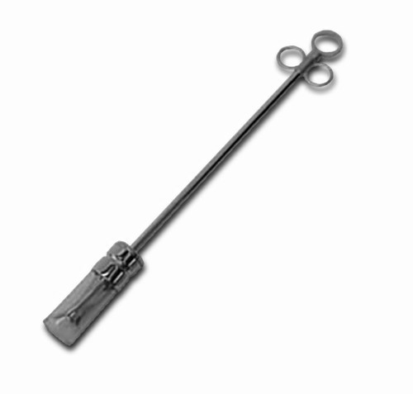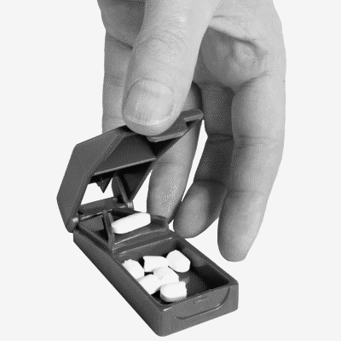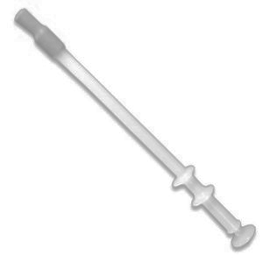*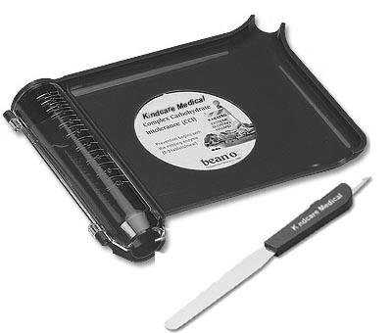Label the following tools and describe what they are used for.*

BALLING GUN

Used to administer medications into a large animal’s mouth

SYRINGES

Used to administer liquids and liquid drugs to an animal

NEEDLES

Used, attached to a syringe, to administer liquid medications as an injection.

PET PILLER

Used to administer pills to animal’s mouth

PILL CUTTER

Used to cut pills in halves

PILL COUNTER

Used to count pills to be dispensed to patient

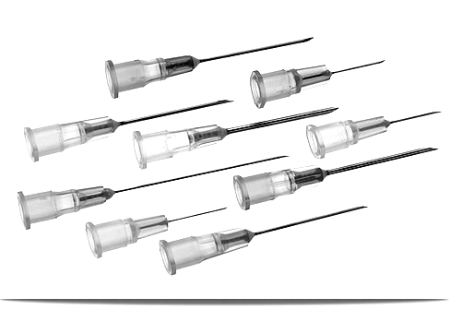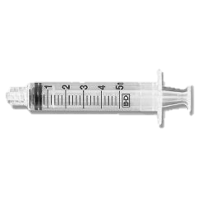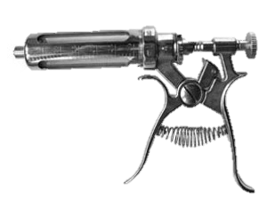

**Pharmacy Equipment**

**Assisting in the Veterinary Pharmacy**

1. How do veterinary assistants help in the pharmacy?

* Fill prescriptions
* Dispense medications
* Keep records in the pharmacy

1. What is a prescription?

-an order written by a licensed veterinarian (DVM) that   
authorizes a patient to be issued with a medication.

1. Why is it important for a veterinary assistant to   
   calculate a CORRECT dosage?

-Wrong amounts of a drug can cause it to become  
ineffective or toxic!

1. What three factors are important to know to be   
   able to calculate an accurate dosage? Define each.
2. WEGHT of animal: how much the patient weighs
3. DOSAGE REQUIREMENT: how much of the drug the animal should take; correlates with weight usually
4. Drug CONCENTRATION: Amount of drug in the solution, caplet, etc. compared to other components of the medication; how strong the drug is.
5. Make the following conversions: (how to convert: on powerpoint)

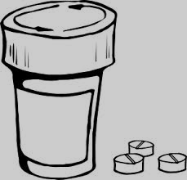

**Calculating Dosages**



20 lb = _9.08_ kg

**TIPS for Converting:**  
*When converting smaller units to larger units (ml –L) *DIVIDE*.

*When converting larger units to smaller units (Kg- g) *MULTIPLY*.

14 cc = __14__ ml

0.00043 kg = __430__ mg

111,208 mg = 1,716.17 gr

2 g = _2,000 mg

14 lb = _6.36_ kg – round up 2 places after the decimal

800 cc = __0.8_ L

.25 ml = .00025 L

1. How much of a drug does a 20 kg dog need if the dosage is 10 mg drug/kg wt?

200 mg drug (how to solve on powerpoint)

1. A 6 lb cat, Luna, will be receiving a prescription that recommends   
   5 mg/ kg of body weight. If the concentration of the drug is   
   50 mg of drug/ ml liquid, what volume of this injection should be administered to Luna?

1.5 ml liquid (how to solve on powerpoint)

1. How much of a drug does a 150 lb pig need if the dosage is 10 ml drug/50 lb wt?

10ml = Xml 50X = 1500 X = 30ml  
50lb = 150lb 50

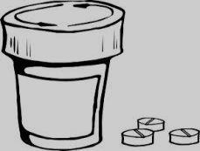

**Calculating Dosages**



1. Your patient, Reveille- the dog, will be receiving a prescription that recommends   
   .5 cc/ 1.5 kg of body weight. If the concentration of the drug is .5 cc of drug/ .2 ml liquid, what volume of this injection should be administered to the 36 lb patient?

36lb *.454 = 16.34kg

.5cc = Xcc 1.5X = 8.17 X = 5.45cc drug  
1.5kg = 16.34kg 1.5

.2ml = Xml .5X = 1.09 X=2.18ml -> round down to 2 ml  
.5cc = 5.45ml .5

1. You are filling a prescription for a 1014 lb quarter horse. The veterinarian recommends this drug be administered 600 mg/ 200 kg of body weight. If the concentration of the pills in your pharmacy contains 600 mg of drug/ capsule, how many pills should the patient be administered for each dosage? (with this particular drug, you may round your calculation up or down to a whole pill)

1014lb *.454 = 460.36kg

600mg = Xmg 200X = 276216 X = 1381.08mg drug  
200kg = 460.36kg 200

600mg = 1381.08 600X = 1381.08 X=2.3 -> round down to 2 whole pills  
1pills = Xpills 600

1. The doctor asks you to prepare a dose of ketamine sufficient to restrain a 15 lb cat. It is recommended to use 15 mg/kg IV or IM. The concentration of ketamine in the vial is 100 mg/ml. What volume of ketamine is the required dosage for this cat?

15lb*.454 = 6.82kg

15mg = Xmg X = 102.3mg of drug   
1kg = 6.82kg

100mg = 102.3mg 100X = 102.3 X = 1.02 -> round down to 1 ml  
1ml = Xml 100

1. What is a ***prescription label***?  
 A tag or sticker marked to give veterinary personnel and animal owners information   
 about a drug

**Completing Prescription Labels**

The **FDA** requires certain identifiers be on each prescription label:

1. Veterinarian name, address, phone number
2. Owner and patient name and animal/species
3. Date of dispensing of drug
4. Drug name and quantity
5. Dosage and duration
6. Route of administration
7. Number of refills

Information that should be on each label, if appropriate or needed:

* Drug strength (*if more than one* strength available)
* Cautionary statements, *as needed*
* Expiration date *if applicable*
* Slaughter withdrawal and/or milk withholding times, *if applicable*

2. Why are the listed identifiers important to have on a prescription? Why would it be dangerous to omit or delete one or more of the identifiers?

Wrong animal could be administered wrong drug, wrong dosages can be given, legal issues can arise…

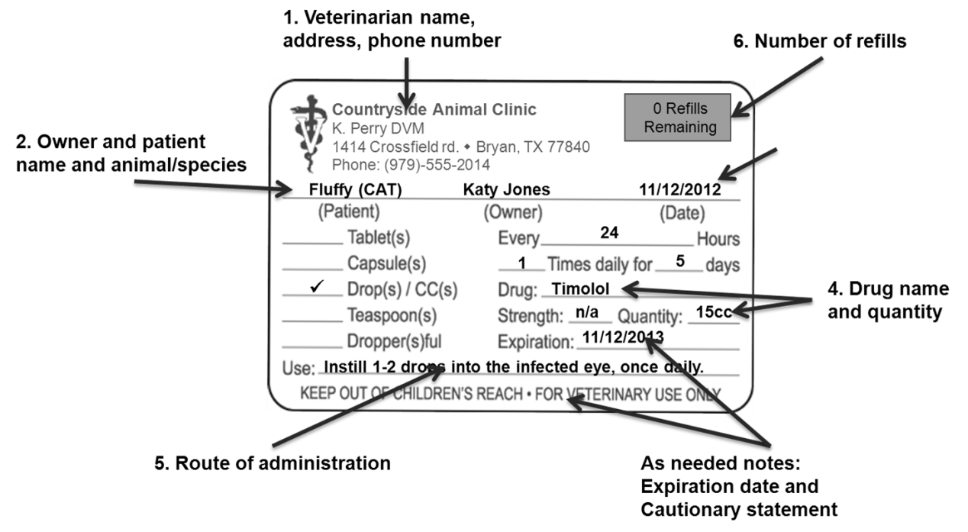Fig. 1 Prescription labels and FDA identifiers

Complete the following prescription labels:

Bob, Spot (DOG) 

Today, Dr. Jennifer Graham *(123 Main St, Wallis, TX (979)-114-5555)* has written a prescription for an anti-inflammatory drug called *Rimadyl*. The owner’s name is Bob and his dog’s name is Spot. The Prescription calls for Spot to take 1 pill each day for 2 weeks. Bob may refill Spot’s prescription one more time, if he would like. This drug can cause appetite loss, vomiting and diarrhea and should only be used for dogs.

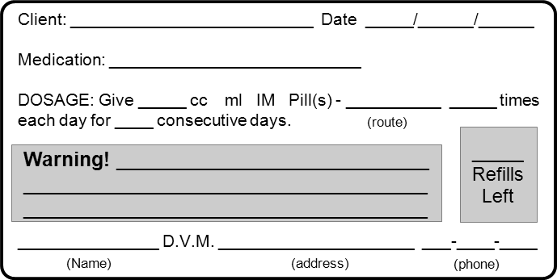

03 21 2013

Wayne, CATTLE 

1

123 Main st. 979 114 5555

J. Grahm

Diarrhea. **ONLY FOR USE OF DOGS!**

Can cause appetite loss, vomiting &

1

14

By mouth 1 

Rimadyl 

*Today’s date* 



36 hours. Do NOT slaughter for food for 21 days.

1

Into affected   
teat

On March 21, 2013, Dr. Leslie Wagner (*11 Vet Rd. College Station, TX (979)-555-5505*) has prescribed *Pirsue*, a bovine mastitis drug, to Mr. Wayne to give to his dairy cattle. 10 ml should be administered into each affected teat every 24 hours for 8 days. Mr. Wayne may not refill this prescription. Milk may not be used for food for 36 hours. Animal may not be slaughtered for food for 21 days.

0

11 Vet rd. 979 555 5505

S. Stevens

Milk should NOT be used for food for

10

8

Pirsue 

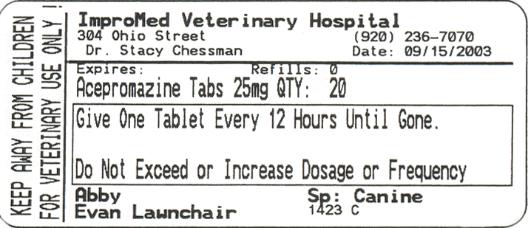  
Label the FDA required identifiers. List any that may be missing.

MISSING IDENTIFIERS  
*route of administration

Remaining refills

Drug name and quantity

Dosage and duration

Owner and patient name and animal species

Date of dispensed

Vet address and   
phone number