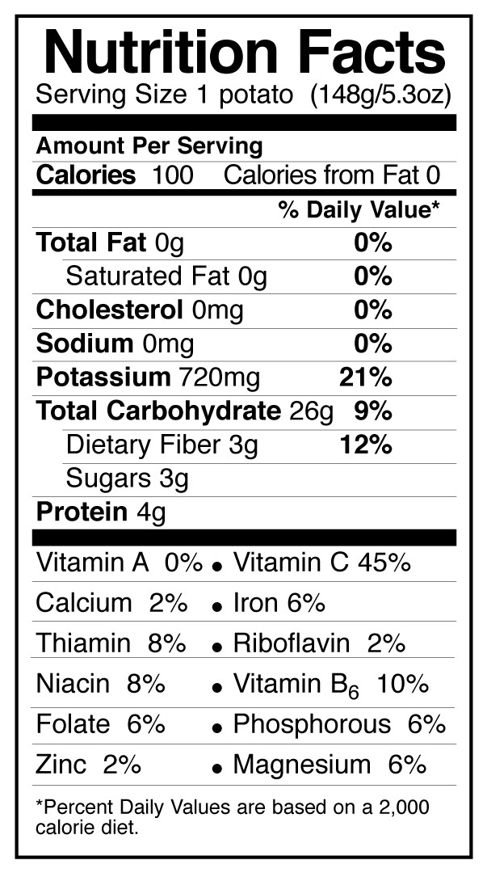
Knowing Nutrition
Summary:
This activity is designed to teach students how to read nutrition labels and calculate important information that pertains to their health. They will compare the same types of foods, and determine which ones have fewer calories, less fat and less percent of calories from fat. They will also be introduced to the concepts of Serving Sizes, Calories, Carbohydrates, Dietary Fiber, Protein, Vitamins and Minerals, Total Fat, Saturated Fat, Cholesterol, Sodium, and Daily Values, and why they are important.
Subject:
Math:
7.13 (A) Identify and apply mathematics to everyday experiences
7.13 (B) Use a problem-solving model that solves a problem using a plan
7.13 (C) Select or develop an appropriate problem-solving strategy

7.3 (A) Estimate and find solutions to application problems involving percent.

8.14 (A) Identify/apply mathematics to everyday experiences
8.14 (B) Use problem-solving model
8.14 (C) Select an appropriate problem solving strategy
Grade Level:
- Target Grade: 7
- Upper Bound: 9
- Lower Bound: 6
Time Required: One class period

Activity Team/Group Size: Pairs

Materials:
- Work sheets, handouts, lesson plans and instructions, and examples: available at http://teachhealthk-12.uthscsa.edu/curriculum/nutrition/pa07pdf/0704LSN.pdf
- Calculators
- Timer/Stopwatch
- Bell/Whistle (optional)
- Nutrition labels, set up at different stations around the classroom. The two labels at each station should be from similar products with different fat contents.

Reusable Activity Cost Per Group: $10.00
Expendable Activity Cost Per Group: $10.00

Learning Objectives:
- The object of this lesson is to teach students how to read a nutrition label, calculate the percent of calories from fat for different kinds of foods, and to use their new knowledge to help them make better food choices.
Lesson Introduction / Motivation:
Possibly open with an introduction that includes statistics about the current obesity problem in the United States. List for them some or all of the problems and health concerns that can be related to obesity and perpetual unhealthy eating and living. Suggest that there are many healthy foods out there that taste just like unhealthy ones, and that it is important to be able to identify them. Healthy eating and living can make a person look and feel better, and that can lead to a more fulfilling and successful life.
Read the student text “Food Labels.” It is suggested that the teacher make a class
set of this text. Through an oral question and answer session go over the components
of the food label and what each component means. Students will complete the student
worksheet “Food Labels.” Each student will need a copy of this worksheet.

Lesson Plan:
http://teachhealthk-12.uthscsa.edu/curriculum/nutrition/pa07pdf/0704LSN.pdf
(Omit Activity 4C, page 7-C)
Arrange the classroom in stations. Two similar food items will be at each station. Perishable foods should be represented with their empty food container. Nutrition labels for fresh produce items should be available at the grocery store. Each station needs to be numbered and each food item needs to be lettered A or B at each station. Pair the students. Each pair will begin at a different station. Students will move from station to station at timed intervals. The number of stations will be dependent on class size. For example, a class of 24 would need 12 stations. Two to three minutes should be spent at each station. A bell or whistle to signal move time will be helpful. At each station the students will record the number of calories per serving and the number calories from fat per serving. Then, they will calculate the percent of calories from fat. The foods at each station should be similar except in regards to fat content. The following is a list of suggested stations:
1. Flour tortilla/Corn tortilla 2. Tuna in oil/Tuna in water
3. Canned beans/Dry beans 4. Whole milk/Skim milk
5. Pretzels/Potato Chips 6. Ice cream/Frozen yogurt
7. Mayonnaise/ Lite Mayo 8. Soda/Diet Soda
9. White bread/Wheat bread 10. Frosted flakes/Corn flakes
11. Salad Dressing/Fat Free Salad Dressing 12. Sugar/Sugar Substitute

Lesson Closure:
Have the students identify which items were the healthier choices. Ask them if any of their discoveries were surprising to them and why? Encourage them to keep looking at the nutrition labels in the cafeteria, in the grocery stores, and in their homes, to make sure they know what is going into their bodies, because they only get one, and they should take good care of it.
Assessment:
After the lesson, the students should have a better understanding of how to calculate percent calories from fat. They should be able to identify which foods at the stations are healthier, and have a better understanding of what to look for and what to avoid on a Nutrition Label.
Vocabulary / Definitions:
- Serving Sizes: specific in their nutritional information to allow for easy comparison with other similar foods. They are loosely based on the amount of a product normally eaten in one sitting or reference amounts, determined from nationwide food consumption surveys.
- Calorie: is the amount of energy required to raise the temperature of one kilogram of water by one degree Celsius.
- Carbohydrates: require less water to digest than proteins or fats and are the most common source of energy in living things. Foods high in carbohydrates include breads, pastas, beans, potatoes, bran, rice and cereals. Most such foods are high in starch.
- Protein: the plant or animal tissue rich in such molecules, considered as a food source supplying essential amino acids to the body.
- Vitamins: Any of various fat-soluble or water-soluble organic substances essential in small amounts for normal growth and activity of the body and obtained naturally from plant and animal foods.
- Minerals: any of the inorganic elements, such as calcium, iron, magnesium, potassium, or sodium, that are essential to the functioning of the human body and are obtained from foods.
- Fat: Examples of edible animal fats are lard (pig fat), fish oil, or butter. They are obtained from fats in the milk, meat and under the skin of the animal. Examples of edible plant fats are peanut, soya bean, sunflower, sesame, coconut, olive, and vegetable oils. Margarine and vegetable shortening, which can be derived from the above oils, are used mainly for baking. These examples of fats can be categorized into saturated fats and unsaturated fats.
- Cholesterol: A white soapy substance found in the tissues of the body and in certain foods, such as animal fats, oils, and egg yolks. Cholesterol has been linked to heart disease and atherosclerosis. (It collects on the walls of arteries and interferes with the flow of blood.) High levels of cholesterol in the blood are considered to be unhealthy.
- Sodium: any salt of sodium, such as sodium chloride or sodium bicarbonate, present in or added to foods or beverages as a seasoning or preservative and used in many pharmaceutical products such as an antacid, anticoagulant, or other agent.
Background and Concepts for Teachers:
- Teachers may want to review concepts and definitions dealing with the definitions listed above, so that they may be able to answer simple questions students have about them.
Lesson Scaling:
For younger students, leave out the practice worksheet, and have the teacher go over all of the calculations and answers after the activity. Or, have fewer calculation stations.
For older students, assign outside homework dealing with the lesson, and/or include Activity 4C on the lesson plan page. Suggestions include, collecting data from their household foods and making graphical representations of the fat percentages.

Multimedia Support and Attachments:
- http://teachhealthk-12.uthscsa.edu/curriculum/nutrition/pa07pdf/0704LSN.pdf This is the link to the website that contains worksheets, hand outs, Nutrition Label examples, and activity suggestions and instructions that pertain to the DLC request.
References:
- Definitions: Dictionary.com, Wikipedia.com
Keywords:
- Nutrition Labels
- Fat
- Calories
- Percentages
Authors:
Graduate Fellow Name: Ben Lawrence
Teacher Mentor Name: Natalyn Maxey
Undergraduate Fellow Name: Kelly Bowen
Date Submitted: 02/23/09
Date Last Edited: 02/25/09
Please email us your comments on this lesson:
E-mail to ljohnson@cvm.tamu.edu
Please include the title of the lesson, whether you are a teacher, resident scientist or college faculty and what grade you used it for.

Teacher’s Comments:

