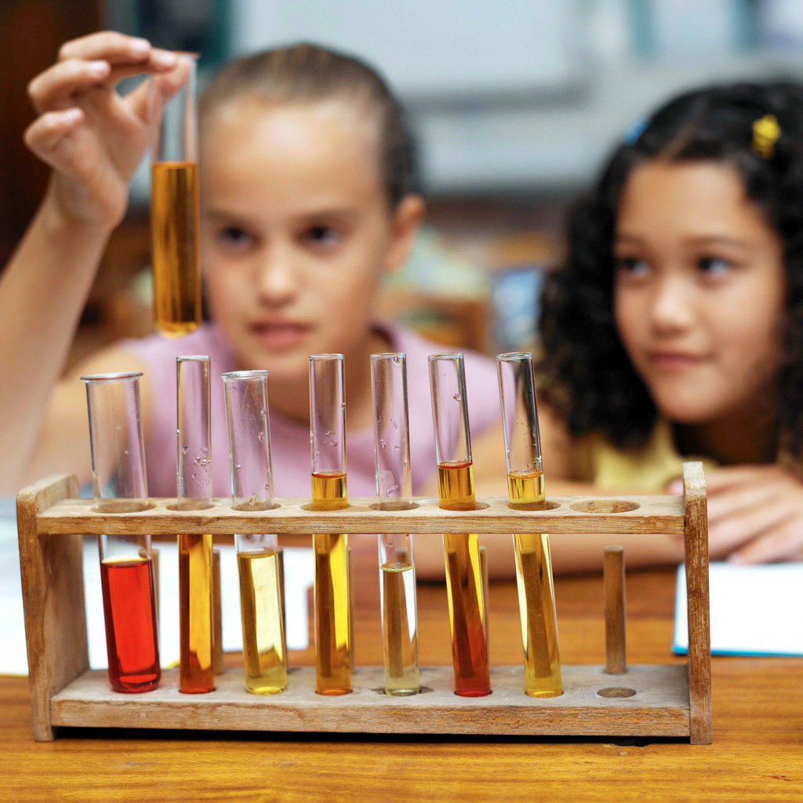
Lesson Summary: The purpose of this lesson is for students to learn the names of equipment used in the laboratory. Students will complete a crossword puzzle individually by observing lab equipment and filling in the name.
Subject: Science

Grade Level: 6th-8th grade

Key words: tool, instruments, lab equipment, stereoscope, hand lens, microscopes, microscope slides, graduate cylinders, test tubes, meter sticks, beakers, petri dishes, metric rulers, tape measure, stop watch, temperature probe, pH probe, thermometers, calculator, computer, globes, insect trap, balance, hot plates, water test kits, collecting nets, journals, notebooks, globes

Time Required: 30 - 45 minutes
Materials:
- Crossword puzzles
- Answer key
- Lab equipment

Activity Introduction/Preparation: The attached PowerPoint, Lab Equipment, may be used as an introduction to teach recognition and identification of lab equipment and their purposes.

Activity Plan:
- Display the lab equipment at different parts of the classroom. Number each tool.
- Pass out the crossword puzzle to the students
- Have the students walk around the room observing the lab equipment and filling out the puzzle.
- If lab equipment is not available, use the sheet attached to the crossword with pictures of the tools.

Assessment: Use the student’s answers to the crossword and the time it takes to complete the crossword to assess their learning of the tools.

Lesson Extensions:
- Play a speed round of tool identification. Have students stand up in pairs and display piece of lab equipment. The student that answers first wins the round and moves on to the next round. Continue to play until there is one winner.
- Make the crossword a competition to see who can finish first.

TEKS: Science-
6.4 (A) use appropriate tools to collect, record, and analyze information, including journals/notebooks, beakers, Petri dishes, meter sticks, graduated cylinders, hot plates, test tubes, triple beam balances, microscopes, thermometers, calculators, computers, timing devices, and other equipment as needed to teach the curriculum
7.4(A) use appropriate tools to collect, record, and analyze information, including life science models, hand lens, stereoscopes, microscopes, beakers, Petri dishes, microscope slides, graduated cylinders, test tubes, meter sticks, metric rulers, metric tape measures, timing devices, hot plates, balances, thermometers, calculators, water test kits, computers, temperature and pH probes, collecting nets, insect traps, globes, digital cameras, journals/notebooks, and other equipment as needed to teach the curriculum
8.4 (A) use appropriate tools to collect, record, and analyze information, including lab journals/notebooks, beakers, meter sticks, graduated cylinders, anemometers, psychrometers, hot plates, test tubes, spring scales, balances, microscopes, thermometers, calculators, computers, spectroscopes, timing devices, and other equipment as needed to teach the curriculum

Authors:
Undergraduate Fellow: Megan Landon
Graduate Fellow: Jennifer Graham

