- Susie walks into lab and puts on her lab apron and gloves. She sits down at her table and starts to mix chemicals according to the instructions the teacher and book has given her. What lab rule has Susie broken?

- Which of the following is a beaker?
  - 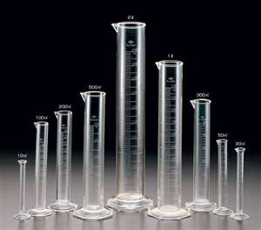 b.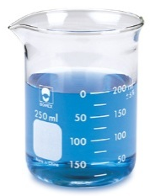c. 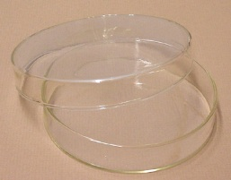 d. 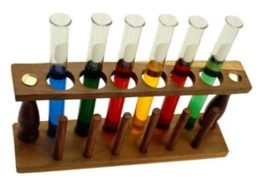
- What should you do if you get something in your eye?

- According to the PowerPoint, when should the safety shower be used?

- When should you tell the teacher if you break glass?
  - When class is over
  - Only after someone gets cut
  - Immediately
  - You don’t, you just throw the glass in the trash can and keep working
- On a safety warning diamond, what does the blue diabmond represent?
  - Fire danger
  - Reactivity danger
  - Health hazards
  - Specific hazards like acids or bases
- True or False- It is ok to eat food in the lab while performing an experiment.
- True of False- If you have long hair you should tie it back.
- True of False- If the beaker is hot it will look different so it is always ok to just pick it up.
- List Four things that you might use in lab.

