Using your knowledge of large animal skeletal systems, follow all directions and correctly answer each question.
1. Match the correct word with its definition:
A. Compact Bone B. Red Marrow C. Periosteum D. Spongy Bone E. Yellow Marrow
_A__ Made of Calcium and gives bones strength
__C___ Outermost layer; responsible for repairing broken bones
__E___ Stores fat and energy in the bone
2. ____Ligaments_____ connects bone to bone and ____Tendons____ connects bone to muscle.
3. Name two types of joints. Saddle, Plane, Hinge, Pivot, Ball and Socket
4. What are the four functions of the skeletal system?
__Protection______ _____Form_______ _____Strength_______ _______Support_______
5. Circle the Pectoral Skeleton of the pig below.
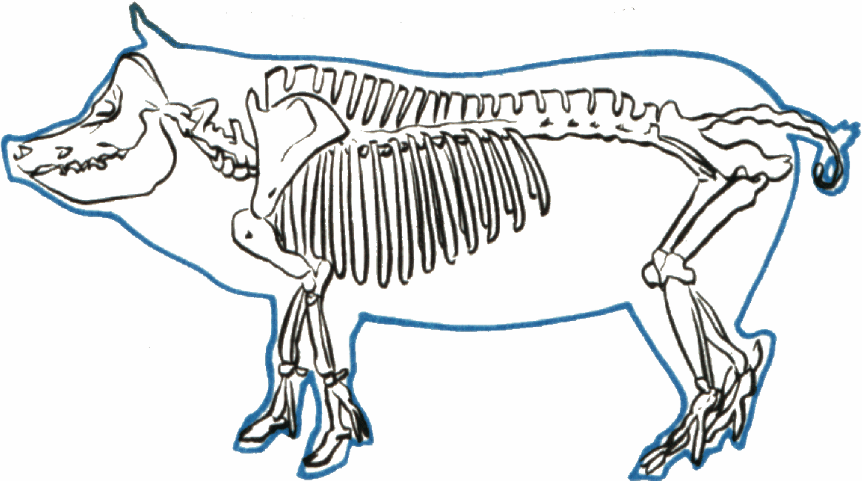
6. Label the following bones: Refer to the PowerPoint diagrams.
Ribs, Tibia, Fibula, Maxilla, Patella, Scapula, Femur, Digits, Caudal Vertebrae, and Cervical Vertebrae

