How Well Do You Sense Your World?
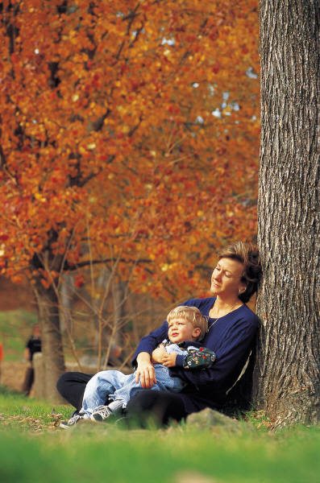

Activity Summary:
This hands-on activity explores our sense of vision, smell, touch and hearing. These senses help us identify odors, sounds and objects. The students will also examine the limitations of their senses.

Subject:
Science: Life Science

Grade Level:
Target Grade: 6
Upper Bound: 8
Lower Bound: 5
Time Required: 40-45 minutes
Activity Team/Group Size: 4
Reusable Activity Cost [in dollars]:
Tube socks (pack of 6 pairs): $4
Styrofoam: $2
Expendable Activity Cost [in dollars]:
Authors:
Graduate Fellow Name: Danielle Lewis
Teacher Mentor Name: Kelly Lazo
Date Submitted: 01/23/06
Date Last Edited:
Parent Lesson Plan(s):
This lab examines hearing, touch, vision, and smell. Hence, students should know the definition of a receptor and how sensory receptors send impulses to the brain via nerves. Students should also know or have been exposed to the parts of the eye (cornea, lens, pupil, retina, optic nerve).

Activity Introduction / Motivation:
This activity is a lot of fun as the students get to use their senses to identify mystery odors, mystery objects in a sock, find their blind spot, determine how accurately they can determine where they have been touched and determine the placement of two blocks in a closed box containing a marble.

Activity Plan:
Students will use the worksheet “How well do you sense” to work through 5 hands-on activities. The worksheet is self-explanatory but here is a detailed account of each activity.

Part 1a. The students feel for objects in a sock (one object per sock), thus they are using mainly their sense of touch to determine the identity of the objects. They are also using memory as they have to touch the object and then recall what it is. Four socks were used, but the number could be varied depending on class size or time constraints. The objects should be a mix of easy and difficult items for them to identify, but certainly can be whatever is available. For this activity a rubber stopper, pencil, marble and hair barrette was used.

Part 1b. Students work in pairs to determine the accuracy of their “sense of touch”. One student will make a pen mark on their partner’s hand. The student receiving the stimulus should have their eyes closed. Still with their eyes closed, the student who was touched will use a sharpie pen to mark where they thought they were touched. Students measure the distance from the actual mark to the mark they thought their partner touched them.

Part 2: Students are handed a “mystery” shoebox. The shoebox contains a marble and two Styrofoam blocks that are glued down. Students gently roll the box around and use the marble in the box to determine the location of the two blocks. Students are not allowed to open the box at any time.

Part 3: Students examine their blind spot. The retina in the eye contains photoreceptors that help sense light. The information collected by the retina is sent to the brain via nerves. In the brain this information is processed and aids in recognition of faces and objects. The retina however, has an area in the eye where there are no photoreceptors, this is called the blind spot. Students use two cards to determine the location of their blind spot. One student holds the card at eye level (see VISUAL DEMO PAPER in the answer key). The second student closes their right eye and stares at the dot with their left eye. As the student moves their head closer to the paper, the broken blue line looks like a continuous line (Fig. a) and the white circle fills in with lines (Fig. b). This change indicates the point at which the student can no longer differentiate between 1 or 2 objects (this is the blind spot).

Part 4: Students identify smells in 4 film canisters. The canisters contain a cotton ball soaked with different chemicals. The students are expected to smell each canister and identify the odor. The types of scents used can vary and the number of canisters can also vary depending on class size and time constraints. For this activity vinegar, water, vanilla and lemon juice was used.

Activity Closure:
Students should fill out the worksheet and the following day the teacher should go over the exercise to help reinforce what was learned.
Assessment:
The worksheet could be used as an assessment.

Learning Objectives:
Students should be able to explain what the function of a receptor.
Students should be able to list where receptors are located on the body.
Students should be able to identify the location of the blind spot.
TEKS 6.12 (B) Identify responses in organisms to external stimuli

Prerequisites for this Activity:
Students should be familiar with the function and location of sensory receptors on the body, what happens to nerve impulses and the parts of the eye.

Background & Concepts for Teachers:
This activity would be most effective after the students had covered the information on the senses. The information provided in the Activity Plan should be sufficient for this lab.

Vocabulary / Definitions:
See prerequisites

Materials List:
To save on materials, this lab could be performed as a series of stations.
Part 1a:
Tube socks (4)
Objects (1 per sock - pencils, marbles, measuring cups, erasers, etc.)
Part 1b:
Fine point sharpie or comparable marker
Part 2:
The materials listed will make 1 mystery box, if you want additional boxes, you will need to increase the number of supplies needed.
Shoebox
Styrofoam blocks (approx. 3 cm x 3 cm, size can vary, 2 per box)
1 marble/box
Glue or hot wax gun
Part 3:
VISION DEMO PAPER (attached)
Part 4:
Film canisters
Cotton balls
Scents (vanilla, lemon juice, water, peppermint extract, vinegar, etc.)

Activity Extensions:
Students could be asked to identify an unknown smell from a list of known scents for Part 4. Instead of having them identify all 4 scents, give them several known scents and then ask them to identify an unknown scent. An activity on taste buds could also be incorporated. A good taste activity is to have the students hold their nose, and then let a lifesavor dissolve in their mouth. After a second or two, have them unplug their nose. When their nose is plugged it should be difficult to identify the flavor or lifesavor.

Multimedia Support and Attachments:

Safety Issues:
None.

Troubleshooting Tips:

Activity Scaling:

References:
For more information on these activities, you could check out these websites.
Touch activities came from:
http://faculty.washington.edu/chudler/chtouch.html
The data on the receptor threshold is from this site:
A 2-pt discrimination threshold experiment (published in The Skin Senses, edited by D. R. Kenshalo, Springfield, IL, 1968)
Shoe box activity came from:
http://www.tryscience.org/experiments/experiments_begin.html?sound
Vision activity came from
http://faculty.washington.edu/chudler/chvision.html
Blind spot tests pdf files:
http://faculty.washington.edu/chudler/pdf/bspots.pdf
Smell:
http://www.iit.edu/~smile/bi9704.html

