Matching Symbiosis
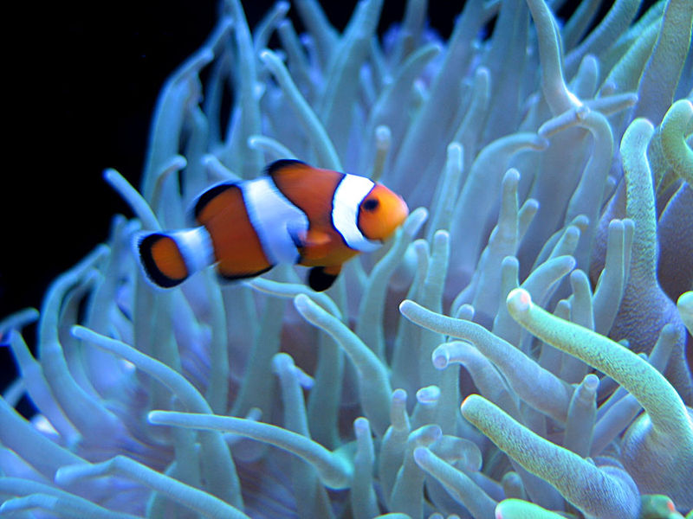
Summary:
Symbiosis is the close association between two or more organisms of different species, often but not necessarily benefiting each member. Sometimes both organisms benefit from the relationship; however one organism may be harmed by the relationship. Most of the cases of symbiosis revolve around food. This can be that one feeds off another or that one uses the other to avoid being eaten. Through the PowerPoint and the provided activity the students will gain an understanding of these relationships and learn how to tell the difference between the three types.

Subject:
- Science
Grade Level:
- Target Grade: 8
- Lower Bound: 6,7
Time Required: 1 class period
Activity Team/Group Size: individual

Materials:
- A copy of the pictures, cut out and shuffled
Reusable Activity Cost Per Group [in dollars]: $0
Expendable Activity Cost Per Group [in dollars]: $0

Learning Objectives:
- Gain understanding of symbiotic relationships and different examples of each.
- Learn how to look at an image and understand what type of symbiosis is taking place and the organisms role in the at symbiosis.
Lesson Introduction / Motivation:
On slide one of the PowerPoint presentation, there are three pictures. Have the students guess at what type of relationship (parasitism, mutualism, or commensalism) is shown. If the students do not know these words yet, ask them what they think is happening and ask them which organism benefits from the relationship in the picture and which is harmed (if applicable).
Activity Plan:
Give each student a copy of the images provided (cut out and shuffled differently). Have the students look at each picture and on the chart provided have then write what the picture is of or what is happening in the picture, what type of symbiosis is occurring, which organism benefits, and which organism is harmed. If there is only one organism available, have the students list what that organism would be seen with. Student then can list how each organism benefits or is harmed.
Lesson Closure:
When all of the students have turned in their papers, go over each picture and discuss the questions asked in the activity.
Assessment:
Grade the activities after they have been turned in. This will tell you if the student understood what each type of symbiosis is.

Vocabulary / Definitions:
- Symbiotic Relationship- the close association between two or more organisms of different species, often but not necessarily benefiting each member.
- Mutualism- the two organisms involved in this relationship both benefit from each other.
- Parasitism- in this relationship, one organism is harmed while the other benefits.
- Commensalism- in this relationship, one organism benefits while the other is unaffected.
- Endosymbiosis- wherein one organism lives inside another organism.
- Ectosymbiosis-wherein one organism lives on another organism.
- Facultative Symbiosis- where the relationship is beneficial to the organisms, but not essential to survival.
- Obligate Symbiosis- the relationship is essential for the life of at least one of the organisms.
Background and Concepts for Teachers:
- Knowledge of symbiotic relationships and some common examples of each type.
Lesson Scaling:

This should be simple enough but if it can be done in groups or the teacher can do it for the class with students who are younger or have learning disabilities.

References:
- http://www.buzzle.com/articles/symbiotic-relationships.html
- http://www.necsi.edu/projects/evolution/co-evolution/mutualistic/co-evolution_mutualistic.html
- http://www.buzzle.com/articles/examples-of-commensalism.html
- http://www.marietta.edu/~biol/biomes/symbiosis.htm
- http://kidshealth.org/parent/infections/common/head_lice.html
- http://users.rcn.com/jkimball.ma.ultranet/BiologyPages/S/Symbiosis.html
Keywords:
- Symbiotic Relationships
- Mutualism
- Parasitism
- Commensalism
- Facultative Symbiosis
- Obligate Symbiosis
- Endosymbiosis
- Ectosymbiosis
Authors:
Undergraduate Fellow Name: Katie Clark
Please email us your comments on this lesson:
E-mail to ljohnson@cvm.tamu.edu
Please include the title of the lesson, whether you are a teacher, resident scientist or college faculty and what grade you used it for.

Teacher’s Comments:

