Download all Associated Files for this lesson from our Website
Is Taste Only in Your Mouth?
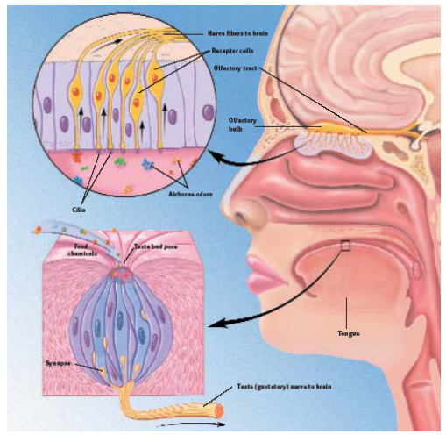
Society for Neuroscience, Brain Facts

Activity Summary:
This activity was part of a six-part lab called the “Observation Lab”. Students worked through six stations over two days with the goal of emphasizing that all 5 senses (vision, touch, hearing, taste and smell) are used in science to make observations. This activity is geared towards 6th graders and is a good introductory exercise to get them used to doing labs. This exercise in particular is good for understanding how smell influences taste. We used lifesavers for this exercise, but it could also be done with a potato and apple (but probably wouldn’t be as appealing J for the students). The reason why using an apple and potato is a useful food item for this exercise is because they both have the same texture but a totally different taste.
Subject:
Science:
Science as Inquiry and Life Science

Grade Level:
Target Grade: 8
Upper Bound: 12
Lower Bound: 6
Time Required: Quick the students worked through this in about 10-15 min. Since there was candy they tended to want to linger.
Activity Team/Group Size: 2, need a partner
Reusable Activity Cost Per Group [in dollars]:
Laminated sheets that contained information about taste was included at the station but this wasn’t necessary. >$10
Expendable Activity Cost Per Group [in dollars]:
Candy for all day was about $3
Authors:
Graduate Fellow Name: Danielle Lewis
Teacher Mentor Name: Susan Coble
Date Submitted: 09/06/04
Date Last Edited:
Parent Lesson Plan(s):
This was a 6 part lab, the worksheet for the lab is included in a file called Worksheet Taste.

Activity Introduction / Motivation:
The students were told a day or 2 before that “fun Friday” would always include a hands on activity. Not much motivation is needed, the students are excited not to have to do book work.
Activity Plan:
For 6th graders a demonstration of the lab is important, although this one is relatively straightforward. Students should work in pairs. One student closes their eyes and pats their tongue with a paper towel while the other student quickly hands them a lifesaver. The student will place the lifesaver in their mouth and tell their partner what flavor they taste.

Here is the to do:
1) Pair up with a partner.
2) One student should close their eyes and pat their tongue dry.
3) The partner should feed a lifesaver to the student with their eyes closed. But don’t tell them anything about the lifesaver! (Both students should try this.)
4) Let the candy dissolve for a second or two, then…..answer the following questions.

Activity Closure:
At the end of class, the students should be asked to describe what they learned at their particular station. This was meant as an introductory lesson, if teaching 8th graders more time could be spent on the role of taste buds and how the nose influences taste.
Assessment:
Here were the questions. It is important to stress to the students that the importance of this exercise is not to guess the correct flavor but to write down what they actually tasted versus what the correct flavor was and maybe help them think about why that may be.

Questions:
  - What was the color of the lifesaver your partner gave you?
  - What flavor did you taste?
  - When you first put the lifesaver in your mouth (when your tongue was dry) was it more or less difficult to determine the flavor?

Learning Objectives:
This is an introductory exercise at the beginning of the year to get the students thinking and it was also to point out that they use ALL of their senses when making observations.

Prerequisites for this Activity:

Background & Concepts for Teachers:
Society for Neuroscience has a lot of useful information about smell and taste. Also listed in the reference section is several other websites that were very useful.

Vocabulary / Definitions:

Materials List:
Laminated copies or regular copies of exercise
Dish for lifesavers
Lifesavers candy

Activity Extensions:
You could cover the tongue map also where the students test a sour taste on the part of the tongue that doesn’t sense sour. This could be done for salt, sweet and bitter tastes. Discuss the role of the nose in our sense of taste. This may lead into a discussion of receptors and how they work.
Safety Issues:
May be food issue depending on the school

Troubleshooting Tips:

Activity Scaling:
This is good for all grades and ages

References:

Pictures copied from:
http://faculty.washington.edu/chudler/tasty.html
Brain Facts, Society for Neuroscience
http://www.vanderbilt.edu/VirtualSchool/taste.htm

Text from:

http://faculty.washington.edu/chudler/tasty.html
Brain Facts, Society for Neuroscience
http://www.vanderbilt.edu/VirtualSchool/taste.htm

By Karen Kalumuck
http://www.exploratorium.edu/snacks/your_sense_of_taste/index.html
http://www.charitywire.com/charity280/05833.html
See the Peer site on brain function
http://peer.tamu.edu/curriculum_modules/OrganSystems/module_5/index.htm

