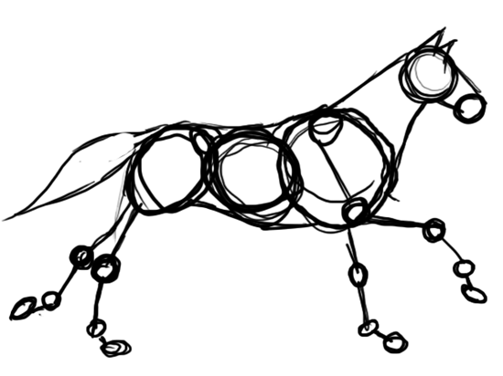
Directional Anatomical Terminology
Download all Associated Files for this lesson from our Website
Summary:
This lesson will present the different terminology used in veterinary medicine to describe locations and joint actions of animals and their anatomy. The activities will apply the material in a fun and interactive manner.
Keywords: Frontal Plane, Sagittal Plane, Transverse Plane, Dorsal, Ventral, Superficial, Deep, Medial, Lateral, Proximal, Distal, Cranial, Rostral, Caudal, Extension, Flexion, Adduction, Abduction, Supination, Pronation

Subject TEKS: 130.6 Veterinary Medical Applications 4B
(4) The student communicates the importance of medical terminology, evaluates veterinary terms to discover their meanings, and demonstrates the ability to use terms correctly. The student is expected to:
(B) Develop appropriate use of directional anatomical terms;

Grade Level: 9th-12th Time Required: 3, 50 Minute Class Periods
Learning Objectives: The learner will:
- Recognize the three different anatomical planes
- Demonstrate the use of the three anatomical planes
- Define directional terms
- Create and label an animal model using directional terms
- Evaluate which directional terms are associated with which anatomical planes
- Describe anatomical actions of joints
- Demonstrate the anatomical actions using legs and arms

Materials:

- Lesson Plan
- PowerPoint
- Computer and Projector
- Quiz
- Materials for Planes Application
- Materials for Directional Terms Application

“Why do I need to learn this” Real life Application of the Material:
These terms are important: to increase a student’s vocabulary by understanding the root words, prefixes and suffixes of medical terms, to be able to understand the terminology used by medical personnel when visiting the dentist, doctor, veterinarian or even the pharmacist, to be prepared for a career in the medical field with the basic knowledge of these terms.
Lesson Introduction / Motivation: Display the first slide of the PowerPoint on the screen as the class is entering the room. Ask students to draw their response to the question in their notebook. Allow for discussion.
Presentation/Explanation: The information is best presented using the PowerPoint presentation provided. There are many pictures displayed to give a picture of each term. Helpful hints to remembering words can be found in the notes section of the PowerPoint.
Activity/Application:
Anatomical Planes Application
- Preparing for this application you will need:
  - 3 fruits or vegetables (per group) - choose appropriately based on program budget, class size and food allergies. Good options include - potatoes (not a fun edible option), apples, kiwis, tomatoes
  - 1 knife (per group)
  - 3 sticky notes (per group)
  - Markers and/or other materials to decorate with
- Divide the class into groups or partners. Give each group their materials. Have students wash their hands as they will be handling food products.
- Each group will decorate their fruits/veggies with faces and other animal features.
- The group will cut their model animals on the appropriate directional planes. They will place each decorated fruit/veggie near a labeled sticky note of the appropriate directional plane.
- After reviewing their work allow students to consume their work (if edible materials).
- **For more examples visit the webpage this activity was adapted from: https://bio111guide.wordpress.com/category/potato-people/ **
Anatomical Directions Application
- Preparing for this application you will need:
  - Paper Mache Ingredients: Flour, Water, Buckets, and Newspaper/Scrap paper
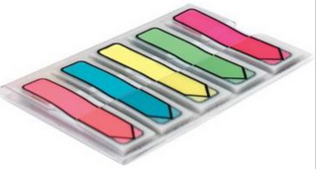
  - Materials to build Paper Mache model: Toilet paper/paper towel/wrapping paper rolls, Balloons, Cardstock, and Tape
Post-it Arrow Flags
  - Paint, Markers, and Post-It Arrow Flags to decorate and label
- Mix up 2 parts water and 2 parts flour for paper Mache paste per student.
- Each student should construct a model for the animal they are choosing to create, using the materials provided for the body, head, legs and cardstock for other features such as ears. These should all be taped to each other.
- Rip the newspaper/scrap paper into strips and then dip each strip into the paste, one by one, placing the strips on the skeleton. Once the skeleton is sufficiently covered in pasty strips allow drying overnight.
- Students will next paint their animal. Using a pen, marker, or sharpie students must draw a line representing the sagittal, coronal and transverse planes and label them correctly. Let them be creative!
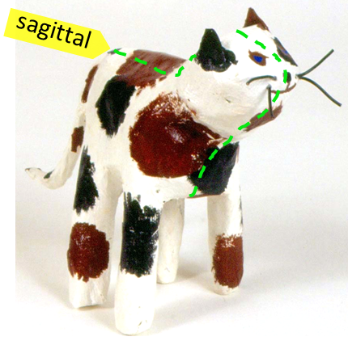
- Next, students must label the correct anatomical directional terminology – name 12 descriptive terms using post-it arrow flags, or any alternative labeling method. [Hint for superficial vs. deep have the students draw/paint one of the internal organs to be labeled as deep].

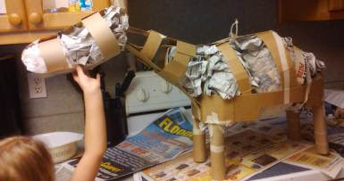

Anatomical Actions Application
During the presentation, ask the students to stand up during the “Relate to Humans” slides. Ask the class to demonstrate these motions shown on the slides. Discuss with the class how this is similar in different animal species and how you might see these actions in cats, dogs, horses, cattle and other animals.

Assessment/Evaluation:
Quiz provided for evaluation of knowledge learned.

Safety Issues:
Food allergies, Sharp knives

Resources:
- https://bio111guide.wordpress.com/category/potato-people/
- http://quizlet.com/13474067/ross-gross-anatomy-i-directional-terminology-flash-cards/

References:
- https://www.google.com/url?sa=t&rct=j&q=&esrc=s&source=web&cd=4&ved=0CDkQFjAD&url=http%3A%2F%2Fwww.gaaged.org%2FGPS%2FCourses%2FAG-VT-02.424%2520Veterinary%2520Science%2520Course%2FLessons%2FAG-VT%2520-%252002.424%252005.1%2520Veterinary%2520Anatomy.doc&ei=6PmgUp3RIILmrgGjoIDgBQ&usg=AFQjCNHOgPZAoNi5J55NQcbZierjXa7G-w&cad=rja

Authors:
Undergraduate Fellow: Lindsey E. Nyquist
Graduate Fellow: Jennifer Graham

