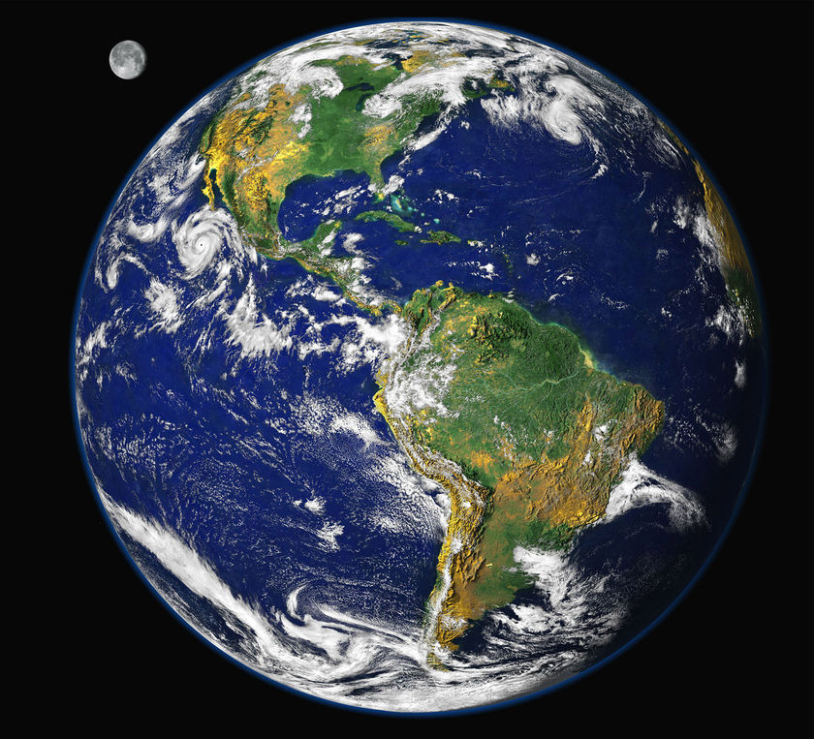
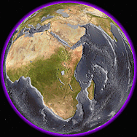
Disappearing Hydrosphere – A Mystery Experiment

Image Citations: (Left) http://www.abc.net.au/reslib/200710/r194556_737903.jpg,
(Right) http://www.howiesfunware.com/ME_EarthNoWaterHR1.gif

Summary:
This activity focuses on the hydrologic cycle by applying a who-dun-it approach to investigating the different between fresh and salt water. The experiment is designed around someone removing all the earth’s water and the students have to determine the proper locations of samples of the stolen water sources to rebalance the hydrosphere. The activity applies previous knowledge of density, temperature, and use of scientific tools to solve the mystery of the stolen hydrosphere.
Subject:
- Science – 6th grade
TEKS:
  - 6.1 : Scientific processes – conduct field and laboratory exercises, safety
  - 6.2 : Scientific inquiry method during field and laboratory exercises
  - 6.3 : Scientific critical thinking and problem solving
  - 6.4 : Scientific use of tools and methods
  - 6.10 : Investigating systems and parts of a system interacting
  - 6.11 : Understanding the hydrologic cycles cycle
- Grade Level:
- Target Grade: 6
- Upper Bound: 7
- Lower Bound: 6
Time Required: 2 45-minute class period (1st – introduce the hydrosphere, 2nd-solve the mystery)
Activity Team/Group Size: 4

Materials:
- Rectangular water tank with partitions to divide into chambers
- Food coloring
- 100 ml beakers or Erlenmeyer flasks to hold mystery samples
  - Each group will need 3
- Aluminum foil
- Hot plates
- Graduated cylinders (10 ml) (one per group)
- Triple beam balance (one per group)
- Salt water (35 ppt: 30-35 grams per 1000 grams of water)(best made with sea salt)
- Distilled water
- Fresh, tap water
- Refractometers
- Thermometers
- Conductivity meters (if available)
- Hydrometers (if available)
- Light-weight blocks (or something similar that will float)
- Calculator
Reusable Activity Cost Per Group [in dollars]: $0
Aluminum foil, salt, and distilled water should be only supplies not regularly available in a science lab.
Expendable Activity Cost Per Group [in dollars]: $10
Learning Objectives:
- Understand the hydrologic cycle and how water circulates around the globe
- Learn the difference between fresh and salt water
- Investigate the differences in physical characteristics between fresh and salt water
- Improve skills in measuring and calculating density
- Apply measurement results to the balance of water in the hydrosphere and be able to explain why fresh and salt water remains constant on earth
- Construct a working model of the hydrologic cycle
Lesson Introduction / Motivation:
Start the lesson with an introduction of the water cycle and how water around the globe. The teacher should focus on how much water is salt and how much is fresh in the hydrosphere, including where the freshwater is distributed around the globe. After the introductory lesson, move into the mystery story where students investigate the differences between salt and fresh water. Have fun with adapting the story to fit your classroom and add dramatic effects by including music, laboratory coats, safety glasses, spyware, etc. to interest the students.
Lesson Plan:
1st Day:
Water is one of the earth’s most valuable resources and is a nonrenewable resource. The earth’s water supply forms the hydrosphere and covers for 70% of the earth’s surface. However, very little of the hydrosphere is fresh water (~3%) and much of that is frozen in the polar icecaps. The hydrologic cycle is the force constantly renewing the earth’s water supply and is driven entirely by solar energy. There are 3 main steps in the hydrologic cycle: Sun provides energy causing evaporation 2: water vapor condensates in the troposphere 3: precipitation occurs as water droplets become too heavy to stay in the troposphere.
There are three basic types of fresh water sources on the earth’s surface – frozen, flowing, and standing. Frozen sources include glaciers, which can form in valleys, on continents, or in the oceans (icebergs). Flowing waters are rivers and streams, occurring around in the world in different sizes. Surface runoff also contributes to flowing water sources. Standing water sources are areas where water enters a region and remains there, including regions where surface runoff may flow into. Lakes, ponds, and reservoirs are standing water sources.
After providing the basic information, have students construct models of hydrologic cycle to include examples of the types of water in a particular step.
2nd Day –
Start the class by showing the following powerpoint presentation with dramatic mystery music. Explain to the students that someone has removed the earth’s hydrosphere and now they must decide how to return the water back to its appropriate location in order to restore the hydrologic cycle. From here, give the students three samples of mystery water and a set of equipment to start measuring and determining which sources of water they have. See the student worksheets and instructions for more information. Also, be creative with the samples. Depending on the equipment available and your location, you can collect river water, pond water, add sediment to water, etc. The purpose of the lab is for students to practice the scientific method and improve their skills with using scientific instruments, formulating hypotheses, and explaining conclusions.
Close the lesson by asking for the students’ predictions on what type of water they have from which location on earth. Also, have the students share their results from each sample to see how accurately each group measured their samples. Extend this discussion into precision and accuracy in scientific procedures. End the lesson by demonstrating the differences between water sources in the hydrosphere using a wave tank to show how layers will from based on different densities. If time remains, lead the lesson into a discussion on how to test if salinity or temperature has more an effect on density in the hydrosphere. Ask the students how this can be tested (heating salt water sample, cooling fresh water) and test the students’ designs with a wave tank.
Lesson Closure:
After the lesson, students should be able to accurately represent the hydrologic cycle and the differences between the physical characteristics of salt and fresh water. Students should also be able to calculate density and measure with basic scientific tools to the same accuracy as their peers. The students should also be able to describe the basic types of fresh water and location of water sources in the hydrosphere based on solving the mystery of the disappearing hydrosphere.
Assessment:
From the lesson, students should be able to explain their results and apply the results to the hydrosphere, more specifically describing the cycling of water in the hydrosphere. The students should be given multiple choice questions about the introductory material, the experiment, and drawings of the hydrologic cycle to label to test their understanding. Depending on the amount of time dedicated to solving the mystery, the students will develop a firm understanding of the hydrologic cycle.

Vocabulary / Definitions:

- Salinity: the amount of dissolved solids in grams per 1 kilogram of water (the definitions can vary)

Background and Concepts for Teachers:
- The only difficulty may be acquiring advance tools for measuring salinity. These tools can be purchased from various websites or borrowed from universities, state departments, or companies that monitor water sources. The optional tools are a good way to introduce students to new scientific measuring tools and serve as improvements to accuracy in addition to their density calculations. Use the tools to compare different methods of measure salinity and discuss which ways are more or less accurate based on the classroom data.
Prerequisites for this Lesson: (Optional)
- Methods for measuring salinity (can be research through government or state department sites focusing on water quality)
Lesson Scaling:

For slower groups, divide up the different measuring tasks. Have students use only two types of measurements to measure the samples and then compare all the results as a class. For more advanced groups, have each group use each tool and calculate the densities of the samples. Expand the activity by having the students collecting the other group’s data to calculate the average salinities of samples.

Safety Issues:
The method of evaporation requires using hot plates and aluminum dishes. The hot plates can be dangerous and hot. Depending on the maturity level of the students, either have a hot plate per table or be the only one to monitor the evaporation plates.
Multimedia Support and Attachments:
- ___ link to website
- ___ link to PowerPoint
- ___ link to other documents
References:
- Region 4 Education Service Center, Gateways to Science Grade 6
- Salinity Lab Exercises, Oceanography 252, Texas A&M University
Keywords:
- Hydrologic cycle
- Salinity
- Salt water
- Fresh water
- Earth systems
Authors:
Graduate Fellow Name: Ruth Mullins
Teacher Mentor Name: Naveen Cunha
Undergraduate Fellow Name: ___
Date Submitted: ___
Date Last Edited: ___
Please email us your comments on this lesson:
E-mail to ljohnson@cvm.tamu.edu
Please include the title of the lesson, whether you are a teacher, resident scientist or college faculty and what grade you used it for.

Teacher’s Comments:

