Disappearing Hydrosphere – A Mystery Experiment

Experimental Set-Up

Salinity by Evaporation

Materials: hot plate, aluminum foil or boats, small samples of mystery waters (5 ml), triple beam balance

Procedures:

Using your pencil, mark each aluminum dish with the name of the sample (i.e. A, B, C)

Weigh and record the dry mass of each sample dish in the table

Add 5 ml of each sample to the appropriate dish

Weigh and record the wet mass of each sample dish in the table

Place the dishes on the hot plate and wait for the water to evaporate

Weigh and record the evaporated mass of each sample dish in the table

Calculate the salinity of each sample using the following ratio:
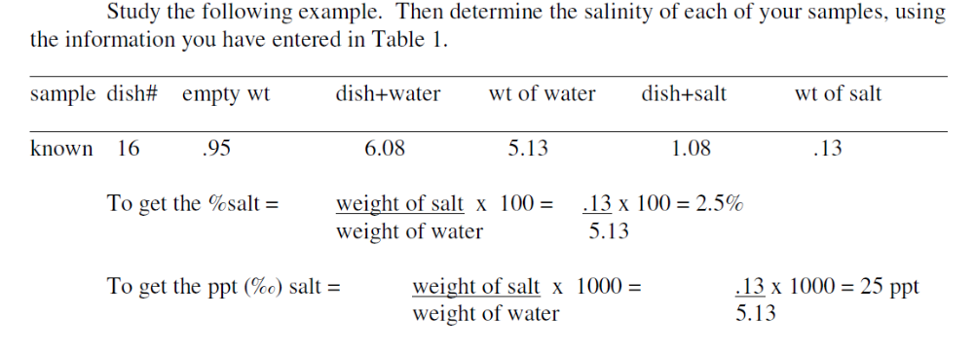

Salinity by Refractometer

Materials: eye dropper, samples of mystery water, refractometers

Procedures:

Open the flap and clean the blue screen of the refractometer with a soft cloth

Use the eye dropper to place ONE drop of sample on the blue screen

Close the screen and hold the refractometer into the light

Look through the eyepiece to calculate the salinity

Read and record the salinity of your sample (Use the diagram below)

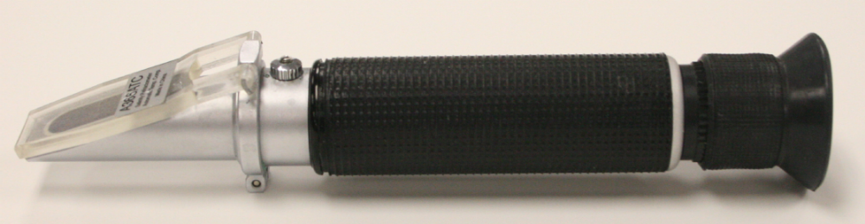
Wipe off the screen and repeat with the other samples.
Eyepiece
Flap & Screen
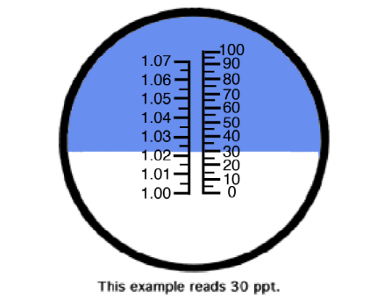

To read your salinity, read the value on the right side of the window where the blue and white line meets. This sample has a salinity of 30 ppt.

Salinity by Density:

Equipment: triple beam balance, graduated cylinder, calculator

Procedures:

Weigh your empty graduate cylinder

Add 50 ml of sample to your cylinder and weigh

Determine the mass of your sample and the volume

Calculate the density of your sample

Repeat for the other two samples

