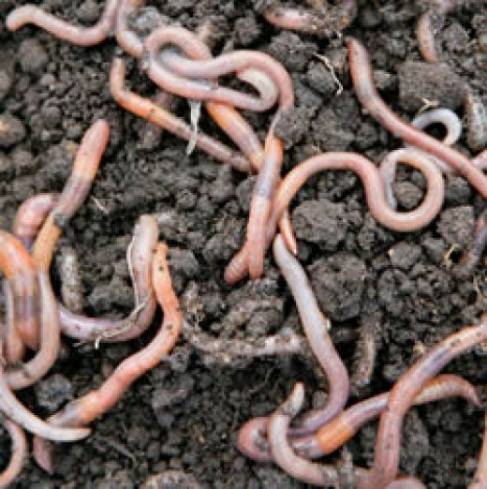
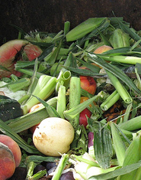
RECYCL-OGY (Worms & Organic Trash)
+

Image credit (http://farm3.static.flickr.com/2399/1801145592_ad77895f52.jpg?v=0 and http://z.hubpages.com/u/175988_f520.jpg)

Summary:
This activity is designed to introduce students to recycling organic materials regularly used in everyday life. Designing worm farms will allow students an avenue to research topics about recycling and what is required create a successful recycling system. Students can further investigate how recycling with living organisms can affect the environment. The activity can be extended into investigating the anatomy of worms and relate how different body functions make the worm useful for organic recycling.
Subject:
- Science: 6.1 – 6.3, 6.5c, 6.8c, 6.10, 6.12c,
Grade Level:
- Target Grade: 7
- Upper Bound: 8
- Lower Bound: 6
Time Required: 4 weeks: Lessons should take 2 days, The remaining time is only to have students check on farm experiments, which takes a few minutes each day

Activity Team/Group Size: 4-8 students or the entire class (Depending on the types of experiments conducted, the groups should be adjusted accordingly – If deciding to focus on how controlling environmental parameters influences rate of composting, group sizes should be medium in size).

Materials:
- Worms (see providers at the end of the Activity document)
- Plastic bin(s)
- Drill (or device to create holes in bin)
- Soil
- Newspaper
- Spray bottles with water
- Organic food scraps (can have the students bring in this item from home)
Reusable Activity Cost Per Group [in dollars]: $45 - 50
Cost depends on the amount of farms created. Worms are relatively expensive, but reusable and can be split among smaller farms.
Expendable Activity Cost Per Group [in dollars]: Food scraps are the only non-renewable expense, but can be replenished by the students bringing in materials from home.

Learning Objectives:
- To understand how living systems work and function
- To learn how recycling is important to global warming and the earth function
- To teach students how design and control experiments with living organisms
- To provoke inquiry thought by having students design the worm bins by identify and controlling the independent variables
- To experiment with factors (independent and dependent) to improve the rates of recycling and worm production
- To understand how organic recycling works and creates renewable resources and how the final product is used to enhance living processes (feedback systems)
Lesson Introduction / Motivation:
Before starting the lesson, have students research information about organic recycling and worm anatomy, depending on the extent of the activity decided on. Try catching students’ interest by asking about composting and having students share experiences with one another. Before actually building the bins, have students design their experiments by deciding size of bin holes, amount of supplies to use, and types of organic materials to supply as the worms’ food source.
Lesson Plan:
The lesson plan depends on the length chosen by the teacher. The teacher can add power-point or book supplements teaching types of recycling, with a primary focus on organic materials. The simple plan is to supply students a supply list and design sheet to create the type of experiment aiming for maximum compost production and worm reproduction. Bin construction is detailed on the website link below:
http://www.ci.euless.tx.us/composting/vc_setupbin.html
Lesson Closure:
After the lesson and monitoring the bins for a long time period, students should be able to accurately measure, explain, and graphically represent conclusions from their experiments. For example, if students are testing the types of organic materials added to the bin, the final outcomes should be a detailed experimental report elaborating on the hypothesis, results, and developing conclusions. Students should be given the opportunity to compare their results to the class and should also be able to give reasoning to why and how the experiments could be improved. If the teacher decides to use one bin for the entire class, the teacher should have different students monitor the bin every day, record data, and publish a report at the end of the experiment.
Assessment:
The students will show understanding of the lesson goals through their experimental reports. The bins are meant to be a ‘fun’, and more importantly hands-on activity showing real-world processes affecting the global environment. Students should be able to accurately discuss the pros and cons of organic recycling and how to implement composting as a means to improve the environments. The hands-on activity also provides a real application to the scientific design process, which students should also be able to communicate after the conclusion of the experiments.

Background and Concepts for Teachers:
- Teachers should use the following website to review ideas, techniques, and applications of organic recycling, or composting. The website is developed by a Texas city, which also serves as a good application for how science affects the everyday community.
  - http://www.ci.euless.tx.us/composting/
Lesson Scaling:

The lesson can be advanced by utilizing the scientific process and creating experiments to test the different factors controlling worm growth and production rates.

Lesson Extensions: None

Safety Issues: Safety issues are minimal. Students may not be receptive to handling organic waste, so keep a supply of heavy-duty cleaning gloves and latex gloves available.

Troubleshooting Tips: None

Multimedia Support and Attachments:
- http://www.ci.euless.tx.us/composting/
References:
- Worm Providers
  - Cosmo’s Red Worms
Attn: Paul Cosmides
432 Lawton St.
San Francisco, CA 94122
(415) 759-7874
www.alcasoft.com/cosmos/
Provides Red Wiggler Worms in a food housing called Vermiculture…using rabbit manure…for mail order direct to consumers. Postage Paid. Five days delivery.
Packages:
Package A: 1-1/2 lbs. – $32.75
Package B: 2 lbs. – $39.90
Package C: 3 lbs. – $53.75
The packages contain half red wiggler worms and half bedding (moist vermiculture).
Bulk Prices
$16.00/lb. (worms w/ bedding)
  - Redenta’s
Cedar Hill
(972) 291-7650
813 Straus Road, Cedar Hill, Texas 75104
Dallas
(214) 823-9421
2001 Skillman Street, Dallas, Texas 75206
Colleyville
(817) 488-3525
www.redentas.com
Keywords:
- Composting
- Organic recycling
- Vermiculture
Authors:
Graduate Fellow Name: Ruth Mullins
Teacher Mentor Name: Naveen Cunha
Date Submitted: December 14, 2008
Please email us your comments on this lesson:
E-mail to ljohnson@cvm.tamu.edu
Please include the title of the lesson, whether you are a teacher, resident scientist or college faculty and what grade you used it for.

Teacher’s Comments:

