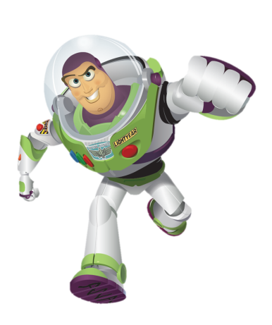
Lesson Summary: This activity gets students out of their desks to practice measuring and manipulating units in a fun, interactive manner. Conversion units of distance are often too awkwardly large to manipulate when discussing planets, solar systems, and galaxies. Units such as light-years are useful when discussing enormous distances but are difficult for students to comprehend. In order to understand the journey light takes in 1 year, students will replicate that journey and walk 9,500,000,000,000 km in 365 days. Well, not exactly. They will generate their own unit of measure based on a distance they travel in a set time interval. We will call the unit of their making a “student minute” because it is the distance that 1 student can walk (normal pace) in 1 minute.

Through this activity, students can learn the meaning of speed (distance over time) and draw parallels between the “student year” and the light-year. Students can also better understand metric measure and the need for extremely large units such as light-years.
Subject: Science

Grade Level: 8th grade

Time Required: One class period.

Key terms:
Light-year: unit of distance that measures the distance light will travel in a year
AU: astronomical unit of the distance between the Earth and the sun

Activity Introduction/Preparation: Show the attached PowerPoint to introduce the students to the concept of light-years before they begin this activity.

Background:
- Light travels at approximately 300,000,000 m/sec.
- A light-year is approximately 9,500,000,000,000 km.
- The Milky Way is 100,000,000,000,000 km or 100,000 light-years wide.
- Sirius, one of the closest stars, is 9 light-years away from Earth.
- Because it takes so long for light to travel such long distances, the images we see of objects in space are images of the past. If the distance to Sirius is 9 light-years, then images of Sirius in a telescope are of the star as it was 9 years ago when that light began its journey towards Earth.
Materials:
- Meter Stick(s) or Trundle Wheel
- Stopwatch(es)
- Calculator(s)
- Scissors
- Masking Tape (or other suitable markers)

Procedure:
- Locate an open space (e.g., hallway, cafeteria, or outdoor recreation area) for conducting this activity.
- Have students mark a linear track about 20-m long with masking tape or, if you conduct the activity outside, a rock or natural feature. If there is space available, create multiple tracks to allow more students to participate simultaneously.
- Have students measure and record how far they walk down the track in 10 sec at a normal pace. Students should attempt to walk at the same speed each time. Have 1 student walk while the other operates the stopwatch. The walking student begins when the timer says “start” and ends when the timer says “stop” as 10 seconds elapse. The distance traveled is marked, measured, and recorded. Each student repeats this measurement 3 times.
- Have students complete the worksheet to calculate the average for 3 trials. This gives them practice using conversions to calculate their “student second,” “student minute,” “student day,” and “student year.” They compare these values with the light-year.
- Follow up with a discussion of units and conversions

Activity Extensions:
- Hand out for homework and/or work through the additional Light-years student worksheet.
References: This activity is directly from:
- http://www.carolina.com/category/teacher+resources/classroom+activities/what+is+a+light+year.do

TEKS: Science- 8.8 D Model and describe how light-years are used to measure distances and sizes in the universe

Authors:
Undergraduate Fellow: Kristen Bowen
Graduate Fellow: Jennifer Graham
Please email us your comments on this lesson:
E-mail to ljohnson@cvm.tamu.edu
Please include the title of the lesson, whether you are a teacher, resident scientist or college faculty and what grade you used it for.

