MAKE YOUR OWN AMORTIZATION TABLE USING MICROSOFT EXCEL

Step 1: Fill out Excel sheet with labels for your amortization table. This will be useful in keeping your table organized.

Step 2: Enter the information you have been given into the table. For reference, I will use an interest rate of 6%, a present value of $30,000.00, and 60 monthly payments. (NOTE: the period column goes all the way to 60. An easy way to do this quickly without typing every number is to type the first few numbers, highlight both cells, and then click and drag the bottom right of the cell downward when you see a black, cross-like icon appear. The numbers will get higher as you keep dragging. Stop when you see your number of periods.)

Step 3: Calculate your payment per period
- Click on the cell just below your payment label. In this example, that is C5. Enter =pmt( and then click on the fx button at the top of your spreadsheet.
- After you do this, you should have a screen pop up with different categories that you will fill out to calculate your payment. Notice that when entering this information, the rate has been divided by the number of payments per year, and the present value has been entered as negative.
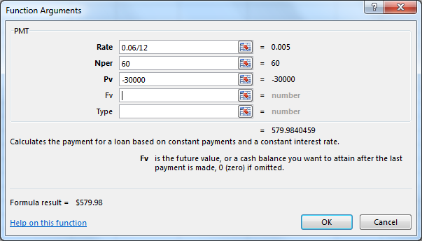
- Press OK. A payment should be calculated in C5 or in whatever cell you entered the function. This is the payment that you will use for the entire amortization table.
Step 4: Start to enter formulas into the table. NOTE: it is extremely important that you link all of the cells in the table. If you don’t, the purpose of creating an amortization table in Excel is defeated.
- First, enter your beginning balance. In this spreadsheet, it is equal to cell B2 ($30,000.00).
- Next, calculate your interest paid. This formula is a little tricky, but you must be sure to do it right. To calculate your interest paid, enter
=B5*($B$1/12)
- This calculation multiplies the beginning balance at that point in the table times the interest rate per month. This is why you must divide the cell contents by 12. If your payments are made quarterly or semi-annually, you would divide the cell contents by 4 or 2 respectively. You must remember to lock the cell contents of your interest rate so that it doesn’t change throughout the table (this can be done by pressing F4 on your keyboard after clicking on the cell, or by manually typing the $ sign as shown in the formula above).
- The next step in creating your amortization table is to calculate the principal paid per period. To do so, subtract the interest paid from the payment. This formula should be linked as well, and can be done by typing this into your cell:
=C5-D5
- The last calculation to be made on this row is to compute the remaining balance. To do so, you subtract the principal paid from the beginning balance on that respective row. The calculation is as follows:
=B5-E5
Step 5: Link the remaining balance of the previous row to the beginning balance of the current row. This can be done by clicking on the second beginning balance and entering =F5
Step 6: Copy the rest of the formulas from the previous row onto the current row. This can be done by highlighting the payment, interest paid, principal paid, and remaining balance cells, and then from bottom, right-hand column, clicking and dragging down one row.
Step 7: Highlight all of your cells on the second row of your table from beginning balance to remaining balance. Click and drag your formulas all of the way down to the last row of the table (on this table, period 60).

- Your table should have a zero balance at the end of your table. If you do not, go back and check to make sure that all of your calculations are correct.
Step 8: Your amortization table is complete! If you would like, you can save this table as a template for future amortizations. Since the table is linked, it will update itself when you change the numbers.
Taking it a step further:
How much interest do you think was paid over the life of the loan? This is easily calculated with this table after your payment has been calculated.
- Off to the side of your amortization table, use an equation to multiply your number of payments by your payment per period. In this example table, this would be =60*579.98
- The number that you get is the total amount of money paid on the loan. To find the amount of interest paid, subtract the present value of your loan from the total amount paid on the loan.

