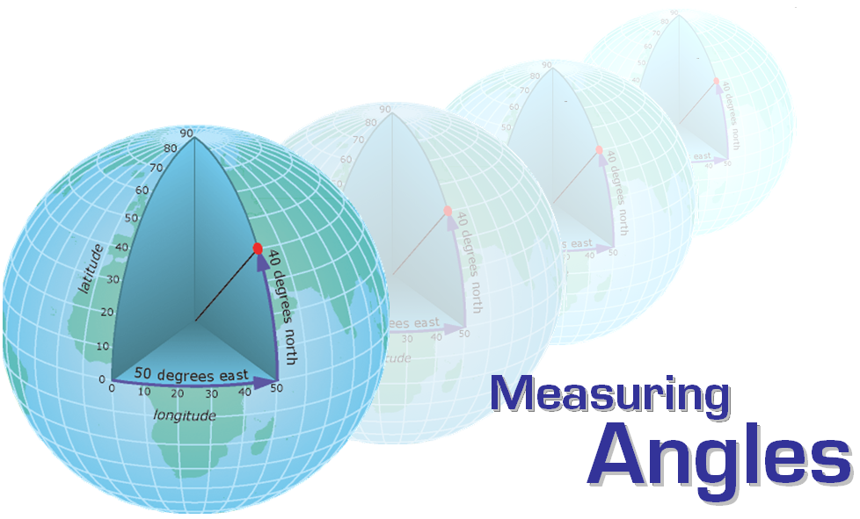

Summary:
This lesson introduces protractors and instructs students on how to use them to measure angles.

Subject:
Math: Measurement, geometry and spatial reasoning

Grade Level:
- Target Grade: 6
- Upper Bound: 7
- Lower Bound: 6

Time Required:
65 minutes

Group Size:
Teams of three

Materials:
- Smartboard or projector and computer to run and display slideshow
- MS PowerPoint (2003 or more recent)
- Transparencies
- Printer paper or Cardstock
- Protractors
- Dry erase markers (fine tip)

Lesson Introduction / Motivation:
Students tend to have difficulty understanding protractors and how to use these to measure angles correctly. This lesson addresses the issue by helping them “filter out” some of the common misunderstandings they develop about protractors through letting them build their own. Also, this activity provides a chance to practice measuring angles of geometric figures while working in groups so that students can help each other understand the concept better.

Preparation:
Prepare printouts of the protractor molds, sets of geometric figures to be used by the students to practice measuring angles, and the worksheet where they will record the measured angles and analyze the data.

The protractor molds are included in the file protractors.pdf. Print these on transparencies and cut along the dotted line to have one mold available per student. Having the mold on a piece of transparency gives flexibility to the students to make modifications or completely redo their protractor without needing additional copies of the mold. Plus, the students will enjoy working with a different material.

The geometric figures are included in the file geometric_figures.pdf. Print one set for every three students on regular printer paper or using cardstock if you would like to laminate and reuse these. The figures were generated using MS PowerPoint 2003.

The worksheet is included in the file worksheet.doc. Print one copy for every three students since they will be working in groups of three.

Lesson Plan:

- Group the students in teams of three
- Introduce the activity using the slideshow Measuring Angles.ppt
- Review angles and common angles (slides 2,3)
- Introduce protractors (slide 4) in the following way:
    - Explain that simple protractors are used in the classroom
    - Pass out real protractors to the class
    - Give students a couple of minutes to observe them –ASK THEM TO MEMORIZE THEM!
    - After the two minutes, ask the class to point out the main features of a protractor and summarize them together
    - Ask them to place the protractors away where they can not see them
- Pass out the protractor molds and fine-tip dry erase markers and ask the students to make their own protractor.
    - Allow a few minutes to work on this.
    - When done, let students take out the real protractors and compare both
    - If necessary, give time to correct any mistakes students may have made when making their own protractor
- Show how to use a protractor to measure an angle by visiting the link included in slide 6
- Pass out the sets of geometric figures (9 figures per set)
- Ask the students to work with their team to measure the angles of Figure 2 (Isosceles Triangle)
    - They may have difficulty doing it without an example at this point, but this is done on purpose
    - After a couple of minutes, offer to go over an example; they will now appreciate going over an example together
- Go over example on how to measure the angles of a triangle (slides 8,9,10)
- Pass out the worksheet
- Let the teams work together to complete their measurements
    - You may suggest that each member of the team measures at least the angles of one triangle, one quadrilateral, and one polygon (there are three of each in the set of geometric figures)
- Leave time at the end to go over the questions in the worksheet together with the class

Assessment:
Use the worksheet answers given by the teams to assess their performance.

TEKS:

6.6 (A) Use angle measurements to classify angles as acute, obtuse, or right
6.6 (B) Identify relationships involving angles in triangles and quadrilaterals
6.8 (C) Measure angles
6.13 (A) Validate conclusions using mathematical properties and relationships

Authors:
Graduate Fellow Name: Alfredo Perez
Teacher Mentor Name: Mrs. Angela Monsivais
Undergraduate Fellow Name: Amy Aldrich
Date Submitted: February 28, 2009
Date Last Edited: ___ February 28, 2009
Please email us your comments on this lesson:
E-mail to ljohnson@cvm.tamu.edu

