Native American Medical Remedies Worksheet

When the settlers arrived to the New World, they learned how to use common plants in their folk medicines from the Native Americans. The Indians also taught the settlers a few new uses for the medicinal plants that they brought with them from their native lands.
The Native Americans and Settlers used many different types of plants to cure various medical symptoms. __________ ___________ roots were used to make a tea to act as a sedative for asthma. A tea was made from the creosote bush leaves for ______________ and other respiratory problems. The blossoms of ______________________ were boiled and the resulting liquid was applied to burns and skin sores. ___________ tea was one of the most frequently used home remedies. The tea was used to cure fevers and ______________. A tea was made from catnip leaves to treat _____________. The alkaloids in the ________________ have been found to possess powerful anti-cancer properties. A ______________ was made and used to cover the malignant area of the body and it was also used for war and dance paint. _______________________ blossoms were submerged in warm water when they were in full bloom and then drank to cure the symptoms of diabetes. The inner bark of the Wild Cherry Tree is used to help cure the symptoms of _______________________.

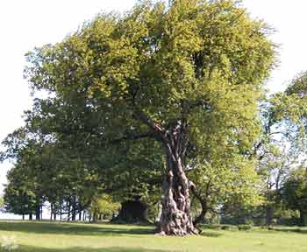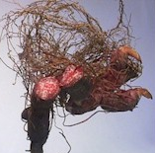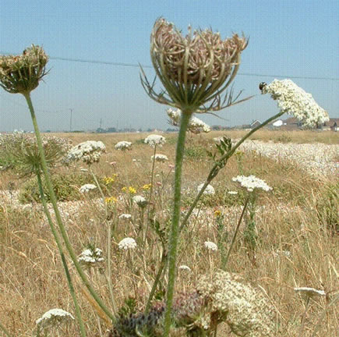
A B C

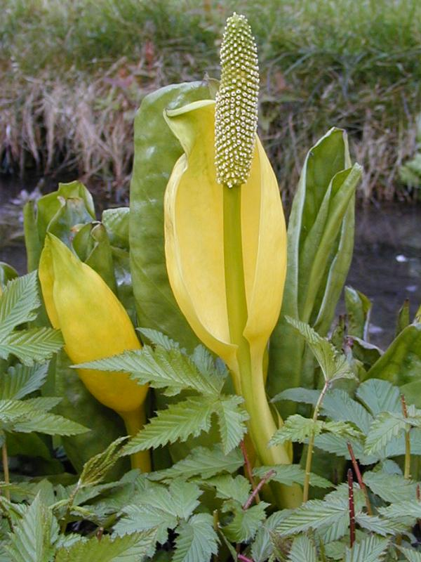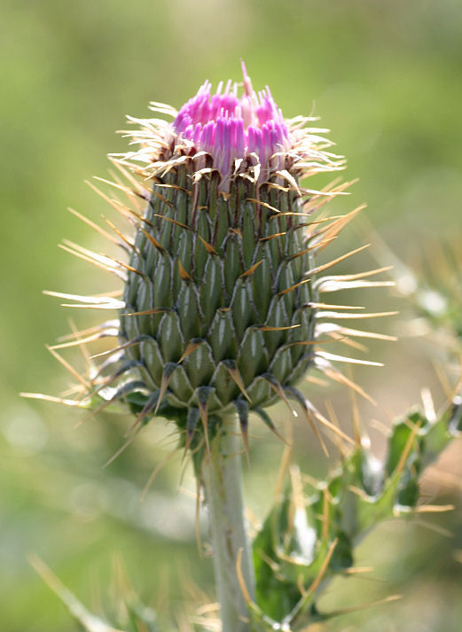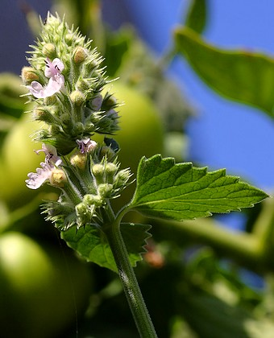
D E F

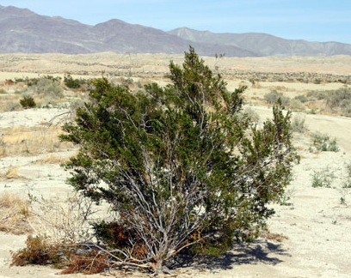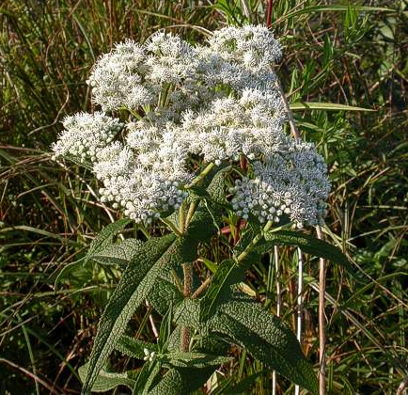
G H

BloodRoot:____________ Boneset:__________________
Wild Cherry:___________ Yellow-Spined thistle________
Catnip:________________ Creosote Bush:_____________
Wild Carrot:____________ Skunk Cabbage:____________

