Mendelian Genetics and Punnett Squares
- Background

Monohybrid crosses are crosses in which only one characteristic/trait is considered. For example, attached earlobes verses unattached earlobes in humans. Sex-Linked crosses are crosses in which the characteristics being considered are related to genes on either the X or Y chromosome. Of all the chromosomes a given species may have, the X chromosome carries the genes for female sex determination and female characteristics, while the Y chromosome carries the genes for male sex determination and male characteristics. Additionally, the X chromosome carries a number of other genes from near sightedness and distichiasis (double eyelashes) in humans, to eye color in fruit flies. Dihybrid crosses involve tracking two traits simultaneously. For example, we can predict the outcome for offspring as the traits for both height and color are concerned.
Original parents in any given set of crosses are called the parent generation or parentals, while the two subsequent generations are denoted with the symbols F1 and F2 (a cross of two F1 individuals). Punnett Squares are one method for visually demonstrating genotypic crosses, the resulting genotypes of the offspring, and subsequent phenotypes as well. See the example below. Note the calculation and reporting of probabilities for the offspring.
- Example 1: (Monohybrid Cross)
For humans, brown eyes are dominant (B) over blue eyes (b). A heterozygous brown-eyed man marries a blue-eyed female. What are the possible genotypes and phenotypes of the offspring? Give your answers in probabilities.

Parents: Male = Bb; Female = bb
The separation of the parental genotype from Bb and bb on either side of the Punnett Square represents meiosis. Each single letter represents a possible haploid condition in either an egg or a sperm – whereas the double letters represent a diploid condition.

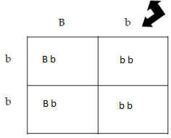
Conventions
1. Male alleles on top of Punnett Square – female alleles on the left
2. Dominant allele (upper case) written before recessive allele (lower case)

Probabilities For F1 Offspring

Genotypes: Bb = 2/4 = 50% Phenotypes: Brown eyed (Bb) = 2/4 = 50%
bb = 2/4 = 50% Blue eyed (bb) = 2/4 = 50%

*Every time you complete a Punnett Square you must list and calculate the probabilities that the cross predicts
for both genotypes and phenotypes. Remember, Punnett Squares predict the probability that a particular
genotype or phenotype will be produced. These values may not always match a given set of offspring.
Monohybrid Problems
- In guinea pigs rough coats are dominant over smooth coats. Let R = a rough coat and r = a smooth coat. *when the problem is not sex-linked and neither the male of female are identified – the convention is to consider the first individual as the male

If a homozygous rough-coated (RR) guinea pig is crossed with a smooth (rr) coated guinea pig, what will be the genotypes and phenotypes of both the F1 and F2 generations? (recall that a F2 generation is the result of crossing two F1 individuals – hint: F2 problems can only be proposed when the F1 offspring all have the same genotype!)

THIS PROBLEM REQUIRES TWO PUNNETT SQUARES: ONE FOR EACH GENERATION.
IDENTIFY EACH PUNNETT SQUARE AS EITHER F1 OR F2.

Parentals: Male = RR; Female = rr
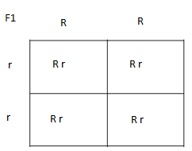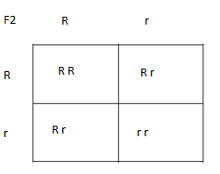
F1: Genotypes: 100% Rr
Phenotypes: 100% rough-coated guinea pig
F2: Genotypes: 25% RR; 50% Rr; 25% rr
Phenotypes: 75% rough-coated guinea pig; 25% smooth-coated guinea pig

2. *This is a more challenging monohybrid problem. A certain rough-coated guinea pig, when breed with a smooth-coated guinea pig gives 8 rough and 7 smooth offspring. What are the genotypes of both the parents and the offspring most likely to be? Show all work.
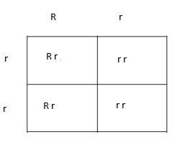Parent genotypes: Rr; rr
Offspring genotypes: Rr; rr
Example 2: (Sex-Linked Cross)
The normal female condition is a result of the chromosomal pairing XX, while the normal male condition is XY. Certain genes located on the X chromosome, not associated with female sex characteristics, cause sex-linked recessive traits. As a result, females must receive two recessive alleles to exhibit any particular characteristic associated with one of these genes, while males need only receive one allele. The reason for the male anomaly is that the Y chromosome does not carry versions of the same genes as the X chromosome.

As you will see in this example, a dominance/recessive situation can occur. However, the fact remains that the male can carry only one allele for a given sex-linked trait. Likewise, only females can be a true heterozygote (one dominant allele and one recessive allele).

- Hemophilia is a rare heredity human disease of the blood. The blood of individuals with this condition does not clot properly. Without the capacity for blood clotting, even a small cut can be lethal. In a marriage of two non-hemophiliac parents, a bleeder son is born. What are the probabilities of these parents giving birth to sons being bleeders, and to daughters being bleeders? Use (H) for the normal “non-hemophiliac” allele and (h) for the hemophilia allele.
Recall: half of all sperm (which are haploid) carry the X chromosomes and half carry the
Y chromosome while 100% of all eggs (which are also haploid) carry only the X chromosome

Parents: Male = X^{H}Y; Female =
Son Bleeder = X^{h}Y
Daughter Bleeder = X^{h}X^{h}

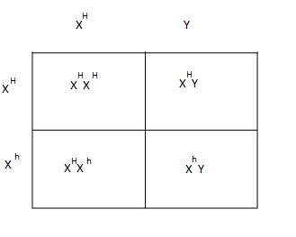
Genotypes: Males = 50% X^{H}Y; 50% X^{h}Y
Females = 50% X^{H}X^{H}; 50% X^{H}X^{h}
Phenotypes: Males = 50% hemophiliac; 50% non-hemophiliac
Females = 100% non-hemophiliac
Answer to the question? It is not possible for two non-hemophiliacs to have daughter bleeders; because the father’s X chromosome must be non-hemophiliac

Sex-Linked Problems

1. In humans colorblindness (b) is an example of a sex-linked recessive trait. In this problem, a male with colorblindness marries a female who is not colorblind but carries the (b) allele.
Using a Punnett Square, determine the genotypic and phenotypic probabilities for their potential offspring.
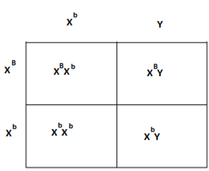
Genotypes: Male: 50% X^{B}Y; 50% X^{b}Y
Female: 50% X^{B}X^{b}; 50% X^{b}X^{b}
Phenotypes: Male: 50% colorblind; 50% non-colorblind
Female: 50% colorblind; 50% non-colorblind

2. In fruit flies red eye color (R) is dominant to white eyes (r). In a cross between two flies, all of the male offspring had white eyes. The all of the females had red eyes. What are the phenotype and genotypes of the parents? If the F1 offspring were crossed, what would the F2 offspring phenotypes and genotypes be?
Show All Work
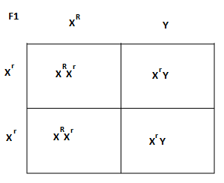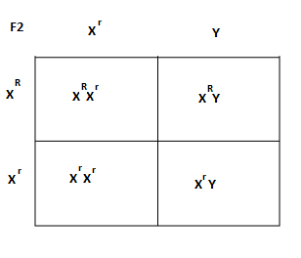
Parents: Genotype: Male: X^{R}Y; Female: X^{r}X^{r}
Phenotype: Male: Red eyes; Female: White eyes
F2 Offspring: Male: Genotypes: XRY; XrY
Phenotypes: 50% red eyes; 50% white eyes
Female: Genotypes: XRXr; XrXr
Phenotypes: 50% red eyes; 50% white eyes
Example 3: (Dihybrid Cross)

In garden peas, tallness (T) is dominant to shortness (t) and axillary flowers (A) are dominant to terminal flowers (a). What are the expected genotypes and phenotypes of the offspring if a heterozygous tall, heterozygous axillary plant is crossed with a heterozygous tall, terminal plant? Give your answers in probabilities, and ratios.

Parents: Male = TtAa; Female = Ttaa
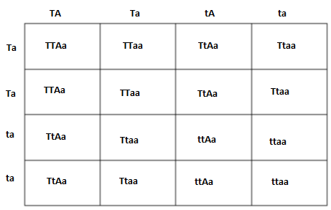
Meiotic Distribution of
Alleles
1. Purpose: to distribute the parental alleles into gametes (eggs and sperm or pollen and ovum) as would be predicted by meiosis.
2. Use the FOIL method from the binomial distributive property of multiplication.
3. ex: gamete distribution for AB Ab aB ab

F1 Offspring: Genotypes = 12.5% TTAa; 25% TtAa; 12.5% TTaa; 25% Ttaa;
12.5% ttAa; 12.5% ttaa

Phenotypes = 37.5% tall, axillary; 37.5% tall, terminal;
12.5% short, axillary; 12.5% short, terminal

Genotypic ratio = 4 TtAa: 4 Ttaa: 2 TTAa: 2 TTaa: 2 ttAa: 2 ttaa

Phenotypic ratio =6 tall, axillary: 6 tall, terminal;
2 short, axillary; 2 short, terminal

Dihybrid Cross Problems

- Long-horned red coat cattle have the genotype (SSLL) and hornless white coat cattle have the genotype (ssll). When red and white coated cattle are mated the offspring have roan coat (Ss) and when long horned cattle are mated with hornless cattle, the offspring have short horns (Ll). Report a full set of data for the offspring resulting from a cross between two roan short horned cattle. Show all Work.
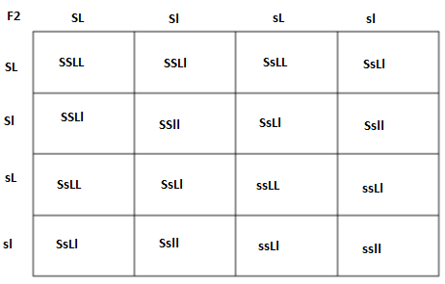

F1 Offspring: Genotypic ratio = 1 SSLL: 2 SSLl; 1 SSll; 2 SsLL; 4 SsLl; 2 Ssll; 1 ssLL; 2 ssLl; 1 ssll

Phenotypes = 1 long horn,red; 2 short horn, red; 1 hornless red; 2 long horn roan; 4 short horn roan; 2 hornless roan; 1 long horn white; 2 short horn white; 1 hornless white

- In rabbits, spotted coats (R) are dominant to solid colored coats (r), and short hair is (P) is dominant to long hair (p). A homozygous spotted longhaired male is mated to a fully solid-colored, homozygous shorthaired female rabbit. If the F1 offspring were allowed to breed to solid colored, long haired rabbits and 64 offspring were produced, how many of the 64 would you predict would be spotted with long hair, and how many will be solid colored? Show all Work

F1 Offspring: All RrPp
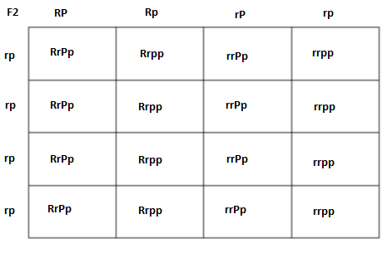
F2 Offspring: Genotypes: 25% RrPp: 25% Rrpp: 25% rrPp: 25% rrpp
Phenotypes: 25% spotted short hair; 25% spotted long hair;
25% solid short hair; 25% solid long hair
Of 64 offspring, there is expected to be 16 rabbits with spotted long hair and it is expected that 32 will be solid colored.

