Methods for Estimating Areas

These are two methods for estimating the area of an irregular shape:
- Break the irregular shape into simple shapes such as rectangles, triangles, and circles. Find these areas & sum them up to estimate the entire area.
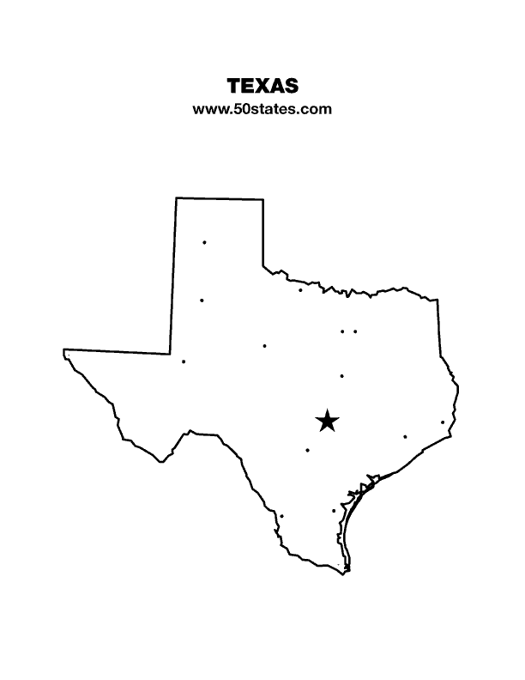
Notice that the simple shapes don’t fit perfectly inside the irregular shape, but by over estimating in some areas & underestimating in other areas we can get pretty close. We can get even closer to estimating the true area by adding smaller shapes in the areas that are not covered.

- Using a grid where each square represents one square-unit (such as 1 meter²), count the number of squares contained in your shape. As you can see, in many cases only part of a square lies inside your shape. As we did in the first method, if you overestimate by counting the squares that are mostly inside & at the same time underestimate by excluding the squares where only a small area is inside your estimate of the area should be close!

