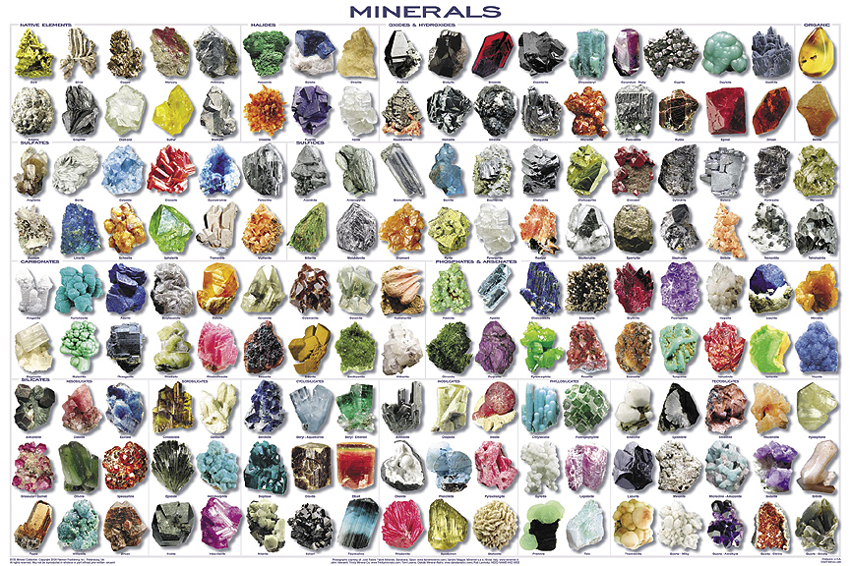Minerals 101!

Summary:
This is a two day activity plan.

Day 1: Students will learn basic mineral background information, and how to identify them. They will watch a PowerPoint presentation, and then complete a worksheet activity.

Day 2: Using the information learned in Day 1, students will complete a lab exercise classifying ten different minerals.
Subject:
- Science:
  - TEKS: 6.1 A- Demonstrate safe practices during field and laboratory investigation.
  - TEKS: 6.3 A- In all fields of science, analyze, evaluate, and critique scientific explanations by using empirical evidence, logical reasoning, and experimental and observational testing, including examining all sides of scientific evidence of those scientific explanations, so as to encourage critical thinking by the student.
  - TEKS 6.4 A- Use appropriate tools to collect, record, and analyze information, including journals/notebooks, beakers, Petri dishes, meter sticks, graduated cylinders, hot plates, test tubes, triple beam balances, microscopes, thermometers, calculators, computers, timing devices, and other equipment as needed to teach the curriculum.
  - TEKS: 6.6 C- Test the physical properties of minerals, including hardness, color, luster, and streak.
Grade Level:
- Target Grade: 6
- Upper Bound: 8
- Lower Bound: 6
Time Required: Two Class periods of about an hour each.
Activity Team/Group Size:
- Day 1: No groups, PowerPoint should be shown to the entire class, and the activity worksheet should be completed individually.
- Day 2: Groups of 2-3 for the “What’s that Mineral?” lab.

Materials:
- Day 1
  - Pencil/Pen
  - “Minerals 101” student worksheet

- Day 2 (Per group)
  - Pencil/pen
  - Mineral Tray (containing: Bauxite, Gypsum, Halite, Calcite, Orthoclase, Augite, Quartz, Garnet, Graphite, Pyrite)
  - Streak plate (one white, one black)
  - Penny
  - Steel nail
  - Glass Plate
  - Goggles
  - Mineral identification chart (2 page document, 1 per group)
  - “What’s that Mineral?” – Lab activity worksheet (one per student)
Reusable Activity Cost Per Group [in dollars]: All materials about $5-10 per student, possibly less if your school has obtained the mineral tray from previous classes.
Learning Objectives:
- To teach students basic knowledge over minerals on earth. To make students aware of what we use them for, and how to identify them.
Lesson Introduction / Motivation:
- Day 1:
  - Introduce the lesson with the “Minerals 101” PowerPoint. Ask students if they know what minerals are. Have they ever learned about them before? Explain that they will be learning about them, and at the end of the PowerPoint get a chance to test their knowledge as a class.

- Day 2:
  - Begin the day by addressing the most commonly asked questions from the Day 1exit activity.
  - Then grab student’s attention by opening the “Minerals Are Everywhere” PowerPoint. This will help show them why minerals are important, and relate them to everyday life. After the quick presentation begin explaining the “What’s That Mineral?” lab activity.
Lesson Plan:
- Day 1:
  - After introducing the lesson as stated above begin the “Minerals 101” PowerPoint presentation. Keep students attention throughout the presentation by clicking through slides and pausing between the appearance of the title on the slide and its explanation text. Take time to ask the students what they know about the title on the slide, can they teach you anything? Be sure that there is class participation during the presentation.
  - After the presentation distribute the “Minerals 101 Student Worksheet”, have students try to fill it out individually. Allow 10-15 minutes for students to work individually, then collect the worksheets and begin the exit activity (This is found in the Day1 lesson closure section below).
- Day 2:
  - When beginning the PowerPoint presentation tell the class that they will be applying what they learned on Day 1 to a lab experiment.
  - At the end of the PowerPoint break students into groups of 2-3 depending on class size. Explain the lab as follows:
    - In your groups, read and follow the procedure carefully.
    - Complete all the identification tests for one mineral, then use the identification chart to identify the mineral. Repeat this for all 10 minerals; be sure to record all data in your data table.
    - Answer all conclusion questions in complete sentences!
  - After the assignment is explained distribute all materials to each group of students. Explain that they will have almost the entire class period to finish the lab, and that five minutes before the bell, the class will stop and begin an exit activity (lesson closure).
    - Note: To make material distribution faster, have small boxes (maybe shoeboxes or plastic containers) containing all materials for each group already prepared. This way a member from each group can come up to the front of the class and obtain a box and student worksheets for the lab.
    - Each group should have (in box) all materials listed on Day 2 materials list.
Lesson Closure:
- Day 1:
  - For students to leave class at the end of the period there will be a 3-2-1 activity. Ask each student to use a sheet of notebook or scratch paper and pen or pencil. Write down 3 things they learned, 2 things they have a question about, and 1 thing they want the (you) the instructor to know. Collect these as students leave class, and before introducing the Day 2 lesson address the most frequently asked questions from this activity with the class.
- Day 2:
  - The exit activity will be “Numbered Heads Together”, keep students in the groups they formed for the lab activity. In their groups they will create a list of 3-5 things that they learned from the lesson. Then call on one member from each group to report to the class something that they learned. Have them turn the list in as they exit the classroom. This will provide a way to gauge student grasp of the lesson.

Assessment:
- Day 1:
  - Grade all student worksheets for accuracy, and assess the students’ ability to grasp the information based on completeness of their answer. Give bonus points to students for participation during the PowerPoint Presentation.
- Day 2:
  - Grade laboratory chart and conclusion questions for completion. Give bonus points for student participation during the PowerPoint presentation and with their group during the lab activity.

Vocabulary / Definitions:
- Mineral: a naturally occurring, inorganic, solid which possesses a characteristic internal atomic structure and a definite chemical composition.
- Element: any substance that cannot be broken down into simpler substances.
- Luster: how light is reflected from the surface of a mineral.
- Hardness: of a mineral is its ability to resist scratching.
- Cleavage: is the ability of a mineral to break along preferred planes
- Streak: is the color of the powder left on a streak plate (piece of unglazed porcelain) when a mineral is scraped across it.

Background and Concepts for Teachers:
- Read over the definitions above, and click through the PowerPoint presentation alone before presenting it in class. Be sure to have a grasp of how to identify minerals, and be able to field student questions, especially during the lab, if needed.
Lesson Scaling:

- To modify the lesson if time or funds are limited, the mineral lab could be shortened from identifying ten minerals to five minerals. Eliminating the lab completely is an option, but not ideal as it reinforces the concepts presented in the PowerPoint and allows students to have “hands on” experience with identifying minerals.

Safety Issues:
Students will be working with glass scratch plates, be sure that students protect their eyes at all times by wearing goggles during the experiment. Instruct students not to hold the scratch plate while performing any tests, as it may break and injure their hands. Keep the plate flat on the desk, or lab table. Also, instruct students to notify you, the instructor, immediately if any glass or lab materials break during lab. Clean up the broken glass according to your lab safety protocol.

Multimedia Support and Attachments:
- There is a PowerPoint attached for the lesson presentation of both lesson days.
References:
- http://www.minsocam.org/MSA/K12/properties/minpropindex.html
- http://www.science-class.net/Geology/rocks_minerals.htm
- http://www.teachersdomain.org/resource/ess05.sci.ess.earthsys.mineralenv/
- http://www.edquest.ca/component/content/article/157

Keywords:
- Mineral
- Identification
- Elements
- Inorganic
- Crystal
- Luster
- Streak
- Hardness
Authors:
Undergraduate Fellow Name: Beverly Crocker
Date Submitted: 5/26/11
Please email us your comments on this lesson:
E-mail to ljohnson@cvm.tamu.edu
Please include the title of the lesson, whether you are a teacher, resident scientist or college faculty and what grade you used it for.
Teacher’s Comments:

