Minerals 101 – Student Worksheet
- Rocks are made of different combinations of Minerals ?

- Minerals are made of elements.
  - Define an element: Any substance that cannot be broken down into simpler substances.

- Outline the properties of minerals with an explanation for each:

  - S – Solid
    - Not a liquid or gas

  - N – Naturally Occurring
    - Found in nature not man made

  - I – Inorganic
    - Not living, not formed by living processes
  - F – Fixed Composition
    - Has a chemical formula

  - C – Crystal Form
    - A structure where atoms are in an orderly and repeated pattern.

- What are the 5 steps for mineral identification?
  - Luster
  - Hardness
  - Color
  - Cleavage
  - Streak

- Define: Luster
  - Luster refers to how light is reflected from the surface of a mineral.

- Define: Hardness
  - Hardness of a mineral is its ability to resist scratching.

- Who developed the hardness scale, and what mineral has a hardness of 10?
  - Friedrich Mohs, and the diamond
- Define: Color
  - Caused by the absorption of wavelengths of light by the mineral and their combination of wavelengths reaching the eye.

- Define: Cleavage
  - The ability of a mineral to break along preferred planes.

- Define: Streak
  - The color of the powder left on a streak plate when the mineral is scraped across it.

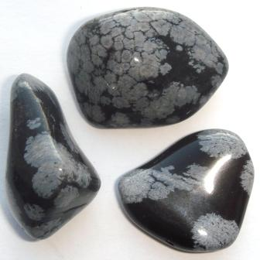

Fun Fact: The mineral pictured above is Obsidian!
- Its name comes from the name of a man, Obsius, who was supposed to have found this rock in Ethiopia thousands of years ago. Obsidian is ancient volcanic glass and was once widely used for arrowheads.

