Minerals 101 – Student Worksheet
- Rocks are made of different combinations of ?

- are made of elements.
  - Define an element:

- Outline the properties of minerals with an explanation for each:

  - S –

  - N –

  - I –

  - F –

  - C –

- What are the 5 steps for mineral identification?

- Define: Luster

- Define: Hardness

- Who developed the hardness scale, and what mineral has a hardness of 10?

- Define: Color

- Define: Cleavage

- Define: Streak

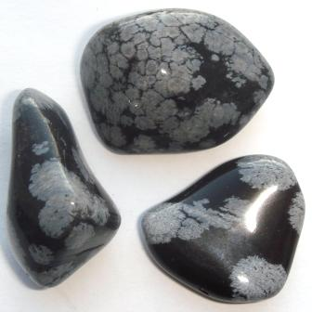

Fun Fact: The mineral pictured above is Obsidian!
- Its name comes from the name of a man, Obsius, who was supposed to have found this rock in Ethiopia thousands of years ago. Obsidian is ancient volcanic glass and was once widely used for arrowheads.

