Mini Greenhouse Project
- Objective: Build a mini greenhouse out of a 2 liter bottle.

- Materials Needed:
- Empty clear 2 liter soda bottle
- Pair of scissors
- Outdoor garden space with soil
- Seeds of any kind

- Directions:
  - Make sure that the liter bottle is clean of any soda residue
  - Cut the bottom off of the soda bottle with the scissors
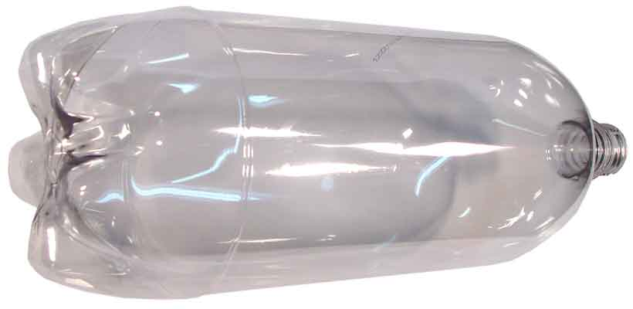
  - Plant a few seeds in the garden area soil where you want them to grow
  - Lightly water the soil
  - Place the 2 liter bottle over the seeds and push into the soil
  - Do not put the cap on the liter bottle once planted in the ground
- Recommendations:
  - Plant the seedlings where they will get morning sun and evening shade
  - Water lightly, do not flood the plant
  - Make sure the plastic bottle is pushed at least 3 inches into the soil
  - Do not put the cap on the liter bottle once it is in the soil
- Safety:
  - Be careful handling scissors and cutting the plastic bottle

