Mohs Hardness Scale

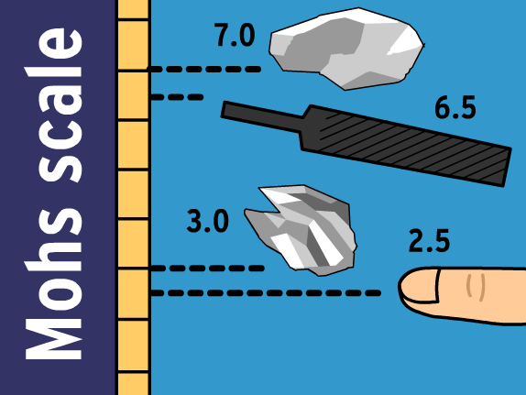

Download all Associated Files for this lesson from our Website

Summary: At the end of this lesson, students will have developed knowledge on four different properties of rocks and minerals, on the origin of Mohs Scale, the scale itself, and the minerals it includes. Students will apply this knowledge to activities exploring further Mohs Scale; they will be able to find the hardness of a given rock using household items and other rocks. This lesson includes a short, introductory activity relating to Mohs Scale, a PowerPoint lesson on mineral properties and Mohs Scale, and a lab activity where students will apply knowledge of Mohs Scale.

Keywords: color, hardness, luster, mineral, Mohs Scale, rock, streak

Subject TEKS: §112.18. Science
Grade 6 (6). Matter and energy
- (C) test the physical properties of minerals, including hardness, color, luster, and streak.

Grade Level: 6th

Learning Objectives:
- Students will be able to distinguish between the different properties of rocks and minerals
- Students will assess the hardness of rocks and minerals, then interpret what this means in comparison to other rocks and minerals
- Students can classify rocks based on rock properties

Time Required: 2 class periods (one for PowerPoint, one for lab)

Materials:
- Magnifying Glass
- Copper Penny
- Steel Nail
- Square Glass Plate
- Duct tape to tape edges of glass
- Steel File
- Any other items you would like to use to test hardness
- Rocks that students bring from home
- Masking tape or labels
- Sharpie or pen that can be used to label rocks

Background/Concepts for Teachers: Teacher must familiarize self with the difference between rocks and minerals, as well as the different properties of minerals. It is also helpful to know the origin of Mohs Scale, as well as how it is set up and how to use it. It would be helpful for the teacher to review all materials on this lesson plan before presenting it to students, as this will give the teacher a good starting place for knowledge on the subject.

Vocabulary / Definitions:
Hardness - the comparative ability of one substance to scratch or be scratched by another.

Color - a phenomenon of light or visual perception that enables one to differentiate otherwise identical objects

Luster – the appearance of the surface of a mineral dependent upon its reflection of light

Streak - the color of the fine powder of a mineral obtained by scratching or rubbing against a hard white surface

Mineral – a naturally occurring inorganic substance

Rock - A hard, naturally occurring material consisting of one or of several minerals

Mohs Scale - a scale of hardness for minerals in which 1 represents the hardness of talc; 2, gypsum; 3, calcite; 4, fluorite; 5, apatite; 6, orthoclase; 7, quartz; 8, topaz; 9, corundum; and 10, diamond

Lesson Introduction/Motivation: Have students create a data table to include the following items: texture (smooth/rough), color, ability to reflect light (shiny/dull), and weight (relative to size). Pass several types of rocks and/or minerals out to students and have them record observations in their data table. Have students draw the conclusion that not all rocks/minerals are the same. Ask them to describe ways scientists might classify them.

Have students complete the Mohs Scale Vocabulary sheet included in the lesson.

Presentation/Explanation: This PowerPoint presentation will begin by demonstrating the difference between rocks and minerals. This is a very important concept, so be sure to assess students’ knowledge of the subject thoroughly. The presentation will continue with mineral properties, and then go on to talk about Mohs Scale and the minerals included on it. Throughout the presentation are “Test Your Knowledge” cues where student assessment can be made by the questions asked. The answers are included in the presentation, and can be found either on the next slide or by clicking once more to activate the animation. It is encouraged that the teacher come up with other assessment questions while teaching as well.

Activity/Application: A lab with a worksheet is included in this lesson plan. This lab applies knowledge attained through the PowerPoint presentation on Mohs Scale by showing students that Mohs Scale can be applied in the real world at any time with commonly-found household items. Students will be asked to collect four rocks from home and bring them to school. If preferred, students can gather rocks while at school. Students will then describe the different characteristics of their rocks, and then test the hardness of their rocks with the materials provided. This will demonstrate to students that the concepts learned from Mohs Scale can be applied outside of the classroom. After the lab activity, a worksheet is provided to further assess students’ knowledge.

Assessment/Evaluation: Mohs Scale lab and worksheet

Lesson Closure: After the lab has been conducted, ask students to discuss with their neighbor the things that they learned from both the PowerPoint and the lab activity. Include discussion points such as comparing and contrasting the observable properties of each other’s rocks, discussing the differences between rocks and minerals, and coming up with questions to ask the class that take this lesson a step further.

Lesson Extensions: There are great YouTube videos that explain mineral properties and Mohs Scale. If desired, show students a video or two to wrap up the lesson or to take the lesson a step further.

Safety Issues: During the lab activity, students will be using sharp objects to test the hardness of their rocks. Do not leave students unsupervised during this activity, and if a student is injured during the activity, take the appropriate precautions to aid the student and to prevent further injury.

Resources: http://archive.fossweb.com/modules36/EarthMaterials/activities/mohsdrill.html
If you have access to computers for your students, this game relating to Mohs Scale can be a lot of fun. Have your students check it out!

References:
- Mineralogical Society of Ameria. "Mohs Scale of Hardness." Mohs Scale of Hardness. Mineralogical Society of America, 2015. Web. 24 Sept. 2015.
- Harder, Vicki. "Mineral Properties." Mineralogy4Kids. Mineralogical Society of America, 2015. Web. 24 Sept. 2015.
- Friedman, Hershel. "Minerals.net." The Mineral and Gemstone Kingdom: Home. Minerals.net, 2015. Web. 24 Sept. 2015.
- Eifert, Dr. Tambra. "Mineral Lusters." Geology for Today . Geology for Today, 2013. Web. 24 Sept. 2015.
- American Federation of Mineralogical Societies, Inc. "Mohs Scale of Mineral Hardness." Mohs Scale of Hardness. American Federation of Mineralogical Societies, Inc., 2014. Web. 24 Sept. 2015.

Authors: Undergraduate Fellow: Emily Pruitt

