**The Nitrogen Cycle Fill-in Diagram**

Fill in the following diagram with the processes of the nitrogen cycle that you learned about in the nitrogen cycle presentation (Hint: two of the bubbles shown use the same process). After completing the diagram, fill in the questions below about the nitrogen cycle.

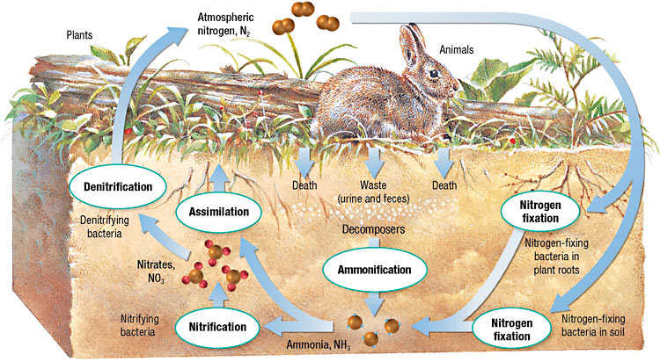

1. What process (or processes) creates ammonia as its main product?

**Nitrogen fixation and ammonification**

1. Ammonia is converted into nitrites and then the nitrites are converted into nitrates through what process?

**Nitrification**

1. What happens when nitrites are converted into nitrates? (Hint: What is different between the chemical formulas of nitrites and nitrates? What is this called?)

**An additional oxygen is added to nitrites to create nitrates, this process is called oxidation.**

1. What do bacteria do in the nitrogen cycle and why are they important? Give at least two examples of where bacteria are utilized in the nitrogen cycle.

**Bacteria are used in many areas of the nitrogen cycle, including: nitrogen fixation, ammonification, nitrification, and denitrification. Without bacteria, sufficient amounts of nitrogen would not be able to be converted through the nitrogen cycle.**