The Ocean’s Give and Take

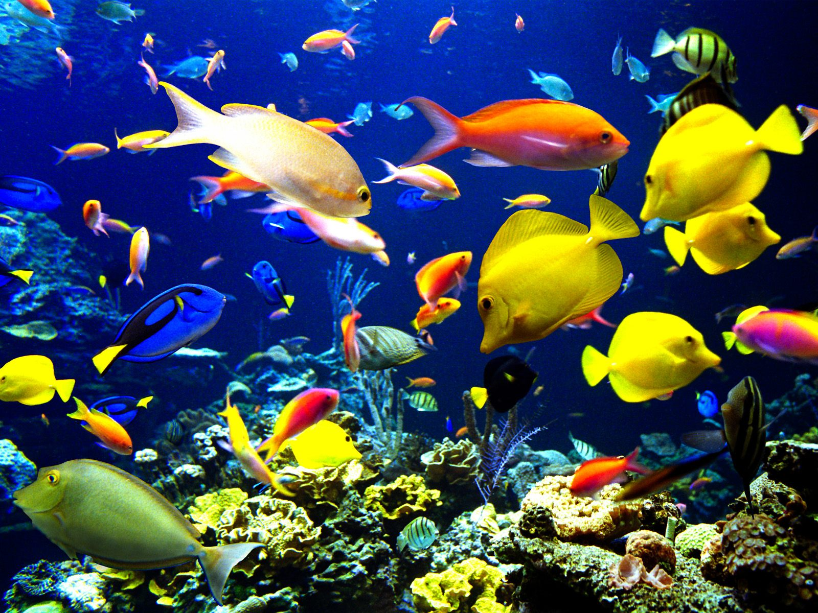
Summary:
This 5E lesson is designed to help the students understand the human dependence on ocean systems and how human activities can modify these systems. Students will clean up an oil spill to learn how the use of the ocean’s resources can impact the ocean’s systems.
Subject:
- Science: 8.11(D)
TEKS: Recognize human dependence on ocean systems and explain how human activities such as runoff, artificial reefs, or use of resources have modified theses systems.
Grade Level:
- Target Grade: 8th
- Lower Bound: 6th, 7th
Time Required: 2 class periods

Activity Team/Group Size: 4 groups for Elaborate activity and groups of 3 or 4 students for Engage and Explore activity.

Materials:
- PowerPoint presentation
- 4 Large Pans
- Water
- Cooking Oil
- Drinking straws
- Sand
- Cotton balls
- Paper towels
Reusable Activity Cost Per Group [in dollars]: ~$50 (tubs; straws; cotton balls; paper towels)
Expendable Activity Cost Per Group [in dollars]: ~$15 (cooking oil; some of the straws, cotton balls, and paper towels)
Learning Objectives:
- Understanding our dependence on ocean systems and how our activities impact those systems
Lesson Introduction / Motivation:
Humans rely heavily on ocean systems. We use the ocean for food, water, commerce, recreation and sadly enough, waste removal. Runoff, artificial reefs, and the use of the oceans resources have all have a large impact on the ocean systems. After viewing the PowerPoint for this lesson, students will have the opportunity to simulate the cleanup of an oil spill.
Lesson/Activity Plan:
Engage:
Have the students break into small groups. Have each group brainstorm things that we rely on the ocean for (food, commerce, etc.) then brainstorm the things that we do to harm the ocean (over fishing, pollution). Have the students take the terms/words and use http://www.wordle.net/create to make two word clouds, one on reliance and the other on harm. In Wordle, the more the word is repeated, the larger it becomes in the word cloud. These can be printed and presented in class or multiple copies can be made so the students can take the ideas home with them. Here is an example:
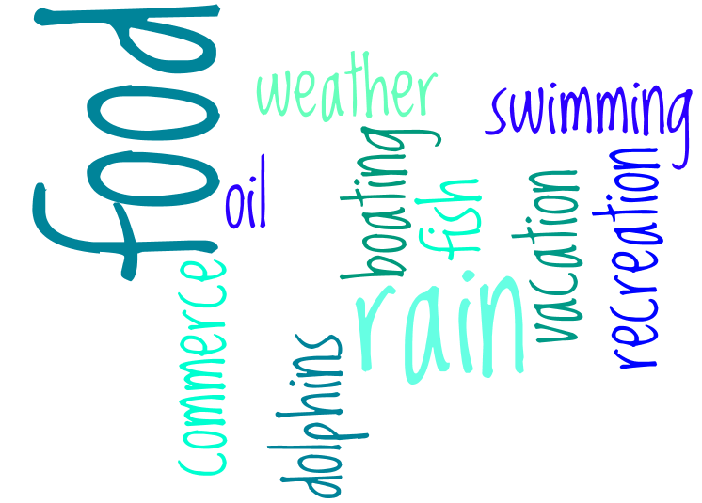
Explore:
Have the students leave their word clouds on the table and then have the groups rotate around to each word cloud. On a piece of paper, have the students write things that their word cloud and the other groups word clouds had in common and things they saw the they did not think of. They should do this for each group. After each group has made it back to their own word clouds, have them present to the class their findings or have a group brainstorm and write the words on the board. Have each group discuss their original ideas.

Explain:
Show the students the PowerPoint presentation. Have the students take turns reading the slides out loud in class. Have them take notes as well so that they can study the material.
Elaborate:
Before class starts the teacher will need to fill the pans halfway with water. Then they will need to carefully pour enough cooking oil to create a complete layer on top of the water that represents an oil spill. The students will be divided into four groups and given the drinking straws, the sand, the cotton balls, or the paper towels. They will each try to clean up the artificial oil spill using the material they were provided.
Each group will need to turn in a piece of paper with their material used; how they used it; and an explanation of how well their technique worked or how they got rid of the oil. They will need to explain what happened to it.
Have each group present their findings to the class. The class should discuss which technique worked best.
(Adapted from: Oily Mess activity: Can You Clean It Up? By Peggy Koenig http://coralreefwatch.noaa.gov/satellite/education/docs/7_Conservation.pdf)

Evaluate:

Give the students the Ocean Systems quiz to test their knowledge of the human dependence on ocean systems and how we affect those systems.

Vocabulary / Definitions:
- Runoff- something that drains or flows off, as rain that flows off from the land in streams
- Groundwater- the water beneath the surface of the ground, consisting largely of surface water that has seeped down: the source of water in springs and wells
- Artificial reef- a structure which is constructed or placed in waters covered under this title for the purpose of enhancing fishery resources and commercial and recreational fishing opportunities
Background and Concepts for Teachers:
- Knowledge and understanding of what an ocean system is
- Knowledge and understanding on how our activities impact the ocean systems we rely so heavily on
- Learn how to use http://www.wordle.net/create so that they can teach the students.
Lesson Extensions:
- http://www.enchantedlearning.com/subjects/ocean/activities.shtml this website has a lot of small activities, such as coloring pages and diagrams to label.

Safety Issues: None

References:
- http://ga.water.usgs.gov/edu/runoff.html
- http://www.pbcgov.com/erm/coastal/reef/
- http://encyclopedia2.thefreedictionary.com/Use+of+ocean+resourses
- http://www.waterencyclopedia.com/Mi-Oc/Mineral-Resources-from-the-Ocean.html
- http://wiki.nsdl.org/index.php/MSP:MiddleSchoolPortal/Ocean_Systems
- http://www.skwirk.com.au/p-c_s-57_u-186_t-502_c-1851/SA/7/The-global-issue-and-differing-perspectives/The-use-of-ocean-resources/Geographical-issues-and-global-citizenship-physical-elements/SOSE-Geography/
- http://dictionary.reference.com/
- http://definitions.uslegal.com/a/artificial-reef/
- http://www.enchantedlearning.com/subjects/ocean/activities.shtml
- http://coralreefwatch.noaa.gov/satellite/education/docs/7_Conservation.pdf

Keywords:
- Ocean Systems
- Runoff
- Artificial Reef
Authors:
Undergraduate Fellow Name: Katie Clark
Please email us your comments on this lesson:
E-mail to ljohnson@cvm.tamu.edu
Please include the title of the lesson, whether you are a teacher, resident scientist or college faculty and what grade you used it for.

Teacher’s Comments:

