Organic Compounds Student Worksheet
- What is an element?
  - An element is any substance that cannot be broken down into simpler substances. The smallest unit of an element is an atom.

- What is a compound?
  - A compound is any chemical that is made of two or more different elements.

- What is the difference between organic and inorganic compounds?
  - Inorganic compounds do not contain carbon. Organic compounds contain carbon and hydrogen and usually are associated with living things

- What elements are most living things made of?
  - CHONPS; Carbon, Hydrogen, Oxygen, Nitrogen, Phosphorus ,and Sulfur

- Which element is considered the foundation for making organic compounds? Why?
  - Carbon; because adding different elements to carbon changes its physical and chemical properties to make all the different organic compounds needed to support life such as carbohydrates, fats, waxes, oils, proteins , and DNA.

- Is the compound water (H₂O) an organic compound? Explain.
  - No, because the compound water does not have a carbon backbone.

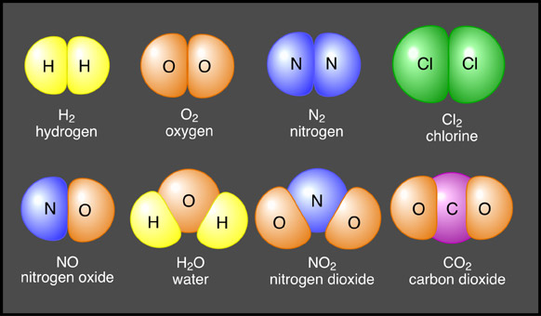
- Circle all organic compounds and square all inorganic compounds in the picture below:

- Fill in the blanks in the table below:
Type of Compound | Example | Major Roles in Living Things
Carbohydrates | - Sugars and Starches | Cells use to get and store energy
- Lipids | Fats, Oils, Waxes | - Store long term energy
Proteins | 12) Hair, nails, enzymes | 13) Build organelles and help with body defense
14) Nucleic Acid | DNA and RNA | Stores genetic information

- For a molecule to be considered inorganic it must NOT contain____________________.
  - Oxygen
  - Carbon
  - Hydrogen
  - Sulfur

- Which group of organic compounds store energy for long periods of time?
  - Carbohydrates
  - Proteins
  - Nucleic acids
  - Lipids

- Two types of Nucleic Acids are _______________and___________________.
  - DNA and ATP
  - ATP and oils
  - Lipids and Starches
  - DNA and RNA

- The building blocks of proteins are________________________.
  - Nucleic acids
  - Amino acids
  - Lipids
  - Fats

