Organic Compounds Student Worksheet
- What is an element?

- What is a compound?

- What is the difference between organic and inorganic compounds?

- What elements are most living things made of?

- Which element is considered the foundation for making organic compounds? Why?

- Is the compound water (H₂O) an organic compound? Explain.

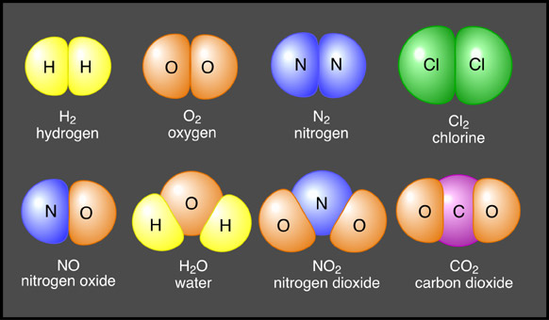
- Circle all organic compounds and square all inorganic compounds in the picture below:

- Fill in the blanks in the table below:
Type of Compound | Example | Major Roles in Living Things
Carbohydrates | 9) | Cells use to get and store energy
10) | Fats, Oils, Waxes | 11)
Proteins | 12) | 13)
14) | DNA and RNA | Stores genetic information

- For a molecule to be considered inorganic it must NOT contain____________________.
  - Oxygen
  - Carbon
  - Hydrogen
  - Sulfur

- Which group of organic compounds store energy for long periods of time?
  - Carbohydrates
  - Proteins
  - Nucleic acids
  - Lipids

- Two types of Nucleic Acids are _______________and___________________.
  - DNA and ATP
  - ATP and oils
  - Lipids and Starches
  - DNA and RNA

- The building blocks of proteins are________________________.
  - Nucleic acids
  - Amino acids
  - Lipids
  - Fats

