
Categorizing Quadrilaterals Through Origami
Lesson Summary: In this active, student-driven lesson, the teacher introduces the characteristics of quadrilaterals through paper folding. The students create a star made up of eight identical pieces. When creating the pieces, the students discuss the different quadrilaterals that appear. Afterwards, the final product serves as a great study tool!
Subject: Math: Geometry
Grade Level:
- Target Grade: 7
- Upper Bound: 7
- Lower Bound: 5
Time Required: 90 minutes
Authors:
Graduate Fellow Name: Marta Kobiela
Teacher Mentor Name: Deborah Parker
Date Submitted: 12-11-05
Date Last Edited: 12-11-05
Lesson Introduction / Motivation: The teacher asks the students to look up the definitions of all the quadrilaterals and related terminology and write them down.
Lesson Plan: After the introduction, the students are each given two 8.5 in x 8.5 in square pieces of paper. The teacher explains that the students will be reinforcing the definitions and distinctions between quadrilaterals that they just looked up. The two squares that each student has received serve as practice pieces. The teacher guides the students through making the origami piece, asking at each step what quadrilateral was made. The steps are shown below.
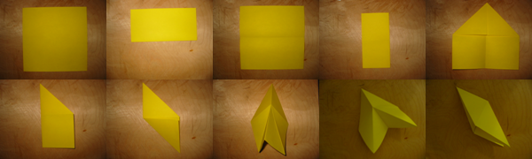
Once the students have completed the first piece with the guidance of the teacher, he/she then asks the students to make a second identical piece with the other square. Since students will work at different paces, whenever a student has completed the task, the teacher may individually show that student how to insert one piece into the other. This step is illustrated below.
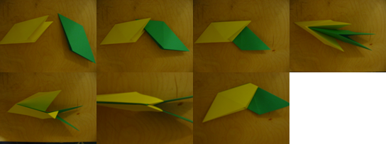
The students are then given eight pieces of colored paper (same size as before) and asked to make eight of the origami pieces. The student must also connect the pieces, one into another, to form a wreath-like object. Once connected, the student may tap the sides of the “wreath” to shift it into the star.
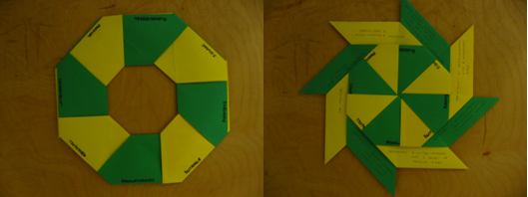
Finally, the student transforms the origami product into a study guide. He or she first writes eight vocabulary words (those looked up at the beginning of the class) in each section of the wreath (see below). The piece underneath a particular vocabulary word will shift out. The definition of this word may then be written on this piece. Sample words that the teacher may use are given in the Vocabulary Section below.
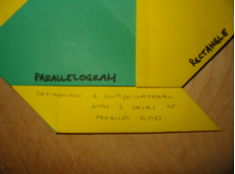
Lesson Closure: The students may practice their vocabulary using their new study guide.
Assessment:
- The teacher may grade on the completeness of the origami project.

Learning Objectives:
- The students will understand the differences between the 5 quadrilaterals.
- The students will utilize geometric terminology.
Prerequisites for this Lesson:
- An understanding of angles, lines, and the concept of parallel.
- An understanding of what a polygon, and, more specifically, a quadrilateral is.
Vocabulary / Definitions:
- Parallel—Two lines are parallel if they belong to the same plane and never intersect.
- Congruent—Two objects are congruent if they are the same size and same shape.
- Quadrilateral—A polygon with four sides.
- Parallelogram—A quadrilateral with two pairs of parallel sides.
- Rhombus—A parallelogram with all four sides congruent.
- Rectangle—A parallelogram with four right angles.
- Square—A rectangle with four congruent sides.
- Trapezoid—A quadrilateral with a pair of parallel sides.

Please email us your comments on this lesson:
E-mail to ljohnson@cvm.tamu.edu
Please include the title of the lesson, whether you are a teacher, resident scientist or college faculty and what grade you used it for.

Keywords:
- Quadrilaterals
- Origami
- Geometry
- Squares
- Rectangles
- Parallelogram
- Trapezoid
- Rhombus

