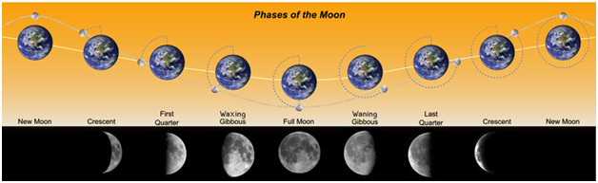
Phases of the Moon – Lyrics
Song by: Songs of Higher Learning
For this and songs of other subjects visit (http://www.songsofhigherlearning.com)

Phases of the Moon
New Moon, Waxing Crescent, First Quarter, Waxing Gibbous
Phases of the Moon
Full Moon, Waning Gibbous, Last Quarter, Waning Crescent
Phases of the Moon
New Moon, Waxing Crescent, First Quarter, Waxing Gibbous
Phases of the Moon
Full Moon, Waning Gibbous, Last Quarter, Waning Crescent

When the moon is in the same direction as the sun it’s called
The New Moon the New Moon
When you don’t see no light coming from the moon it is a dark moon
Called the New Moon

A Crescent Moon is in the next stage
When the moon is lit a quarter of the way
Less than half but more than zero..Ooooo
This is called a Crescent Moon…True

Now a Quarter Moon is a Half Moon
You see a Half Moon’s a Quarter Moon
Quarter Moon’s a Half Moon
They call a Half Moon a Quarter Moon word
Because it made a quarter of its turn around the Earth
You see half of the Moon lit up
And I know what you’re thinking but
It’s a Half Moon, called a Quarter Moon
Half Moon’s a Quarter Moon
Quarter Moon’s a Half Moon

Phases of the Moon
New Moon, Waxing Crescent, First Quarter, Waxing Gibbous
Phases of the Moon
Full Moon, Waning Gibbous, Last Quarter, Waning Crescent
Phases of the Moon
New Moon, Waxing Crescent, First Quarter, Waxing Gibbous
Phases of the Moon
Full Moon, Waning Gibbous, Last Quarter, Waning Crescent

Now the Gibbous Moon is a little more full
But not all the way full
The lit up part is between a Full Moon and a Half Moon
Called the Gibbous Moon

Now the Full Moon shine so bright
You see the Full Moon light up the night
Halfway through a circle, circle
You’ll see the Full Moon Light up the night

Phases of the Moon
New Moon, Waxing Crescent, First Quarter, Waxing Gibbous
Phases of the Moon
Full Moon, Waning Gibbous, Last Quarter, Waning Crescent
Phases of the Moon
New Moon, Waxing Crescent, First Quarter, Waxing Gibbous
Phases of the Moon
Full Moon, Waning Gibbous, Last Quarter, Waning Crescent

