The Photosynthesis Factory
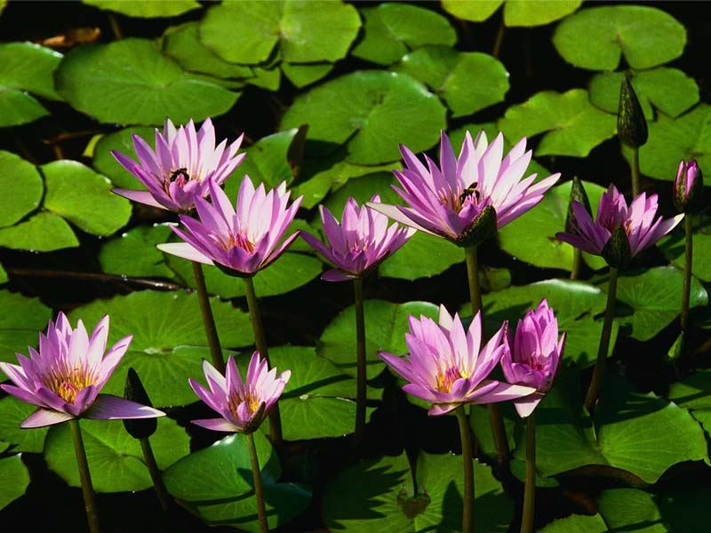
Summary:
The students will learn about the process of photosynthesis. This lesson focuses on the energy conversion and chemical reaction that takes place during photosynthesis. It also explores how the structures of a plant aid in the photosynthesis process. Students will then relate the parts of a plant to the parts of a factory as an analogy.
Subject:
- Science:
TEKS:
  - 6.3 (C) represent the natural world using models and identify their limitations
  - 6.7 (A) demonstrate that new substances can be made when two or more substances are chemically combined and compare the properties of the new substances to the original substances;
  - 7.3 (C) represent the natural world using models and identify their limitations
  - 7.8 (B) identify that radiant energy from the Sun is transferred into chemical energy through the process of photosynthesis.
  - 8.3 (C) represent the natural world using models and identify their limitations
  - 8.9 (A) demonstrate that substances may react chemically to form new substances;
Grade Level:
- Target Grade: 7
- Upper Bound: 8
- Lower Bound: 6
Time Required: 40 minutes for the powerpoint, 30-45 minutes for the activity
Activity Team/Group Size: individual activity

Materials:
- Crayons, colored pencils, markers, or other coloring utensil
Reusable Activity Cost Per Group [in dollars]: $ 0.50
Expendable Activity Cost Per Group [in dollars]: $0.00

Learning Objectives:
- Understand what happens during photosynthesis
- Know the type of energy conversion in photosynthesis
- Recognize the parts of a plant essential to photosynthesis
- Generate a “photosynthesis factory” plan
Lesson Plan:
Present the photosynthesis powerpoint so the students understand the chemical reactions and energy conversions that occur in photosynthesis. Present the parts of a plant that are significant for photosynthesis to occur. Lead the students through the “Virtual Lab,” where they can identify parts of a plant as seen in a microscope. Instruct the students to generate a “Photosynthesis Factory” diagram.
Lesson Closure:
Extend the virtual lab to include more parts of a plant.

Assessment:
Check that the students were able to generate a data table and graph from the class data. Both should include a title, variables, units, and data.

Vocabulary / Definitions:
- Photosynthesis: the chemical process in which plants use the energy contained in sunlight to turn carbon dioxide and water into energy in the form of a carbohydrate (sugar) called glucose
- Xylem: transport tissue that carries water from the roots to the leaf
- Phloem: transport tissue that carries nutrients from the leaf to the root
- Epidermis: the outer single-layered group of cells covering a plant.
- Palisade cells: a type of leaf tissues that contain chloroplasts
- Chloroplasts: organelles found only in plants and plant-like organisms in which photosynthesis takes place
- Stoma: the opening that connects the outside of the plant to the inside and allows for air exchange.

Background and Concepts for Teachers:
- None
Prerequisites for this Lesson:
- Students should be familiar with chemical reactions and should understand the components of a chemical equation. It would be helpful for students to understand energy conversion prior to the lesson.
Lesson Extensions:

In lieu of the “Virtual Lab,” prepared slides could be set up at microscopes so that the parts of a plant are presented in a more scientific setting.

Safety Issues:
None

Troubleshooting Tips:
None

Multimedia Support and Attachments:
- Photosynthesis power point

Keywords:
- Photosynthesis
- Plant Parts
- Energy
- Chemical Reaction
Authors:
Graduate Fellow Name: Holly Phillips
Teacher Mentor Name: Kathy Polzer
Undergraduate Fellow Name: Darlene Sanchez
Date Submitted: 12/21/07
Date Last Edited: ___
Please email us your comments on this lesson:
E-mail to ljohnson@cvm.tamu.edu
Please include the title of the lesson, whether you are a teacher, resident scientist or college faculty and what grade you used it for.

Teacher’s Comments:

