Exploring the Properties of Light

Property 1: “Light travels in a straight line”

Materials: 3 index cards, play-doh, flashlight, hole punch, ruler
Procedure:
- Use the ruler to draw diagonal lines connecting the opposite corners of the index card to determine the middle. Repeat for all three cards
- At the intersection of these two lines, punch holes in the center of the three index cards
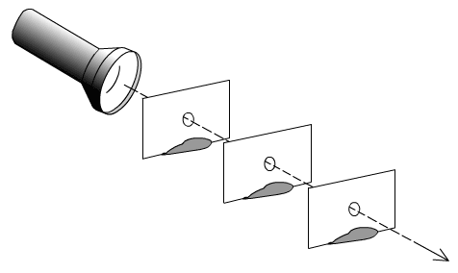
- Use the play-doh to create a base so that the index cards can stand up vertically
- Arrange the cards at an equal distance from each other so that light can be seen through all the holes
- Dim the lights in the room and shine the flash light through the holes
- Record your observations by answering the questions below.

Analysis
- What did you notice about the path of light through the index cards?
___________________________________________________________________________________________________________________________________________________________________________________________________________________________________________________

- What does the experiment prove about how the path light travels?
___________________________________________________________________________________________________________________________________________________________________________________________________________________________________________________

- What would happen if the holes were smaller? Larger?
______________________________________________________________________________________________________________________________________________________________________________________________________________________________________________________________________________________________________________________________________________________________________________________________________________________________________________________________________________________________________

Property 2: “Light travels faster than sound”
We know that we see things because they reflect light into our eyes, the best way we know this occurs is through the use of mirrors. When you stand in front of a mirror, an exact image of yourself is reflected back into your eyes (considering the mirror is a smooth and flat surface). In the same way that light can be reflected, so can sound through the process of creating an echo. An echo is the reflection of sound off of a surface. In this activity we are going to see how light and sound varies in speed.

Materials: large room, preferably with high ceiling and made of windows or marble (the emptier; the better, most school lobbies will do the trick), yardstick, calculator, mirror, flashlight, stopwatch
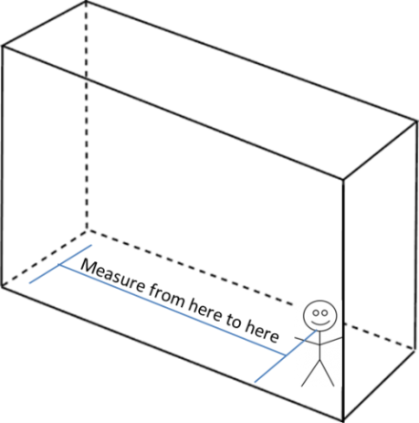
Procedure:
- Standing in the large room that will produce an echo, measure the greatest possible distance in yards away from the wall in order to achieve the best echo.
- Have one person at a time clap once to produce the sound for the echo, while another uses the stopwatch to record the amount of time it takes for the echo noise to travel back. Do this three times to get an average.
- Now place a mirror on the far side of the wall. Shine a flashlight toward the mirror and observe the light beam that bounces off. Record the amount of time it takes for this light beam to reflect off the mirror. This may have to be your best estimate!

Echo | Time (seconds) |  | Reflection | Time (seconds)
Trial 1 |  |  | Trial 1
Trial 2 |  |  | Trial 2
Trial 3 |  |  | Trial 3
Average |  |  | Average

Using the formula: Speed = Distance / Time, find out how quickly the echo and reflection traveled. Use the average for time from the chart above. Be sure to show all calculations!

Distance away from the back end of the wall =___________ yards

Speed of echo =___________ yards/second

Speed of reflection =___________ yards/second

Analysis
- What did you notice about the difference in the time it took to hear the echo bounce back in comparison to the time it took for the reflection to bounce back?
__________________________________________________________________________________________________________________________________________________________________________________________________________________________________________

- What does the difference stated above say to you about the speed of sound in comparison to the speed of light? Could you say that we have just proven that light travels faster than sound?
__________________________________________________________________________________________________________________________________________________________________________________________________________________________________________
____________________________________________________________________________________________________________________________________________________________

- Based on what you know about sound amplification and absorption, name a few requirements that the lobby had that enabled a good echo to be produced? Can you think of other spaces that would produce a sufficient echo?
__________________________________________________________________________________________________________________________________________________________________________________________________________________________________________
____________________________________________________________________________________________________________________________________________________________

Property 3: “Shadows are formed when light is blocked”
Material: overhead projector, materials from around the room (preferably unique!)
Procedure:
- Split into small groups of 4-5 people and collect small to medium sized objects from around the class room.
- Once all objects are determined class should come together. The instructor should darken the room and shine the light from the overhead projector onto a screen. Each object should be shown on the screen and students should take guesses at what each object may be.
- In the space below, using only two shown objects, draw what you observe in the box. Using the lines next to the box, record your observations of the object and how you came to determine what the shadow object may be.
Object One: ______________________
My observations and ideas:
___________________________________________________
___________________________________________________
___________________________________________________
___________________________________________________
___________________________________________________
___________________________________________________
___________________________________________________
___________________________________________________

Object Two: ______________________
My observations and ideas:
___________________________________________________
___________________________________________________
___________________________________________________
___________________________________________________
___________________________________________________
___________________________________________________
___________________________________________________
___________________________________________________

Analysis
- What was the result of shining the light on the object and projecting it onto the wall?
_________________________________________________________________________________________________________________________________________________________________________________________________________________________________

- How would you make the shadow bigger?
___________________________________________________________________________________________________________________________________________________________________________________________________________________________________________________
- How would you make the shadow smaller?
_________________________________________________________________________________________________________________________________________________________________________________________________________________________________

- Did you observe any shadows that were lighter or darker than the shadows of other objects? Explain why this may be or why it might happen. (Hint: remember the different types of objects light interacts with!)
______________________________________________________________________________________________________________________________________________________________________________________________________________________________________________________________________________________________________________________________________________________________________________________________________________________________________________________________________________________________________

Property 4: “We see things because they reflect into our eyes”
Part One:
Warm-up: We do not see things, but we do see the light reflected off of those things.
What do you think the validity of this statement is?
___________________________________________________________________________________________________________________________________________________________________________________________________________________________________________________
What would you see if you were sitting in a completely dark room? Explain by using what you have learned about light.
___________________________________________________________________________________________________________________________________________________________________________________________________________________________________________________
Things cannot be seen unless they are reflecting light or emitting light themselves. Mirrors are capable of reflecting light, and are able to produce images of the object that is in front of it. Not all mirror surfaces are able to reflect light rays in parallel lines, so not all surfaces are true mirrors. In this activity we will be exploring how a beam of light can be reflected off a mirror and projected in a new direction.

Materials: flashlight, cardboard, mirror, protractor
Procedure:
- Cover the front of each flashlight with a piece of cardboard that has a small hole in the center.
- Divide into partners or small groups, each with a flashlight and a mirror.
- Darken the class room as much as possible and shine the light at your partner’s mirror.
- Now try to “hit” different objects around the room and take note of the angle of the mirror to bounce the light, as well as the path of the light.
Analysis
- What happened when you shone the light towards your partners’ mirror?
__________________________________________________________________________________________________________________________________________________________________________________________________________________________________________Draw a diagram in the space below of you and your partner and the path of the light reflecting off of the mirror in the space below:
- What happened when the mirrors were moved around to try and hit an object in the room?
__________________________________________________________________________________________________________________________________________________________________________________________________________________________________________
____________________________________________________________________________________________________________________________________________________________
Draw what you observed in the space below when you tried to hit a specific point in the room (the clock, a poster, the bookshelves, etc):
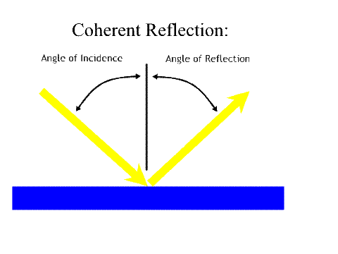
Angle of incidence and reflection
Angle of Incidence
Angle of Reflection
Reflecting surface

The ray of light that is hitting the mirror is the ray of incidence, and creates the angle of incidence along an imagined “normal” line. The normal line being the path of light if the ray hit the reflective surface at a straight angle. The ray of reflection is the path of light being reflected from the mirror, it is the angle of incidence along the imagined normal line.

Take the protractor and measure the estimated angle of the path of light hitting the mirror and bouncing off the mirror towards the object in the picture above. Record your angle of incidence and reflection in the spaces below:
Angle of incidence: _________ Angle of reflection: _________
What do you notice about the two angles? __________________________________________________
Part Two –“We see things because they reflect into our eyes” - Scattering:
Materials: large glass, whole milk, tablespoon, flashlight, cardboard 8 ½ x 11, hole punch, ruler, pencil
Procedure
- Fill the glass full with water and let it sit so that any particles may settle to the bottom
- Using the ruler, locate the center of the cardboard using the same diagonal technique as before in the “Path of Light” activity and punch a hole in the cardboard
- Shine the flashlight through the hole in the cardboard. The flashlight should be touching the cardboard to focus the light through the hole
- Turn off the lights in the room and aim the flashlight towards the glass
- Observe what happens to the light as it travels through the glass, draw what you observe in the spaces provided below
- Add a table spoon of milk into the glass and shine the flashlight into the glass and observe, record observations in the space provided below.
- Continue to add milk to the glass of water one teaspoon at a time. Repeat steps 3-5 and observe and record after each teaspoon.
- Continue until the glass appears to be more milk than water.

No Milk in Water 2 Tablespoons of Water

4 Tablespoons of Water More Milk Than Water

Analysis
- What can you conclude about the light beam as it goes through the glass of water?
___________________________________________________________________________________________________________________________________________________________________________________________________________________________________________________
- As the milk was added to the glass of water, what happened to the path that the light beam traveled? Why do you think this occurred?
_____________________________________________________________________________________________________________________________________________________________________________________________________________________________________________________________________________________________________________________________________________________________________________________________________________________
- What observations can be made about the beam of light as it goes through the glass of water?
___________________________________________________________________________________________________________________________________________________________________________________________________________________________________________________

