What’s the Matter with Matter?!
Properties of Matter Worksheet
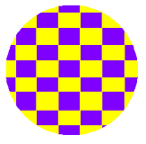

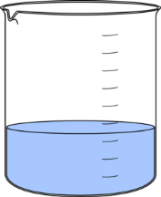
Physical Property – any characteristic of a material that can be observed or measured without changing the identity of the material. These are properties that can be observed with our senses.
50mL

Dependent on Amount
Part A: By observing the liquid in the beaker, categorize the physical properties by whether it is dependent on or independent of the amount of liquid.
Independent of Amount

4. Density: 1 g/mL
5. Shape: Beaker
7. Mass: 50 g
1. Color: Blue
2. Melting Point: 0° C
3. Volume: 50 mL
6. Odor: none

Part B: It’s time for you to get creative. In the space below, you are going to create and draw something made out of your element (which you got at the beginning of this lesson). Then you will describe its physical properties and write those down in the appropriate column (You can describe more properties than were included in Part A like texture, length, boiling point, etc.)

Properties:
Independent of Amount
Dependent on Amount

